Grace Lutheran Church

493 Forest Avenue, Glen Ellyn IL 630.469.1555
www.graceglenellyn.org

19th Sunday after Pentecost October 3, 2021

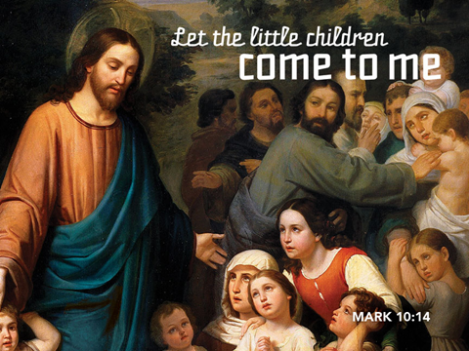

+ Proclaim Christ + Build Community +
+ Serve Our Neighbors +

Introduction
Today’s gospel combines a saying that makes many of us uncomfortable with a story we find comforting. Jesus’ saying on divorce is another of his rejections of human legislation in favor of the original intent of God’s law. Jesus’ rebuke of the disciples who are fending off the children should challenge us as well. What does it mean to receive the kingdom of God as a child does?

Gathering
The Holy Spirit calls us together as the people of God.
Welcome/Announcements
Helpful Reminders for those joining in person:
- Maintain 6’ distance between family groups
- Remain in your pews for communion.
- You may place your offering in the box in the narthex.

Prelude

*Please stand as you are able and turn to face the font.
*Confession and Forgiveness
All may make the sign of the cross, the sign marked at baptism, as the presiding minister begins.Blessed be the holy Trinity, ☩ one God, whose teaching is life, whose presence is sure, and whose love is endless. Amen.

Let us confess our sins to the one who welcomes us with an open heart.
Silence is kept for reflection.

God our comforter: like lost sheep, we have gone astray. We gaze upon abundance and see scarcity. We turn our faces away from injustice and oppression. We exploit the earth with our apathy and greed. Free us from our sin, gracious God. Listen when we call out to you for help. Lead us by your love to love our neighbors as ourselves. Amen.

All have sinned and fall short of the glory of God. By the gift of grace in ☩ Christ Jesus, God makes you righteous. Receive with glad hearts the forgiveness of all your sins. Amen.

*Entrance Hymn ELW#796 How Firm a Foundation
sts. 1,2,4
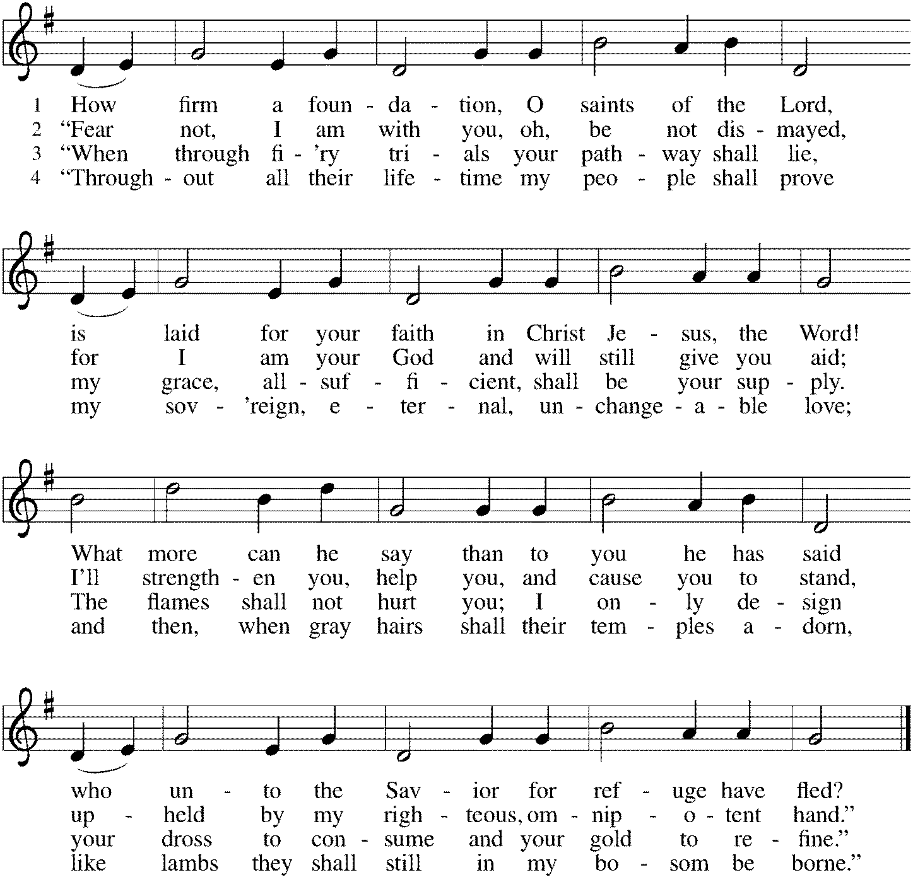

*Greeting
The grace of our Lord Jesus Christ, the love of God, and the communion of the Holy Spirit be with you all. And also with you.

*Kyrie p. 184 Bradford sings the verses, Congregation sings the refrain.
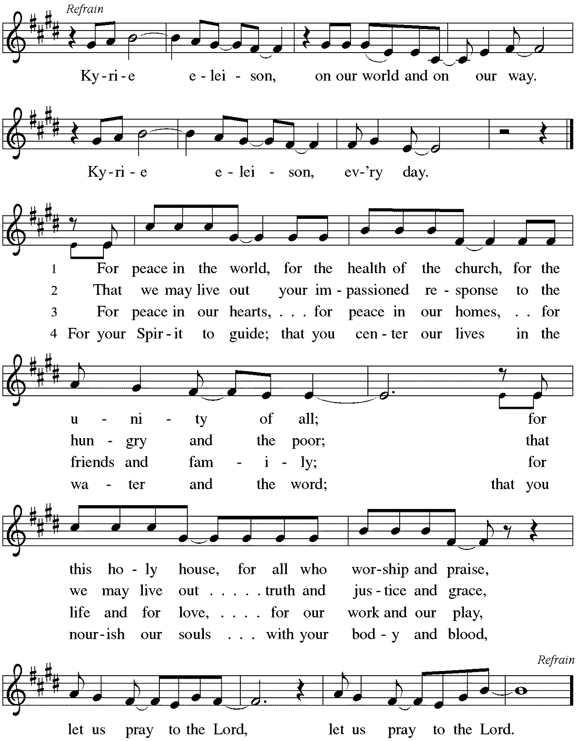
*Prayer of the Day
Sovereign God, you have created us to live in loving community with one another. Form us for life that is faithful and steadfast, and teach us to trust like little children, that we may reflect the image of your Son, Jesus Christ, our Savior and Lord. Amen. Be seated.

Word
God speaks to us in scripture reading, preaching, and song.
First Reading Genesis 2:18-24
Genesis 2 stresses that people are not meant to live in isolation but in relationship. Out of love for humanity, God creates them male and female, to provide companionship for each other and to become with each other “one flesh.” The Hebrew words used here are ish (man) and ishshah (woman).

¹⁸The Lord God said, “It is not good that the man should be alone; I will make him a helper as his partner.” ¹⁹So out of the ground the Lord God formed every animal of the field and every bird of the air, and brought them to the man to see what he would call them; and whatever the man called every living creature, that was its name. ²⁰The man gave names to all cattle, and to the birds of the air, and to every animal of the field; but for the man there was not found a helper as his partner. ²¹So the Lord God caused a deep sleep to fall upon the man, and he slept; then he took one of his ribs and closed up its place with flesh. ²²And the rib that the Lord God had taken from the man he made into a woman and brought her to the man. ²³Then the man said, “This at last is bone of my bones and flesh of my flesh; this one shall be called Woman, for out of Man this one was taken.”
²⁴Therefore a man leaves his father and his mother and clings to his wife, and they become one flesh.

Word of God, Word of Life. Thanks be to God.

Psalm Psalm 8
You crown us with glory and honor. (Ps. 8:5)

¹O Lord our Lord, how majestic is your name in all the earth!—
²you whose glory is chanted above the heavens out of the mouths of infants and children; you have set up a fortress against your enemies, to silence the foe and avenger.
³When I consider your heavens, the work of your fingers, the moon and the stars you have set in their courses,
⁴what are mere mortals that you should be mindful of them, human beings that you should care for them?
⁵Yet you have made them little less than divine; with glory and honor you crown them.
⁶You have made them rule over the works of your hands; you have put all things under their feet:
⁷all flocks and cattle, even the wild beasts of the field,
⁸the birds of the air, the fish of the sea, and whatever passes along the paths of the sea.
⁹O Lord our Lord, how majestic is your name in all the earth!

Second Reading Hebrews 1:1-4:5-12
Quoting from the psalms, this passage from Hebrews emphasizes that Jesus, the one through whom God created everything and who sits at God’s right hand, is also the one who experienced human suffering and death in order to blaze the path of salvation for us.

¹Long ago God spoke to our ancestors in many and various ways by the prophets, ²but in these last days he has spoken to us by a Son, whom he appointed heir of all things, through whom he also created the worlds. ³He is the reflection of God’s glory and the exact imprint of God’s very being, and he sustains all things by his powerful word. When he had made purification for sins, he sat down at the right hand of the Majesty on high, ⁴having become as much superior to angels as the name he has inherited is more excellent than theirs.
^{2:5}Now God did not subject the coming world, about which we are speaking, to angels. ⁶But someone has testified somewhere, “What are human beings that you are mindful of them, or mortals, that you care for them? ⁷You have made them for a little while lower than the angels; you have crowned them with glory and honor, ⁸subjecting all things under their feet.” Now in subjecting all things to them, God left nothing outside their control. As it is, we do not yet see everything in subjection to them, ⁹but we do see Jesus, who for a little while was made lower than the angels, now crowned with glory and honor because of the suffering of death, so that by the grace of God he might taste death for everyone.
¹⁰It was fitting that God, for whom and through whom all things exist, in bringing many children to glory, should make the pioneer of their salvation perfect through sufferings. ¹¹For the one who sanctifies and those who are sanctified all have one Father. For this reason Jesus is not ashamed to call them brothers and sisters, ¹²saying, “I will proclaim your name to my brothers and sisters, in the midst of the congregation I will praise you.”

Word of God, Word of Life. Thanks be to God.

*Please stand as you are able.
*Gospel Acclamation p. 188 Alleluia
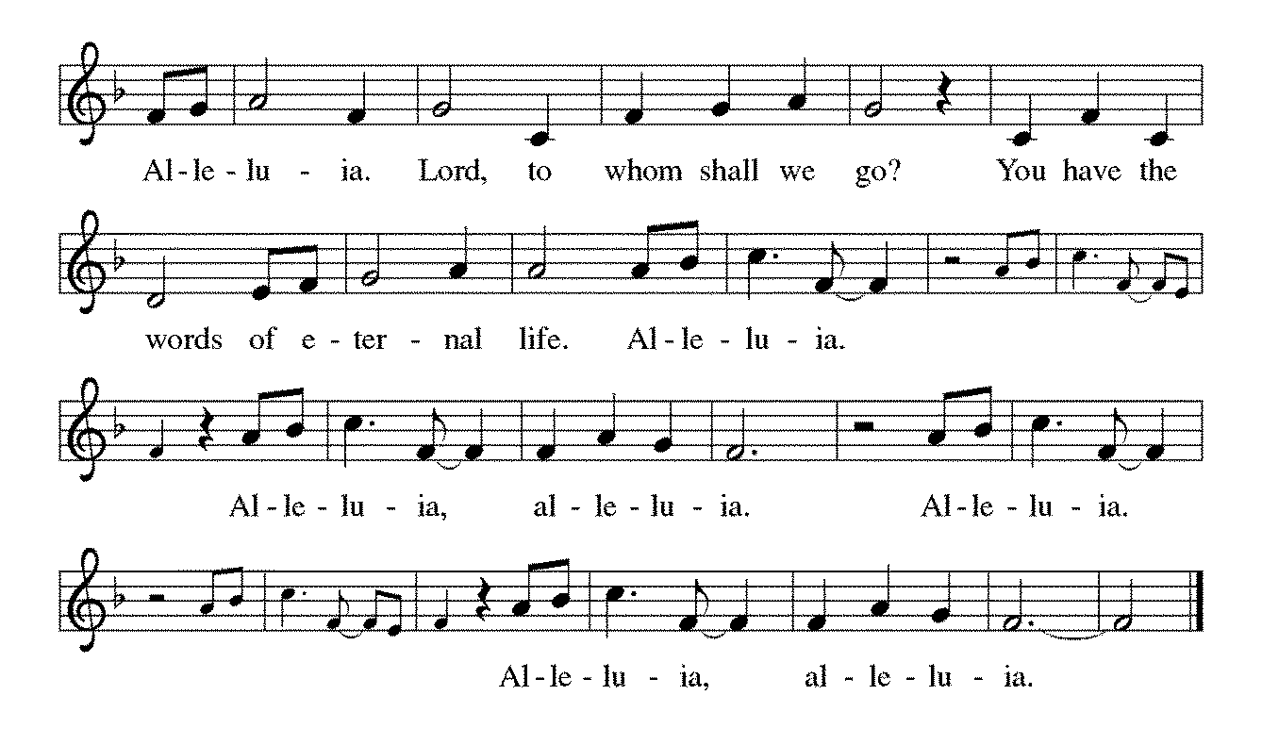

The holy Gospel according to Mark. Glory to you, O Lord.

*Gospel Mark 10:2-16
Jesus announced and enacted in history the new reality of God’s surprising activity. These two stories demonstrate this new reality: Women and children are accepted and valued, not dismissed as inferior to adult men.

²Some Pharisees came, and to test [Jesus] they asked, “Is it lawful for a man to divorce his wife?” ³He answered them, “What did Moses command you?” ⁴They said, “Moses allowed a man to write a certificate of dismissal and to divorce her.” ⁵But Jesus said to them, “Because of your hardness of heart he wrote this commandment for you. ⁶But from the beginning of creation, ‘God made them male and female.’ ⁷‘For this reason a man shall leave his father and mother and be joined to his wife, ⁸and the two shall become one flesh.’ So they are no longer two, but one flesh. ⁹Therefore what God has joined together, let no one separate.”
¹⁰Then in the house the disciples asked him again about this matter. ¹¹He said to them, “Whoever divorces his wife and marries another commits adultery against her; ¹²and if she divorces her husband and marries another, she commits adultery.”
¹³People were bringing little children to him in order that he might touch them; and the disciples spoke sternly to them. ¹⁴But when Jesus saw this, he was indignant and said to them, “Let the little children come to me; do not stop them; for it is to such as these that the kingdom of God belongs. ¹⁵Truly I tell you, whoever does not receive the kingdom of God as a little child will never enter it.” ¹⁶And he took them up in his arms, laid his hands on them, and blessed them.

The Gospel of the Lord. Praise to you, O Christ. Be seated.

Sermon The Rev. Melody Eastman

*Please stand as you are able.
*Hymn of the Day ACS #1049 Before the Waters Nourished Earth
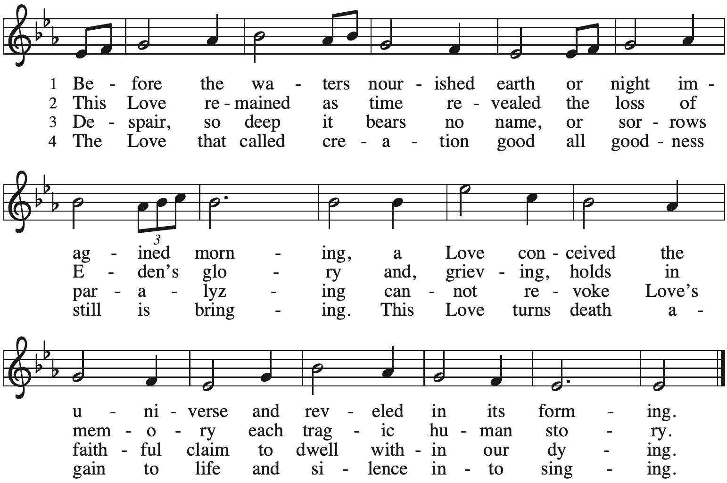

*Please turn to face the baptismal font
*Holy Baptism of Audrey Kay Yount Parents: Basia Yount
Andrew Yount

Sponsors: Jessica Sobon
Mirek Kawula

God, who is rich in mercy and love, gives us a new birth into a living hope through the sacrament of baptism. By water and the Word God delivers us from sin and death and raises us to new life in Jesus Christ. We are united with all the baptized in the one body of Christ, anointed with the gift of the Holy Spirit, and joined in God’s mission for the life of the world.
Sponsors We present Audrey Kay Yount for baptism.

Basia and Andrew, called by the Holy Spirit, trusting in the grace and love of God, do you desire to have Audrey baptized into Christ?
Parents We do.

As you bring your child to receive the gift of baptism, you are entrusted with responsibilities: To live with her among God’s faithful people, to bring her to hear the word of God and to the holy supper, to teach her the Lord’s Prayer, the Creed and the Ten Commandments, to place in her hands the holy scriptures and nurture her in faith and prayer so that she may learn to trust God, proclaim Christ through word and deed, care for others and the world God made, and work for justice and peace.

Do you promise to help Audrey to grow in the Christian faith and life?
Parents We do.

Jessica and Mirek, do you promise to nurture Audrey in the Christian faith as you are empowered by God’s Spirit, and to help her live in the covenant of baptism and in communion with the church?
Sponsors We do.

People of God, do you promise to support Audrey and pray for her in her new life in Christ?
Congregation We do.

*Profession of Faith
I ask you to profess your faith in Christ Jesus, reject sin, and confess the faith of the church.

Do you renounce the devil and all the forces that defy God?
Parents/Sponsors I renounce them.

Do you renounce the powers of this world that rebel against God?
Parents/Sponsors I renounce them.

Do you renounce the ways of sin that draw you from God?
Parents/Sponsors I renounce them.

The congregation joins in the profession of faith.
Do you believe in God the Father?
I believe in God, the Father almighty, creator of heaven and earth.

Do you believe in Jesus Christ, the Son of God?
I believe in Jesus Christ, God's only Son, our Lord, who was conceived by the Holy Spirit, born of the virgin Mary, suffered under Pontius Pilate, was crucified, died, and was buried; he descended to the dead. On the third day he rose again; he ascended into heaven, he is seated at the right hand of the Father, and he will come to judge the living and the dead.

Do you believe in God the Holy Spirit?
I believe in the Holy Spirit, the holy catholic church, the communion of saints, the forgiveness of sins, the resurrection of the body, and the life everlasting.

*Thanksgiving at the Font
The Lord be with you. And also with you.

Let us give thanks to the Lord our God. It is right to give our thanks and praise.

We give you thanks, O God, for in the beginning your Spirit moved over the waters and by your Word you created the world, calling forth life in which you took delight. Through the waters of the flood you delivered Noah and his family, and through the sea you led your people Israel from slavery into freedom. At the river your Son was baptized by John and anointed with the Holy Spirit. By the baptism of Jesus' death and resurrection you set us free from the power of sin and death and raise us up to live in you. Pour out your Holy Spirit, the power of your living Word, that those who are washed in the waters of baptism may be given new life. To you be given honor and praise through Jesus Christ our Lord, in the unity of the Holy Spirit, now and forever. Amen.

*Baptism
Audrey Kay Yount, I baptize you in the name of the Father, and of the Son, and of the Holy Spirit. Amen. You belong to Christ, in whom you have been baptized.

Let us pray. We give you thanks, O God, that through water and the Holy Spirit you give your beloved children new birth, cleanse them from sin, and raise them to eternal life. Sustain Audrey Kay with the gift of your Holy Spirit: the spirit of wisdom and understanding, the spirit of counsel and might, the spirit of knowledge and the fear of the Lord, the spirit of joy in your presence, both now and forever. Amen.

Audrey Kay, child of God, you have been sealed by the Holy Spirit and marked with the cross of Christ forever. Amen.

*Welcome
Let your light so shine before others that they may see your good works and glorify your Father in heaven.

Let us welcome the newly baptized.
We welcome you into the body of Christ and into the mission we share: join us in giving thanks and praise to God and bearing God's creative and redeeming word to all the world.

*Prayers of Intercession
Made children and heirs of God’s promise, we pray for the church, the world, and all in need.
A brief silence.

Holy One, you have raised up faithful leaders throughout history. Empower those discerning a call to ministry and all seminarians, that they continue to be formed for the sake of the gospel. Lord, in your mercy, hear our prayer.

You have established a diverse and beautiful creation. Revive declining species and preserve endangered lands. Cultivate in us a sense of wonder for the world you created. Lord, in your mercy, hear our prayer.

You desire for us not to be alone and to live in community with one another. Strengthen relationships between nations and peoples, that we celebrate and support one human family. Lord, in your mercy, hear our prayer.

You share in our experiences and struggles. Bless all who live with any mental or physical disability. Inspire creative communities, spaces, and environments that are accessible and hospitable. Lord, in your mercy, hear our prayer.

You have established and nurtured relationships that extend beyond those gathered here today. Bless members who can no longer travel to worship with us especially Carol, Dolores, Jim, Cathy, Dorothy, and Norma and remind us of their continued role in this community of faith. Lord, in your mercy, hear our prayer.
Here other intercessions may be offered.

Be with all who celebrate and increase their joy, especially Ray and Bette Dieter as they celebrate their 60th wedding anniversary. Lord, in your mercy, hear our prayer.

You promise eternal life to all your children. Thank you for the people of faith who have gone before us. Strengthen our trust we have in you. Lord, in your mercy,
hear our prayer.

Receive these prayers, O God, and those in our hearts known only to you; through Jesus Christ our Lord. Amen.
*Peace
The peace of Christ be with you always. And also with you.
Please share the peace with others in your household, or by making a sign of peace to those on Zoom. Please remain standing.

Meal
God feeds us with the presence of Jesus Christ.
*Offering Prayer
God of abundance,
you cause streams to break forth in the desert
and manna to rain from the heavens.
Accept the gifts you have first given us.
Unite them with the offering of our lives
to nourish the world you love so dearly;
through Jesus Christ, our Savior and Lord. Amen

*Great Thanksgiving
The Lord be with you. And also with you.
Lift up your hearts. We lift them to the Lord.
Let us give thanks to the Lord our God. It is right to give our thanks and praise.

*Preface
It is indeed right, our duty and our joy, that we should at all times and in all places give thanks and praise to you, almighty and merciful God, through our Savior Jesus Christ; who on this day overcame death and the grave, and by his glorious resurrection opened to us the way of everlasting life. And so, with all the choirs of angels, with the church on earth and the hosts of heaven, we praise your name and join their unending hymn:

*Sanctus p. 190 Holy, Holy, Holy
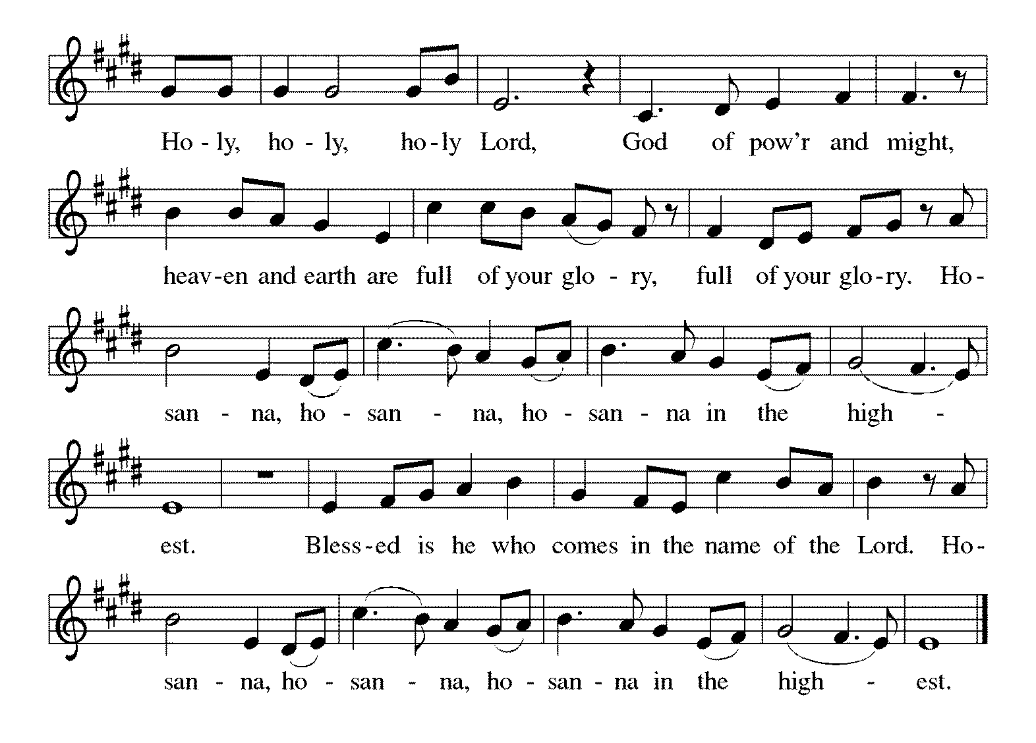

*Thanksgiving at the Table
Holy God, holy and mighty,
holy and immortal:
you we praise and glorify,
you we worship and adore.

You formed the earth from chaos;
you encircled the globe with air;
you created fire for warmth and light;
you nourish the lands with water.
You molded us in your image,
and with mercy higher than the mountains,
with grace deeper than the seas,
you blessed the Israelites and cherished them as your own.
That also we, estranged and dying,
might be adopted to live in your Spirit,
you called to us through the life and death of Jesus.

In the night in which he was betrayed,
our Lord Jesus took bread, and gave thanks;
broke it, and gave it to his disciples, saying:
Take and eat; this is my body, given for you.
Do this for the remembrance of me.

Again, after supper, he took the cup, gave thanks,
and gave it for all to drink, saying:
This cup is the new covenant in my blood,
shed for you and for all people for the forgiveness of sin.
Do this for the remembrance of me.

Together as the body of Christ, we proclaim the Lord's death until he comes.
Christ has died. Christ is risen. Christ will come again.
With this bread and cup we remember your Son,
the first-born of your new creation.
We remember his life lived for others,
and his death and resurrection, which renews the face of the earth.
We await his coming,
when, with the world made perfect through your wisdom,
all our sins and sorrows will be no more.
Amen. Come, Lord Jesus.

You may hold up your (unopened) communion kit as you are able.
Holy God,
holy and merciful,
holy and compassionate,
send upon us and this meal your Holy Spirit,
whose breath revives us for life,
whose fire rouses us to love.
Enfold in your arms all who share this holy food.
Nurture in us the fruits of the Spirit,
that we may be a living tree, sharing your bounty with all the world.
Amen. Come, Holy Spirit.
You may lower your communion kit.

Holy and benevolent God,
receive our praise and petitions,
as Jesus received the cry of the needy,
and fill us with your blessing,
until, needy no longer and bound to you in love,
we feast forever in the triumph of the Lamb:
through whom all glory and honor is yours, O God, O Living One,
with the Holy Spirit, in your holy church, now and forever.
Amen.

*The Lord’s Prayer Ecumenical Version
Gathered into one by the Holy Spirit, let us pray as Jesus taught us.
Our Father in heaven, hallowed be your name, your kingdom come, your will be done, on earth as in heaven. Give us today our daily bread. Forgive us our sins as we forgive those who sin against us. Save us from the time of trial and deliver us from evil. For the kingdom, the power, and the glory are yours, now and forever. Amen.

*Invitation to Communion
All who hunger and thirst, come. The table is ready. Be Seated.

If you have difficulty opening your communion, please signal an usher for assistance.
Peel up the clear top seal over the wafer, and hold the wafer up when you are ready.
This is the Body of Christ, given for you. (Eat the bread.) Amen.

Peel up the second foil seal over the juice, and hold your cup up when you are ready.
This is the blood of Christ, shed for you. (Drink the wine/juice.) Amen.
After communion you may place the packaging in the bowl in your pew. The ushers will dispose of these following the service.

Agnus Dei p. 191 Lamb of God
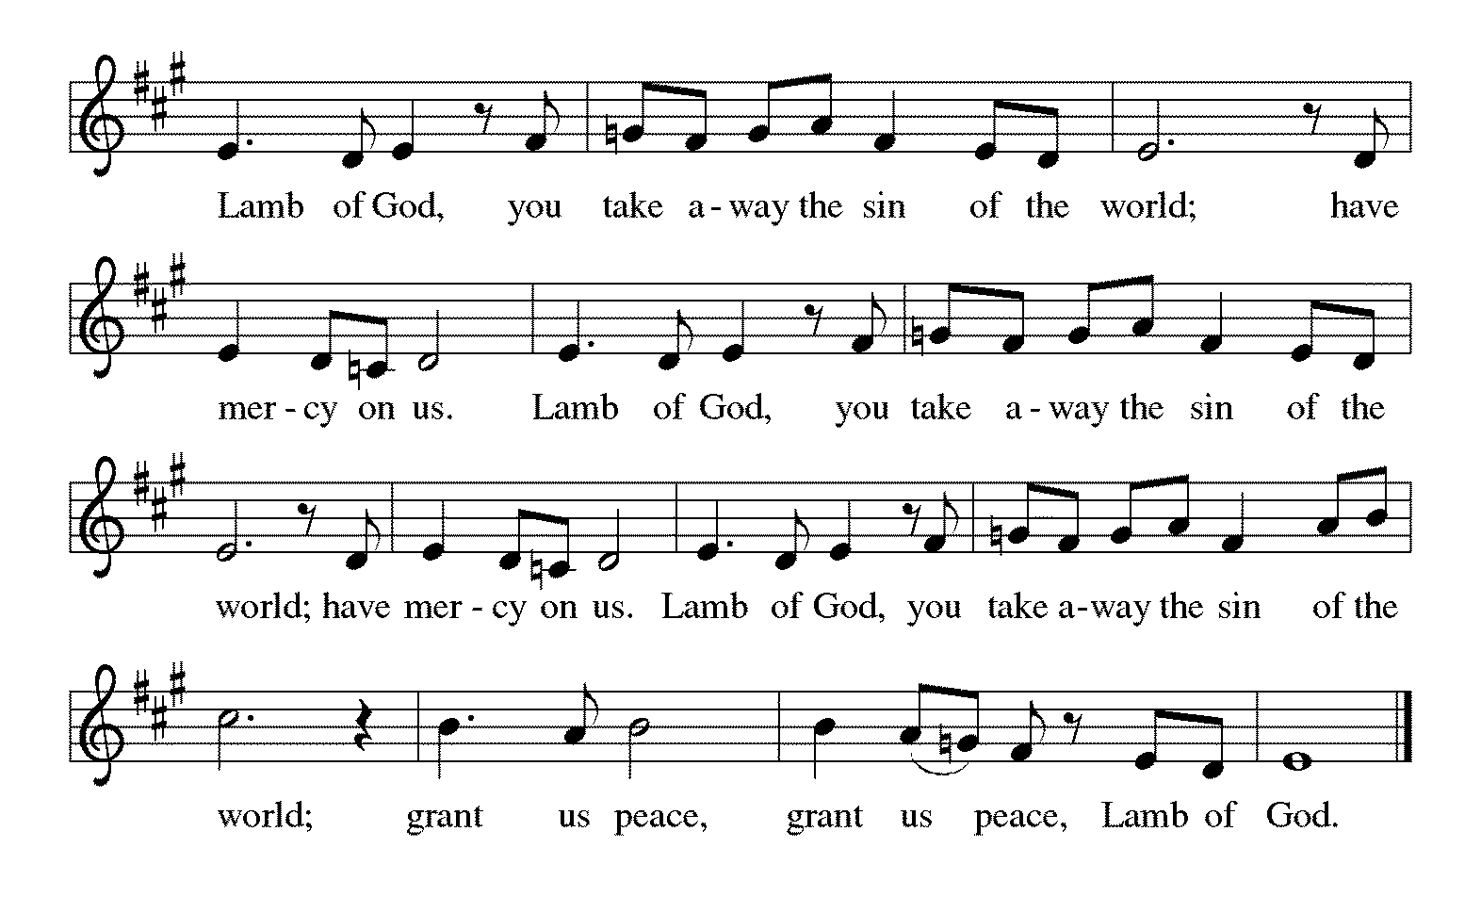

*Please stand as you are able.
*Post-Communion Blessing
The body and blood of our Lord Jesus Christ strengthen you and keep you in his grace. Amen.
*Prayer after Communion
Lord of life,
in the gift of your body and blood
you turn the crumbs of our faith into a feast of salvation.
Send us forth into the world with shouts of joy,
bearing witness to the abundance of your love
in Jesus Christ, our Savior and Lord. Amen.

Sending
God blesses us and sends us in mission to the world.
*Blessing
People of God,
you are Christ’s body,
bringing new life to a suffering world.
The holy Trinity, ☩ one God,
bless you now and forever. Amen.

*Sending Hymn ELW #543 Go, My Children, with My Blessing
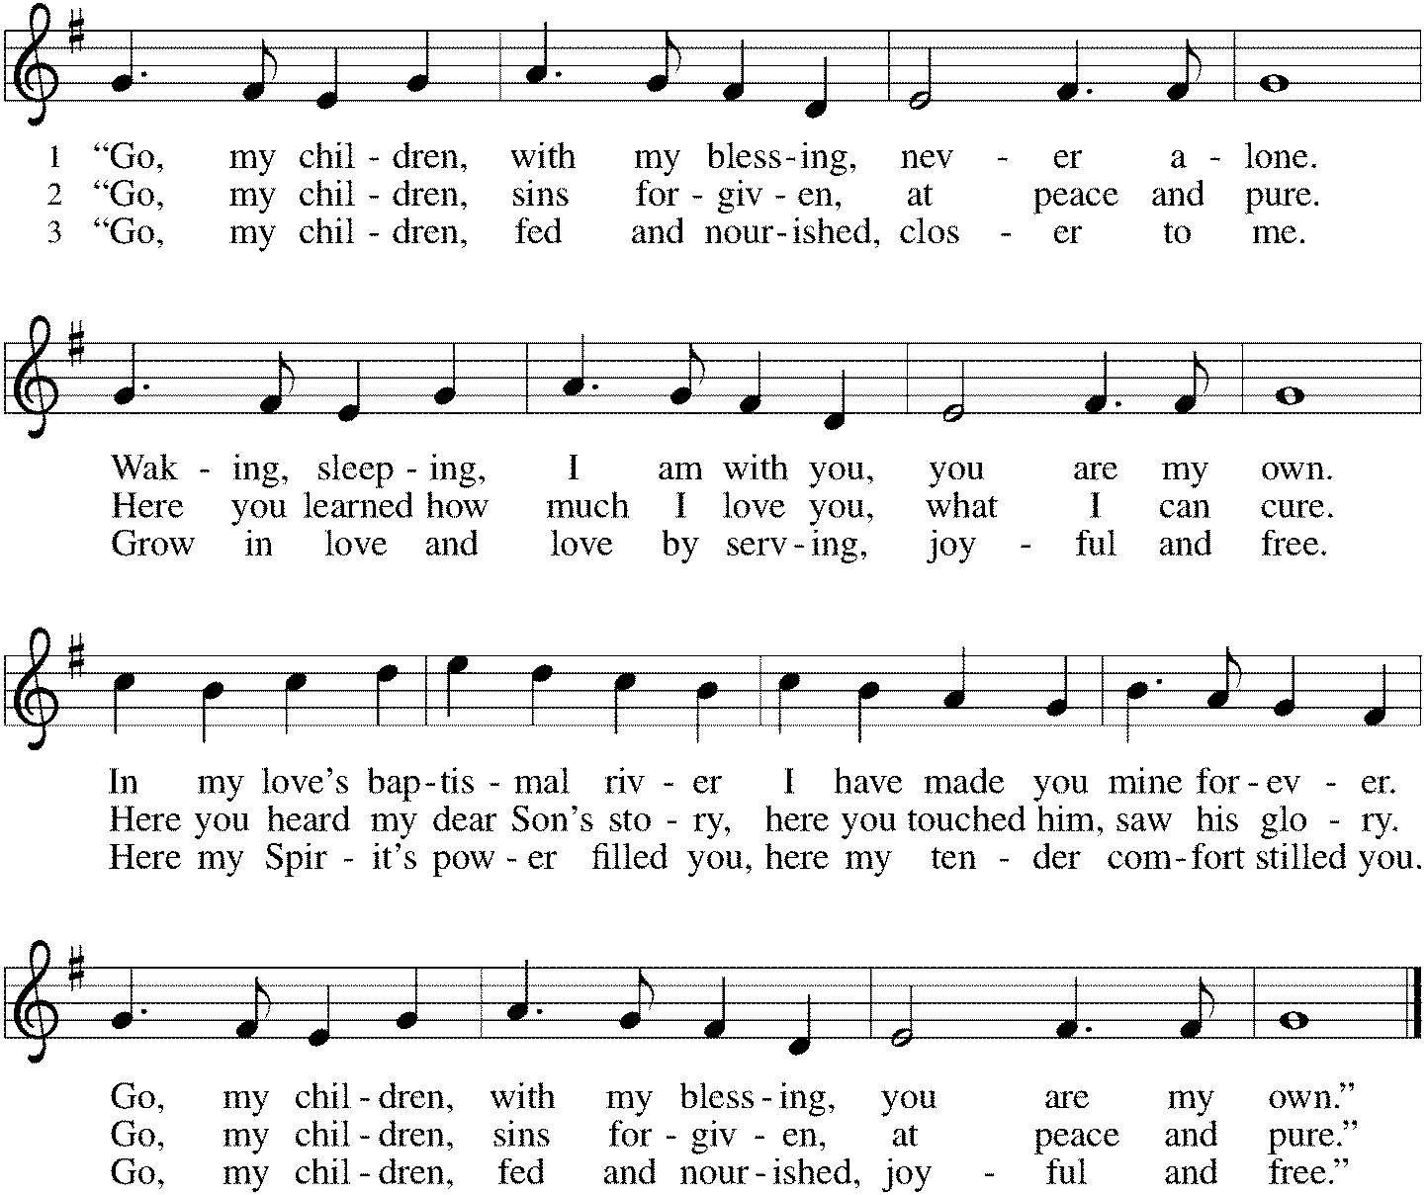

*Sent to the World
Go in peace. The living Word dwells in you. Thanks be to God.

Postlude

After the postlude, those who have joined via Zoom may unmute your mics
and share a greeting with your fellow worshippers.

From Sundays and Seasons
v.20190109.1233 Copyright © 2021 Augsburg Fortress. All rights reserved.
Reprinted by permission under Augsburg Fortress Liturgies Annual License #30867.
All rights reserved. Reprinted under OneLicense.net #A-718333.
Assisting in Worship Today
Ministry Associate Becky Ficarella
Minister of Music Bradford Thompson
Lector Vince Hardt
Ushers Mark Hamilton, Jon Milleville, Jeff Nelson, Open
Zoom Mark Hamilton, Jon & Cathy Milleville

Current Prayer Requests
Please keep these people in your prayers and reach out to our sisters and brothers in Christian love. Names will be left on the list for two weeks, unless you indicate that they should remain in our prayers for a longer period.
Name Relationship Prayer For
Ray & Bette Dieter Members 60th Anniversary 9/26
Rich Davison Member Healing & Strength
Cathy Milleville Member Healing & Strength
Sigrid Elliott Member Healing & Strength
Dorothy Tracy Member Healing & Strength
Keith Petras Brother of Dru Geraghty Healing & Strength
Lori Garabrandt Relative of Chuck Miller and Lois Pertle Healing & Strength
Chris Danly Son of Mark & Pat Danly Healing & Strength
Prayers for our homebound Members
Dolores Nosal, Carol Petersen, Norma Petersen

Articles for the November issue of Grace to You are due to the church office on Wednesday, October 6.

Sunday Faith Formation: Worship at 9am, Fellowship at 9:45am; Faith Formation (all ages) at 10:20am. Sunday school will meet in the Sanctuary with Becky. Adult Faith Formation will be in the Fellowship Room with Pr. Melody. Sunday will be an introduction and exploring of topics for upcoming Sundays.

Join us on October 3 for the baptism of Audrey Yount.

Illinois Holocaust Museum and Education Center in Skokie, IL: Open to Ignite Confirmation, Fusion High School Students and friends: Sunday, October 3rd 11:00am-4:00pm. All Confirmation and High School students are invited to attend the Holocaust Museum trip. We will be travelling with the students from St. Paul Lutheran church in Wheaton for this trip. Please RSVP with Becky Ficarella if you would like to attend. Parents are ALWAYS welcome too!

All Church Fellowship Zoom: Sunday, October 3, 7:00pm. This event is open to all Grace members as it has been a while since we have all gathered to chat! Let’s connect over zoom so that those of our friends who are unable to see us in person have an opportunity to connect and catch up again! Look for the link in your News From Grace e-blast for this event!

Due to the Columbus Day Holiday there will be no Faith Formation on Sunday, October 10.

PADS Meal Packaging: Tuesday, October 5 at 2:30pm on the lower level at Grace. How did that sneak up on us so quickly? Please join us if you can as we can use some extra hands. Please bring food and drinks to the church (upstairs kitchen) or our house (last house on the left on Prairie Ave off of St. Charles Rd)
Update from PADS:
-They are transitioning out of the Naperville location and slowly moving everyone to the Downers Grove location.
-They are hoping to close on the purchase of a hotel in April so our current arrangement will continue through March. They're looking for donations to help with the cost of the purchase.
-They have opened a resource room in room 201 in Downers Grove. This will allow us to stuff our bags with the standard food and bring the extras to the resource room so those who want it can get it. This should lighten our bags as well.
Donna Jacobo (630) 740-4542; Joe Jacobo (630) 740-4527; Thank you all so much!

Bridge 36 Hand Chime Choir: Open to 3rd-6th Grade Students Wednesdays, October 6th & 20th 4:45-5:45pm. Bridge 36 is a new group for our older elementary students not quite in Confirmation yet! This is open for all
3rd-6th grade students, however we must have a group of at least five consistent students to make this offering work. We will open the day with a devotional and then rehearse hand chime songs for Advent. Our students will eventually present this music during a worship service in December. If this proves to be successful, we will offer this again in January to prepare for Holy Week and Easter services. Please RSVP with Becky Ficarella ASAP if you would like your student to participate.

FaithTalk: Thursday, October 7. FaithTalk is a study and conversation group that meets to ask the deep and challenging questions of living our faith in today’s world. We gather the first Thursday of each month from 12:30-2:00 in the lower level of the church. (If you are attending Sue Davison’s exercise class that ends at noon, feel free to bring a sack lunch and meet before class. We’ll start our discussion at 12:30.) Please join us if you’re interested! If you have questions, feel free to reach out to Pastor Melody.

Save the Date: Blood Drive to take place at Grace on Thursday, November 4 from 2:30-7pm. Sign up information will be forthcoming.

RAMP (Reduce Another Mortgage Payment): As we continue to RAMP up to refinance our mortgage with Mission Investment Fund in October, we wish to thank you all who have contributed to date. We are still hopeful we can raise an additional $75,000 before October 5. Our monthly mortgage payment is a big ticket item in our budget at $6,777 monthly ($81,324 annually) and lowering that amount by an additional $1,000 or more (yes please) per month will greatly help our annual budget and free up funds that we can utilize on the ministries of Grace. The current principal balance on our mortgage is $889,079. Earlier this year we removed the comma, and then some! How low can we get this principal balance to go? Can we get out of $800K and into a $700K number?) Please give any amount you can between now and October 5. Indicate your contribution is for the Mortgage Reduction Fund. Envelopes are on the table in the Narthex.

Got Capital Gains? Did you know that stock donations allow you to both claim a deduction at the appreciated value AND allow you to avoid capital gains taxes on these assets? Further, consolidating donations in a tax year could lead to increased ability to deduct charitable contributions in a given tax year. Consult your tax advisor for details, but if you’d like more information on how to go about donating stock, reach out to the church office.

Contributions to Grace: You may continue to mail your contributions for the General Fund and the Mortgage Reduction Fund to the church office; have your bank mail your contribution to the church office (this works great); or contribute on-line through Grace’s website (Grace/you pay fees). Please know, pandemic or no, our mission continues! Thank you for your continued support of our ministries at Grace Lutheran.

Choir rehearsal Wednesdays at 7pm! Come join us for an hour of fun, super low-pressure music-making! Not free on Wednesday evenings? You’re still welcome to join us on Sunday mornings at 8:40! Don’t feel good about your voice/singing? We can work on that, too! No matter your voice type or skill level, there’s room for you! Get excited, my friends! The fun starts now :)

Monday Evening Bible Study: Mondays at 7:00pm, the group will begin review of a new, as yet unpublished, book from Dr. George Byron Koch. The topic is the Jewish roots of Christianity. Kindly contact Mark Hamilton or Vince Hardt if you have not participated before so that we may add you to our Email list.

Pill Bottle Project: Calling all volunteers! After being shut down for over a year, we will meet weekly on Tuesdays from 6-7:30pm in the upstairs kitchen next to the gym. We need to work through our backlog of pill bottles. If you would like to volunteer, just show up! Please note: at this time we are not accepting any pill bottles as it will take some time to get through the current inventory we have. If you have any questions, please contact Mark Hamilton at (630) 841-2941 / mark.hamilton@ifs.com

Sr. Center Chair Exercise: The exercise class meets Mondays at 10:00am, Tuesdays at 10:00am, and Thursdays at 11:00am. Registration is required as the number of attendees will be limited. Please contact Sue Davison at 630-858-6343 to register.

Sr. Center Book Club: The Book Club meets on the third Tuesday of the month at 11:00am. Please contact Sue Davison at 630-858-6343 to register.

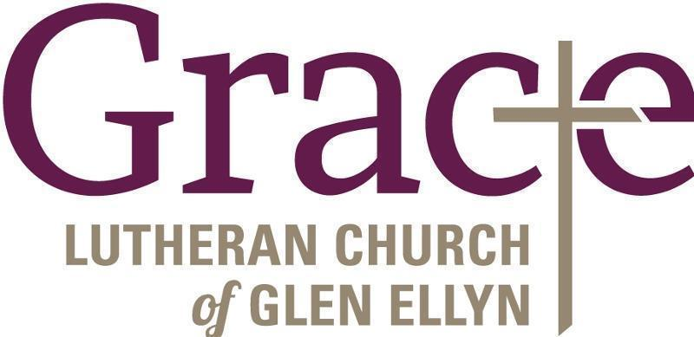

Every Member a Minister and Missionary!

Phone: 630-469-1555 Emergency Pastoral Contact: 630-674-2887
info@graceglenellyn.org www.graceglenellyn.org

Pastor
Rev. Melody Eastman office ext. 14
meastman@graceglenellyn.org

Minister of Music
Bradford Thompson 219-718-8879
bradfordmthompson@gmail.com

Ministry Associate
Becky Ficarella office ext. 17
bficarella@graceglenellyn.org

Office Manager
Barbara Sudds office ext. 10
bsudds@graceglenellyn.org

Parish Counselor
Carole LoGalbo M.S., LCPC 630-668-4594
carolelogalbo@yahoo.com

