Grace Lutheran Church

493 Forest Avenue, Glen Ellyn IL 630.469.1555
www.graceglenellyn.org

20th Sunday after Pentecost October 10, 2021

+ Proclaim Christ + Build Community +
+ Serve Our Neighbors +

Introduction
The rich man who comes to ask Jesus what he should do to inherit eternal life is a good man, sincere in his asking. Mark’s gospel is alone in saying that Jesus looked on him and loved him. Out of love, not as judgment, Jesus offers him an open door to life: sell all you own and give it to the poor. Our culture bombards us with the message that we will find life by consuming. Our assemblies counter this message with the invitation to find life by divesting for the sake of the other.

Gathering
The Holy Spirit calls us together as the people of God.
Welcome/Announcements

Helpful Reminders for those joining in person:
- Maintain 6’ distance between family groups
- Remain in your pews for communion.
- You may place your offering in the box in the narthex.

Prelude

*Please stand as you are able and turn to face the font.
*Confession and Forgiveness
All may make the sign of the cross, the sign marked at baptism, as the presiding minister begins.

Blessed be the holy Trinity, ☩ one God, whose teaching is life, whose presence is sure, and whose love is endless. Amen.

Let us confess our sins to the one who welcomes us with an open heart.
Silence is kept for reflection.

God our comforter: like lost sheep, we have gone astray. We gaze upon abundance and see scarcity. We turn our faces away from injustice and oppression. We exploit the earth with our apathy and greed. Free us from our sin, gracious God. Listen when we call out to you for help. Lead us by your love to love our neighbors as ourselves. Amen.

All have sinned and fall short of the glory of God. By the gift of grace in ☩ Christ Jesus, God makes you righteous. Receive with glad hearts the forgiveness of all your sins. Amen.

*Entrance Hymn ELW#532 Gather Us In
sts. 1,2,4
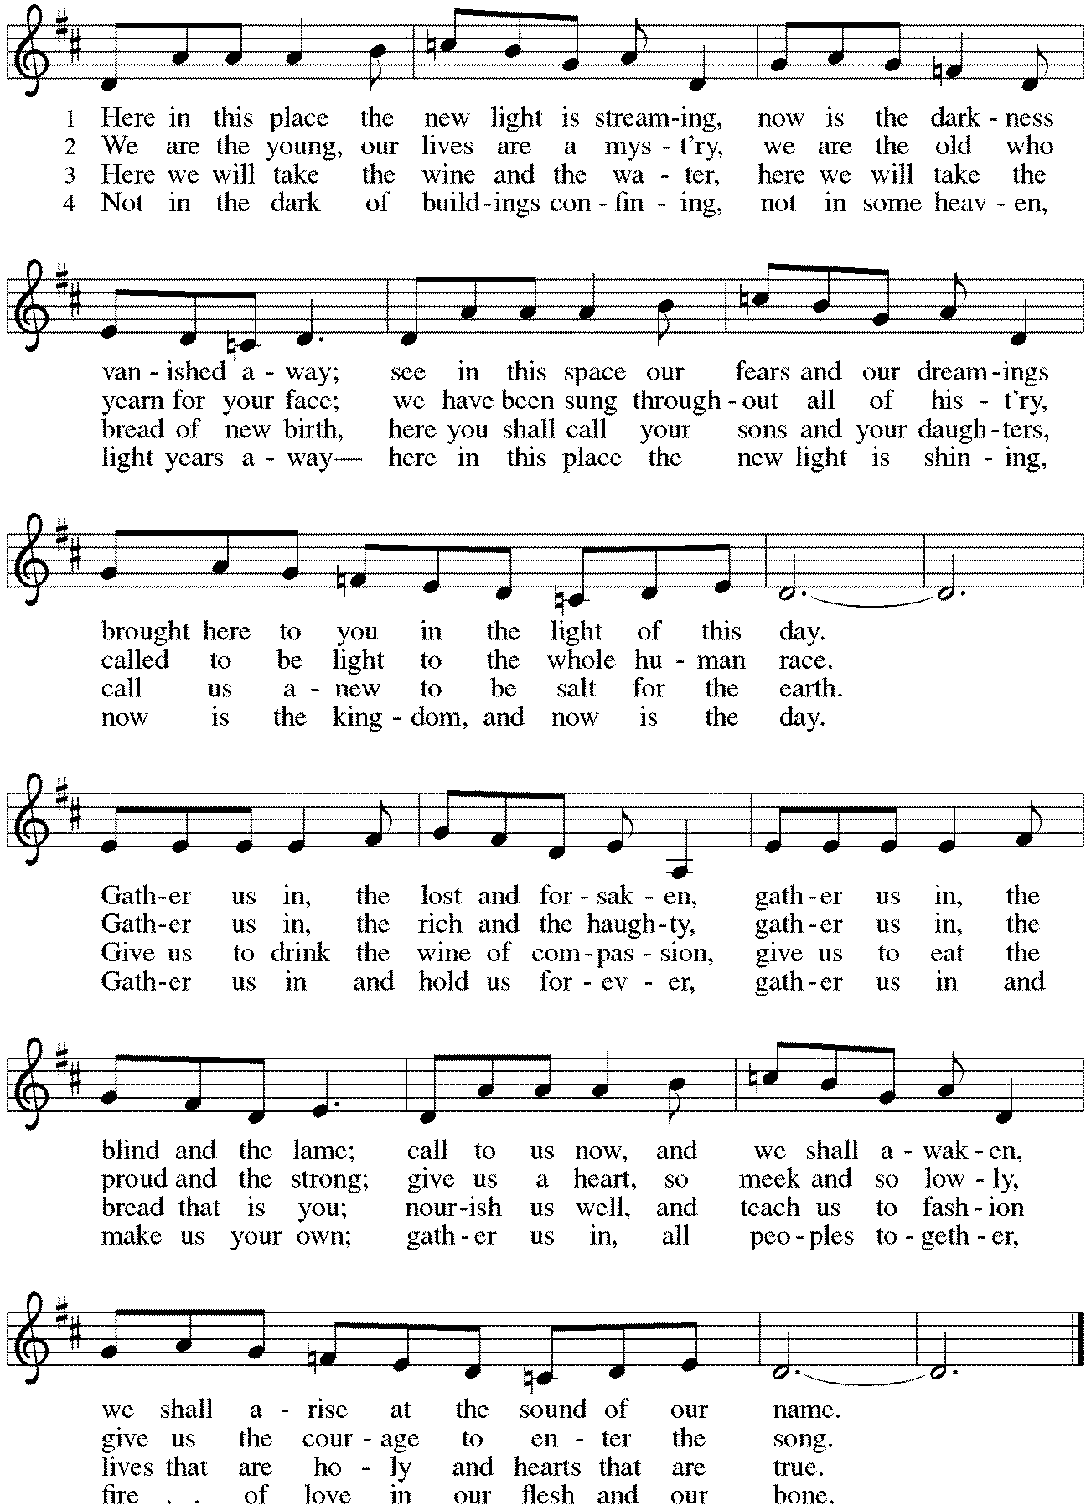
*Greeting
The grace of our Lord Jesus Christ, the love of God, and the communion of the Holy Spirit be with you all. And also with you.

*Kyrie p. 184 Bradford sings the verses, Congregation sings the refrain.
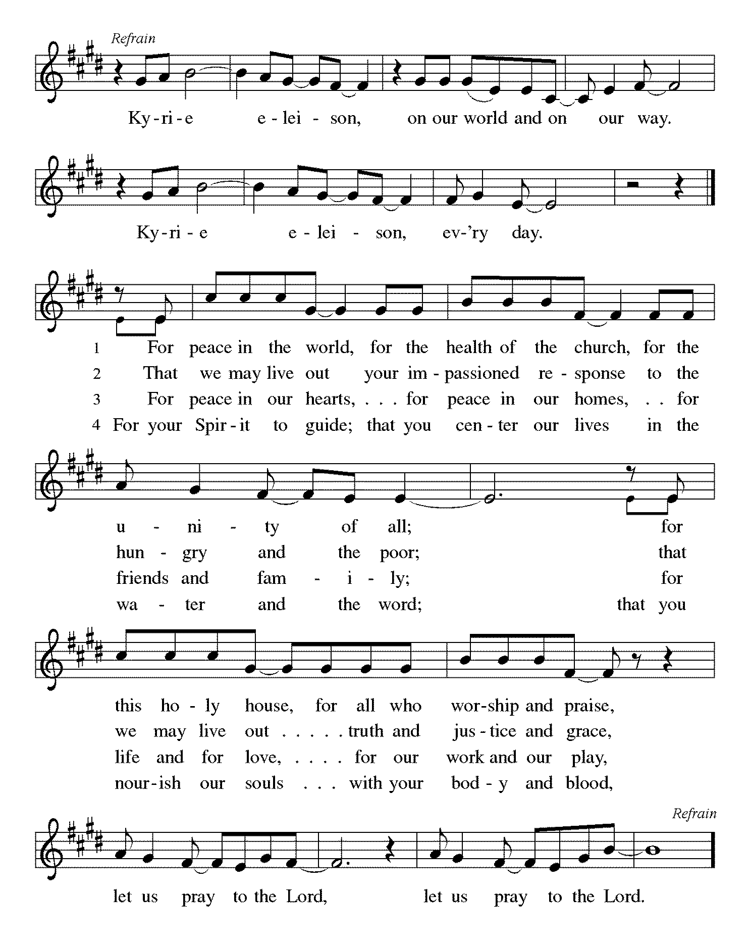
*Prayer of the Day
Almighty and ever-living God, increase in us your gift of faith so that, forsaking what lies behind and reaching out to what lies ahead, we may follow the way of your commandments and receive the crown of everlasting joy, through Jesus Christ, our Savior and Lord. Amen. Be seated.
Word
God speaks to us in scripture reading, preaching, and song.
First Reading Amos 5:6-7, 10-15
Amos was a herdsman by profession and a prophet by God’s call. During a time of great prosperity in the northern kingdom of Israel, the prophet speaks to the wealthy upper class. He warns his listeners that fulfilling God’s demand for justice brings blessing, while corruption and oppression incur God’s wrath.

⁶Seek the Lord and live, or he will break out against the house of Joseph like fire, and it will devour Bethel, with no one to quench it. ⁷Ah, you that turn justice to wormwood, and bring righteousness to the ground!
¹⁰They hate the one who reproves in the gate, and they abhor the one who speaks the truth. ¹¹Therefore because you trample on the poor and take from them levies of grain, you have built houses of hewn stone, but you shall not live in them; you have planted pleasant vineyards, but you shall not drink their wine. ¹²For I know how many are your transgressions, and how great are your sins— you who afflict the righteous, who take a bribe, and push aside the needy in the gate. ¹³Therefore the prudent will keep silent in such a time; for it is an evil time.
¹⁴Seek good and not evil, that you may live; and so the Lord, the God of hosts, will be with you, just as you have said. ¹⁵Hate evil and love good, and establish justice in the gate; it may be that the Lord, the God of hosts, will be gracious to the remnant of Joseph.

Word of God, Word of Life. Thanks be to God.

Psalm Psalm 8
So teach us to number our days that we may apply our hearts to wisdom. (Ps. 90:12)

¹²So teach us to number our days that we may apply our hearts to wisdom.
¹³Return, O Lord; how long will you tarry? Be gracious to your servants.
¹⁴Satisfy us by your steadfast love in the morning; so shall we rejoice and be glad all our days.
¹⁵Make us glad as many days as you afflicted us and as many years as we suffered adversity.
¹⁶Show your servants your works, and your splendor to their children.
¹⁷May the graciousness of the Lord our God be upon us; prosper the work of our hands; prosper our handiwork.
⁹O Lord our Lord, how majestic is your name in all the earth!
Second Reading Hebrews 4:12-16
We cannot hide our thoughts, desires, and actions from God, to whom we are completely accountable. Nevertheless, Jesus understands our human weakness and temptations, because he also experienced them. Therefore we can approach the throne of grace to receive divine mercy from Christ.

¹²Indeed, the word of God is living and active, sharper than any two-edged sword, piercing until it divides soul from spirit, joints from marrow; it is able to judge the thoughts and intentions of the heart. ¹³And before him no creature is hidden, but all are naked and laid bare to the eyes of the one to whom we must render an account.
¹⁴Since, then, we have a great high priest who has passed through the heavens, Jesus, the Son of God, let us hold fast to our confession. ¹⁵For we do not have a high priest who is unable to sympathize with our weaknesses, but we have one who in every respect has been tested as we are, yet without sin. ¹⁶Let us therefore approach the throne of grace with boldness, so that we may receive mercy and find grace to help in time of need.

Word of God, Word of Life. Thanks be to God.

*Please stand as you are able.

*Gospel Acclamation p. 188 Alleluia
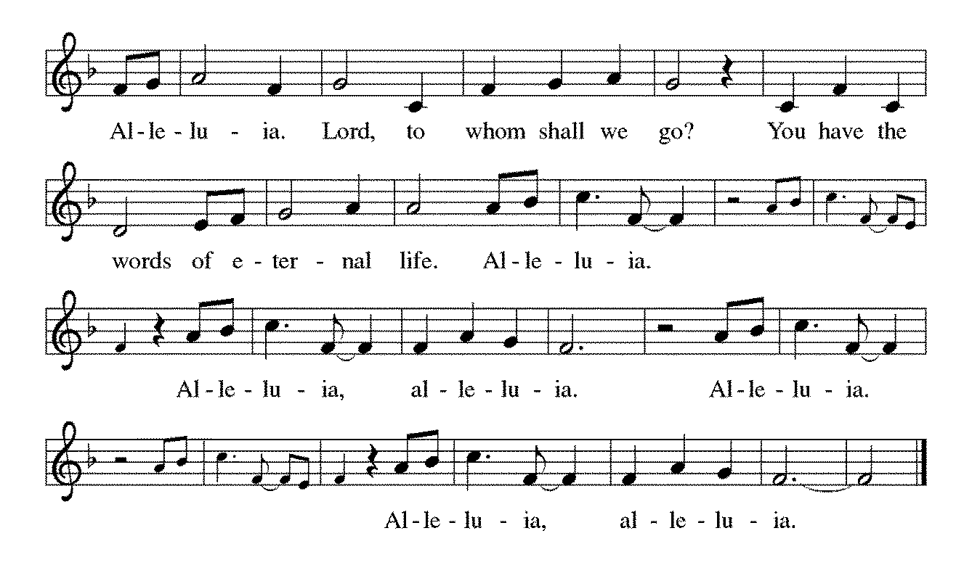

The holy Gospel according to Mark. Glory to you, O Lord.
*Gospel Mark 10:17-31
Jesus has been teaching his disciples about what is most valued in God’s eyes. Now, a conversation with a rich man brings his message home to the disciples in a way that is surprising but unforgettable.

¹⁷As [Jesus] was setting out on a journey, a man ran up and knelt before him, and asked him, “Good Teacher, what must I do to inherit eternal life?” ¹⁸Jesus said to him, “Why do you call me good? No one is good but God alone. ¹⁹You know the commandments: ‘You shall not murder; You shall not commit adultery; You shall not steal; You shall not bear false witness; You shall not defraud; Honor your father and mother.’ ” ²⁰He said to him, “Teacher, I have kept all these since my youth.” ²¹Jesus, looking at him, loved him and said, “You lack one thing; go, sell what you own, and give the money to the poor, and you will have treasure in heaven; then come, follow me.” ²²When he heard this, he was shocked and went away grieving, for he had many possessions.
²³Then Jesus looked around and said to his disciples, “How hard it will be for those who have wealth to enter the kingdom of God!” ²⁴And the disciples were perplexed at these words. But Jesus said to them again, “Children, how hard it is to enter the kingdom of God! ²⁵It is easier for a camel to go through the eye of a needle than for someone who is rich to enter the kingdom of God.” ²⁶They were greatly astounded and said to one another, “Then who can be saved?” ²⁷Jesus looked at them and said, “For mortals it is impossible, but not for God; for God all things are possible.”
²⁸Peter began to say to him, “Look, we have left everything and followed you.” ²⁹Jesus said, “Truly I tell you, there is no one who has left house or brothers or sisters or mother or father or children or fields, for my sake and for the sake of the good news, ³⁰who will not receive a hundredfold now in this age—houses, brothers and sisters, mothers and children, and fields, with persecutions—and in the age to come eternal life. ³¹But many who are first will be last, and the last will be first.”

The Gospel of the Lord. Praise to you, O Christ. Be seated.

Sermon The Rev. Melody Eastman

*Please stand as you are able.
*Hymn of the Day ELW #583 Take My Life, That I May Be
sts. 1,2,4
*Prayers of Intercession
Made children and heirs of God’s promise, we pray for the church, the world, and all in need.
A brief silence.

Uniting God, you call forth different gifts in those who follow you. Encourage us to welcome the diverse benefits and blessings of the whole church in teaching, preaching, prophecy, healing, and more. Lord, in your mercy, hear our prayer.

Nurturing God, you bring forth crops from the soil and bounty from the trees. Increase the produce of the land and bless all who toil in fields and orchards. Provide for good working conditions and keep them safe. Lord, in your mercy, hear our prayer.

Empowering God, you offer compassion for those who are overlooked or forgotten. Open the hearts of local, national, and world leaders to show such compassion and love for their neighbors. Lord, in your mercy, hear our prayer.
Sheltering God, in Jesus you travelled among us without a place to lay your head. Provide safe places to sleep and rest for those who have no place to live. Sustain ministries that offer food, clothing, and peace of mind. Lord, in your mercy, hear our prayer.

Renewing God, you bring life out of death. Help us part with those things that are no longer beneficial to us and open our hearts to see where new life is budding in this congregation. Lord, in your mercy, hear our prayer.
Here other intercessions may be offered.

Eternal God, we praise you for the love and witness of Bette and Ray Dieter, celebrating their 60th wedding anniversary, and we ask your blessing on them and their family who rejoice with them. We ask your strength and healing for all in need of you, especially Rich, Cathy, Sigrid, Dorothy, Dolores, Carol, Norma and those we name before you now…. We thank you for the lives and witness of loved ones who have died, especially Dorothy and Lucille. Comfort their families who grieve, make us all confident in your promise of salvation, and support us in our own journey of faith. Lord, in your mercy, hear our prayer.

Receive these prayers, O God, and those in our hearts known only to you; through Jesus Christ our Lord. Amen.

*Peace
The peace of Christ be with you always. And also with you.
Please share the peace with others in your household, or by making a sign of peace to those on Zoom. Please remain standing.
Meal
God feeds us with the presence of Jesus Christ.
*Offering Prayer
God of abundance, you cause streams to break forth in the desert and manna to rain from the heavens. Accept the gifts you have first given us. Unite them with the offering of our lives
to nourish the world you love so dearly; through Jesus Christ, our Savior and Lord. Amen

*Great Thanksgiving
The Lord be with you. And also with you.
Lift up your hearts. We lift them to the Lord.
Let us give thanks to the Lord our God. It is right to give our thanks and praise.

*Preface
It is indeed right, our duty and our joy, that we should at all times and in all places give thanks and praise to you, almighty and merciful God, through our Savior Jesus Christ; who on this day overcame death and the grave, and by his glorious resurrection opened to us the way of everlasting life. And so, with all the choirs of angels, with the church on earth and the hosts of heaven, we praise your name and join their unending hymn:

*Sanctus p. 190 Holy, Holy, Holy
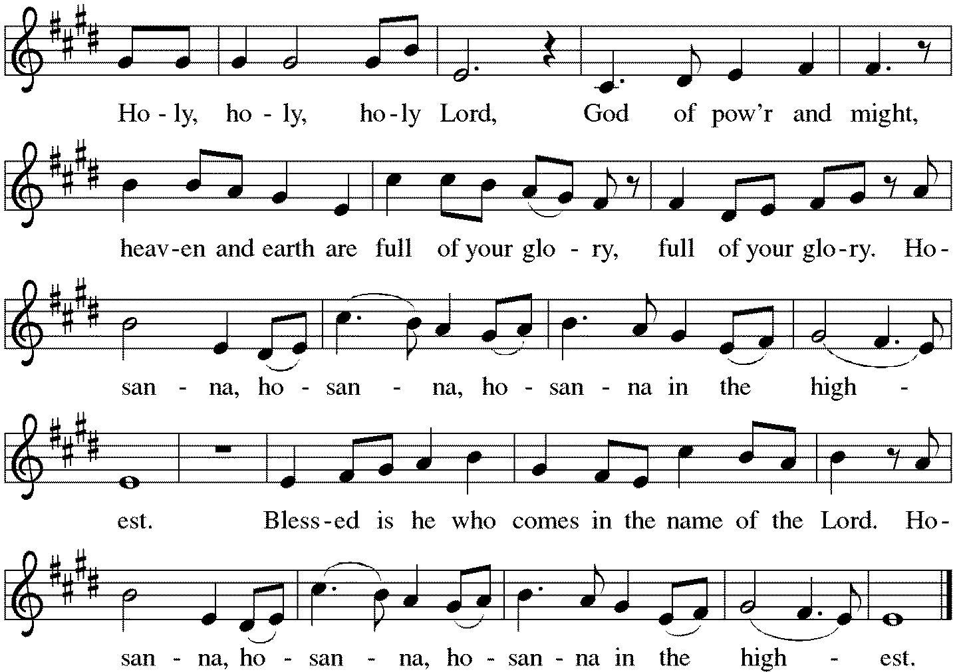

*Thanksgiving at the Table
. . . In the night in which he was betrayed, our Lord Jesus took bread, and gave thanks; broke it, and gave it to his disciples, saying: Take and eat; this is my body, given for you. Do this for the remembrance of me. Again, after supper, he took the cup, gave thanks, and gave it for all to drink, saying: This cup is the new covenant in my blood, shed for you and for all people for the forgiveness of sin. Do this for the remembrance of me.

Together as the body of Christ, we proclaim the Lord's death until he comes. Christ has died. Christ is risen. Christ will come again.

With this bread and cup we remember your Son, the first-born of your new creation. We remember his life lived for others, and his death and resurrection, which renews the face of the earth. We await his coming, when, with the world made perfect through your wisdom,
all our sins and sorrows will be no more. Amen. Come, Lord Jesus.
You may hold up your (unopened) communion kit as you are able.
Holy God, holy and merciful, holy and compassionate, send upon us and this meal your Holy Spirit, whose breath revives us for life, whose fire rouses us to love. Enfold in your arms all who share this holy food. Nurture in us the fruits of the Spirit, that we may be a living tree, sharing your bounty with all the world. Amen. Come, Holy Spirit.
You may lower your communion kit.

Holy and benevolent God, receive our praise and petitions, as Jesus received the cry of the needy, and fill us with your blessing, until, needy no longer and bound to you in love, we feast forever in the triumph of the Lamb: through whom all glory and honor is yours, O God, O Living One, with the Holy Spirit, in your holy church, now and forever. Amen.

*The Lord’s Prayer Ecumenical Version
Gathered into one by the Holy Spirit, let us pray as Jesus taught us.
Our Father in heaven, hallowed be your name, your kingdom come, your will be done, on earth as in heaven. Give us today our daily bread. Forgive us our sins as we forgive those who sin against us. Save us from the time of trial and deliver us from evil. For the kingdom, the power, and the glory are yours, now and forever. Amen.

*Invitation to Communion
All who hunger and thirst, come. The table is ready. Be Seated.

If you have difficulty opening your communion, please signal an usher for assistance.

Peel up the clear top seal over the wafer, and hold the wafer up when you are ready.
This is the Body of Christ, given for you. (Eat the bread.) Amen.

Peel up the second foil seal over the juice, and hold your cup up when you are ready.
This is the blood of Christ, shed for you. (Drink the wine/juice.) Amen.

After communion you may place the packaging in the bowl in your pew. The ushers will dispose of these following the service.

Agnus Dei p. 191 Lamb of God
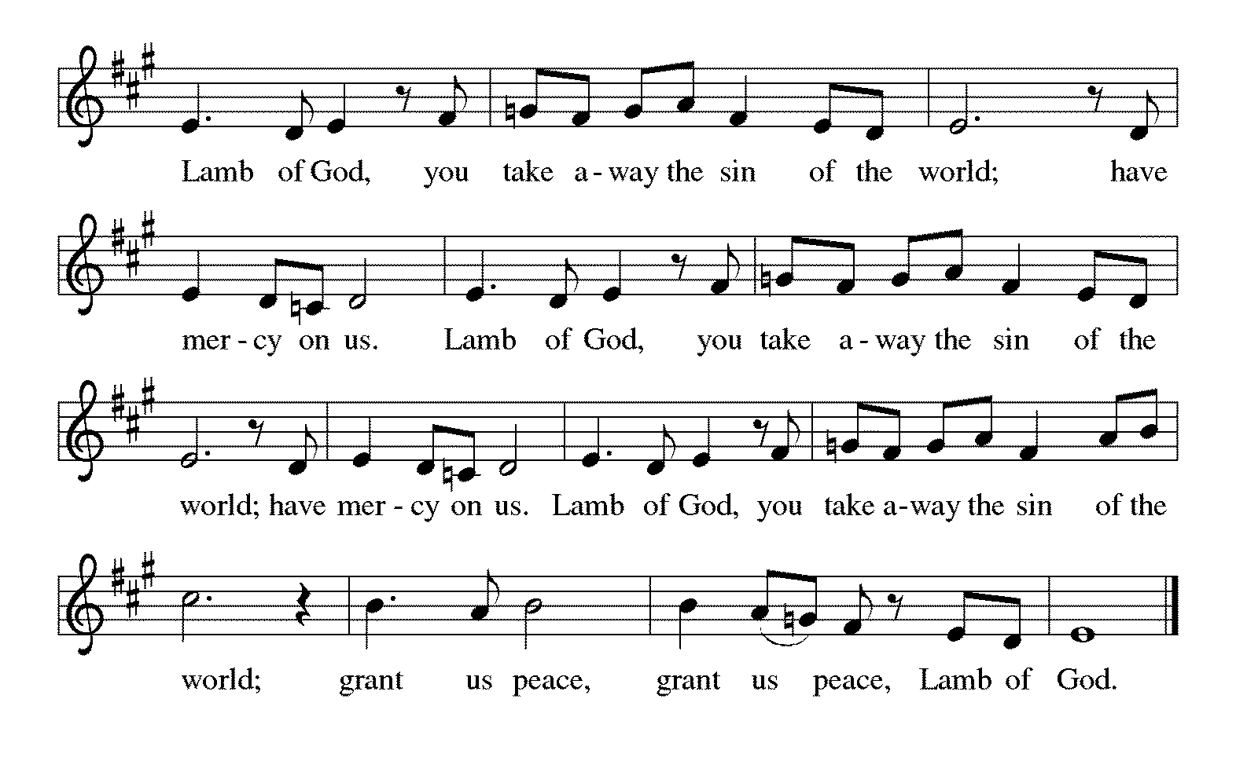

*Please stand as you are able.
*Post-Communion Blessing
The body and blood of our Lord Jesus Christ strengthen you and keep you in his grace. Amen.

*Prayer after Communion
Lord of life, in the gift of your body and blood you turn the crumbs of our faith into a feast of salvation. Send us forth into the world with shouts of joy, bearing witness to the abundance of your love in Jesus Christ, our Savior and Lord. Amen.

Sending
God blesses us and sends us in mission to the world.
*Blessing
People of God, you are Christ’s body, bringing new life to a suffering world. The holy Trinity, ☩ one God, bless you now and forever. Amen.

*Sending Hymn ELW #705 God of Grace and God of Glory
sts. 1,3,4
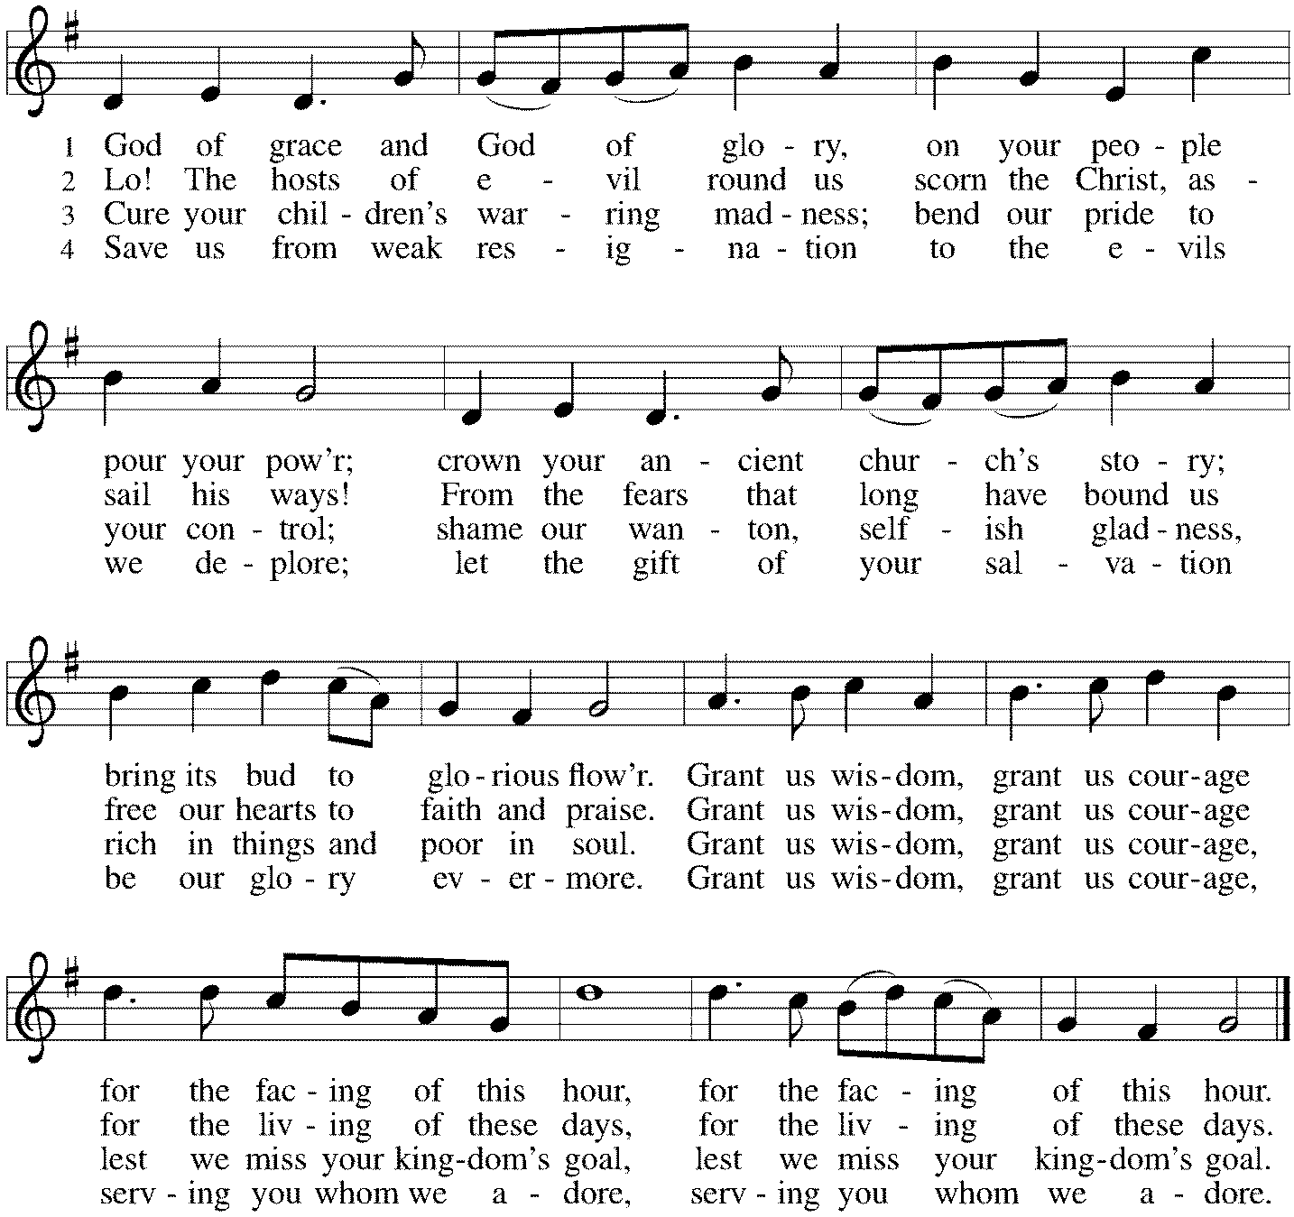

*Sent to the World
Go in peace. The living Word dwells in you. Thanks be to God.

Postlude
After the postlude, those who have joined via Zoom may unmute your mics
and share a greeting with your fellow worshippers.
From Sundays and Seasons
v.20190109.1233 Copyright © 2021 Augsburg Fortress. All rights reserved.
Reprinted by permission under Augsburg Fortress Liturgies Annual License #30867.
All rights reserved. Reprinted under OneLicense.net #A-718333.

Assisting in Worship Today
Ministry Associate Becky Ficarella
Minister of Music Bradford Thompson
Lector Jason Graf
Ushers Mark Hamilton, Jon Milleville, Jeff Nelson, Open
Zoom Mark Hamilton, Jon & Cathy Milleville

Current Prayer Requests
Name Relationship Prayer For
Family of Lucille Drager Mother of Mark Drager Comfort in Grief
Family of Dorothy Stein Member Comfort in Grief
Ray & Bette Dieter Members 60th Anniversary 9/26
Rich Davison Member Healing & Strength
Cathy Milleville Member Healing & Strength
Sigrid Elliott Member Healing & Strength
Dorothy Tracy Member Healing & Strength
Mike, Dani DeVasto and family, friends of JoAnne Grewe Healing & Strength
Lori Garabrandt Relative of Chuck Miller and Lois Pertle Healing & Strength
Chris Danly Son of Mark & Pat Danly Healing & Strength
Prayers for our homebound Members
Dolores Nosal, Carol Petersen, Norma Petersen

Due to the Columbus Day Holiday there will be no Faith Formation on Sunday, October 10.

Worship Volunteers: We have made it through the first few months of gathering in person with a core group of Lectors, so we are reaching out to see if there are any others who are willing to help with Lector duties in November and December this year. We are currently having all Lectors sit with their own family during the service and only coming forward to do the readings from the lectern. We are not using robes or assisting with communion. Please contact Susan Jacobson so she can add your name to the list moving forward. susan.lb.jacobson@gmail.com

Quilting Ministry October 12: This ministry will meet on the 2nd and 4th Tuesday of the month from 9:00-10:00am. Even if you can’t sew but are able to cut fabric into a 9” square we need you! We have 10⁺ bins of fabric waiting to be cut. After quilting you are invited to stay and attend the chair exercise class at 10:00am and if you like to knit hats, scarves, and gloves you can join the Wooly Knitters at 1pm! Everyone is welcome, bring a friend!

Women of Grace: Join us on Thursday, October 14 at 7pm.

Holy Communion Instruction and Lunch: Open to all 1st-4th graders on October 17, 11:30-1:00pm. The Holy Communion Service will take place on Sunday, October 24 during worship. Please RSVP to Becky Ficarella at bficarella@graceglenellyn.org.

Bridge 36 Hand Chime Choir October 20: Open to 3rd-6th Grade Students the 1st and 3rd Wednesday of the month from 4:45-5:45pm. Bridge 36 is a new group for our older elementary students not quite in Confirmation yet! This is open for all 3rd-6th grade students, however we must have a group of at least five consistent students to make this offering work. We will open the day with a devotional and then rehearse hand chime songs for Advent. Our students will eventually present this music during a worship service in December. If this proves to be successful, we will offer this again in January to prepare for Holy Week and Easter services. Please RSVP with Becky Ficarella ASAP if you would like your student to participate.

Dorothy Stein Memorial Service Update: A memorial gathering will be held on Saturday, October 23 beginning at 1:30pm with the funeral service at 2pm. A reception will follow at the Village Links Reserve 22 restaurant beginning at 3:30pm.

Save the Date: Blood Drive to take place at Grace on Thursday, November 4 from 2:30-7pm. Sign up information will be forthcoming.

Got Capital Gains? Did you know that stock donations allow you to both claim a deduction at the appreciated value AND allow you to avoid capital gains taxes on these assets? Further, consolidating donations in a tax year could lead to increased ability to deduct charitable contributions in a given tax year. Consult your tax advisor for details, but if you’d like more information on how to go about donating stock, reach out to the church office.

Choir rehearsal Wednesdays at 7pm! Come join us for an hour of fun, super low-pressure music-making! Not free on Wednesday evenings? You’re still welcome to join us on Sunday mornings at 8:40! Don’t feel good about your voice/singing? We can work on that, too! No matter your voice type or skill level, there’s room for you! Get excited, my friends! The fun starts now :)

Monday Evening Bible Study: Mondays at 7:00pm, the group will begin review of a new, as yet unpublished, book from Dr. George Byron Koch. The topic is the Jewish roots of Christianity. Kindly contact Mark Hamilton or Vince Hardt if you have not participated before so that we may add you to our Email list.

Pill Bottle Project: Calling all volunteers! After being shut down for over a year, we will meet weekly on Tuesdays from 6-7:30pm in the upstairs kitchen next to the gym. If you would like to volunteer, just show up! Please note: at this time we are not accepting any pill bottles as it will take over a year to get through the current inventory we have. If you have any questions, please contact Mark Hamilton at (630) 841-2941 / mark.hamilton@ifs.com

Contributions to Grace: You may continue to mail your contributions for the General Fund and the Mortgage Reduction Fund to the church office; have your bank mail your contribution to the church office (this works great); or contribute on-line through Grace’s website (Grace/you pay fees). Please know, pandemic or no, our mission continues! Thank you for your continued support of our ministries at Grace Lutheran.

Sr. Center Chair Exercise: The exercise class meets Mondays at 10:00am, Tuesdays at 10:00am, and Thursdays at 11:00am. Registration is required as the number of attendees will be limited. Please contact Sue Davison at 630-858-6343 to register. (Monday’s class will not be held from October 18 - December 6 as Sue Davison will be working on Open Enrollment for Medicare Part D. Monday’s class will resume on December 13.)

Sr. Center Book Club: The Book Club meets on the third Tuesday of the month at 11:00am. The book for October is “My Left Foot.” Please contact Sue Davison at 630-858-6343 to register.

Every Member a Minister and Missionary!

Phone: 630-469-1555 Emergency Pastoral Contact: 630-674-2887
info@graceglenellyn.org www.graceglenellyn.org

Pastor
Rev. Melody Eastman office ext. 14
meastman@graceglenellyn.org

Minister of Music
Bradford Thompson 219-718-8879
bradfordmthompson@gmail.com

Ministry Associate
Becky Ficarella office ext. 17
bficarella@graceglenellyn.org

Office Manager
Barbara Sudds office ext. 10
bsudds@graceglenellyn.org

Parish Counselor
Carole LoGalbo M.S., LCPC 630-668-4594
carolelogalbo@yahoo.com

