Grace Lutheran Church

493 Forest Avenue, Glen Ellyn IL 630.469.1555
www.graceglenellyn.org

21st Sunday after Pentecost October 17, 2021

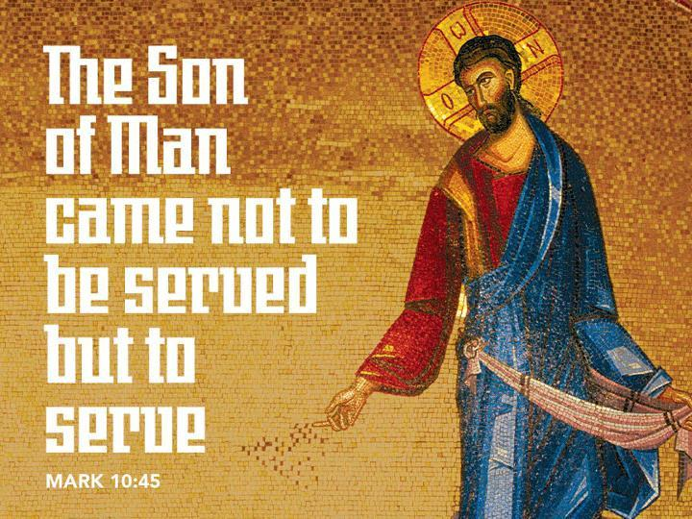

+ Proclaim Christ + Build Community +
+ Serve Our Neighbors +

Introduction
Today’s gospel starts with disciples obsessing over who will be closest to Jesus, leading to Jesus teaching his followers about God’s take on importance and power. Here Jesus makes it explicit that the reversal of values in God’s community is a direct challenge to the values of the dominant culture, where wielding power over others is what makes you great. When we pray “your kingdom come” we are praying for an end to tyranny and oppression. We pray this gathered around the cross, a sign of great shame transformed to be the sign of great honor and service.

Gathering
The Holy Spirit calls us together as the people of God.
Welcome/Announcements
Helpful Reminders for those joining in person:
- Maintain 6’ distance between family groups
- Remain in your pews for communion.
- You may place your offering in the box in the narthex.

Prelude

*Please stand as you are able and turn to face the font.
*Confession and Forgiveness
All may make the sign of the cross, the sign marked at baptism, as the presiding minister begins.

Blessed be the holy Trinity, ☩ one God, whose teaching is life, whose presence is sure, and whose love is endless. Amen.

Let us confess our sins to the one who welcomes us with an open heart.
Silence is kept for reflection.

God our comforter: like lost sheep, we have gone astray. We gaze upon abundance and see scarcity. We turn our faces away from injustice and oppression. We exploit the earth with our apathy and greed. Free us from our sin, gracious God. Listen when we call out to you for help. Lead us by your love to love our neighbors as ourselves. Amen.

All have sinned and fall short of the glory of God. By the gift of grace in ☩ Christ Jesus, God makes you righteous. Receive with glad hearts the forgiveness of all your sins. Amen.
*Entrance Hymn ELW#580 How Clear Is Our Vocation, Lord
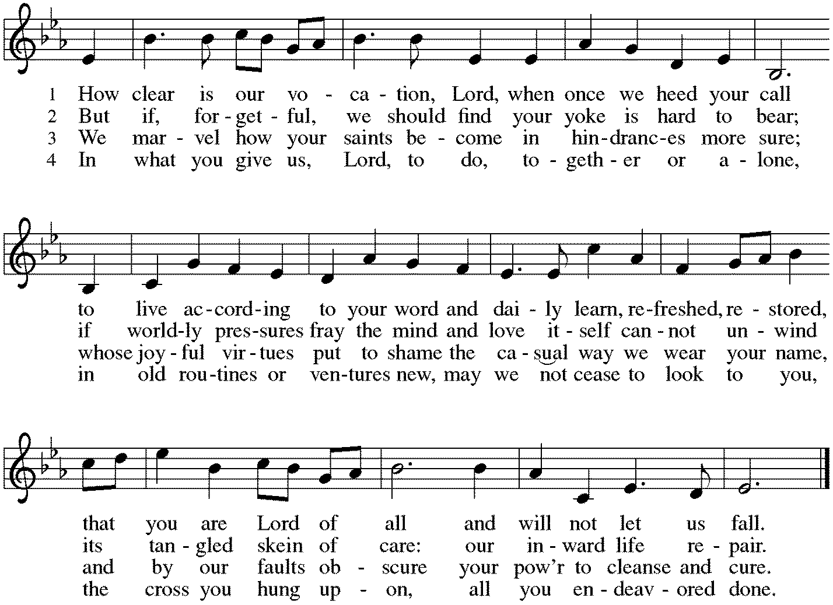

*Greeting
The grace of our Lord Jesus Christ, the love of God, and the communion of the Holy Spirit be with you all. And also with you.

*Kyrie
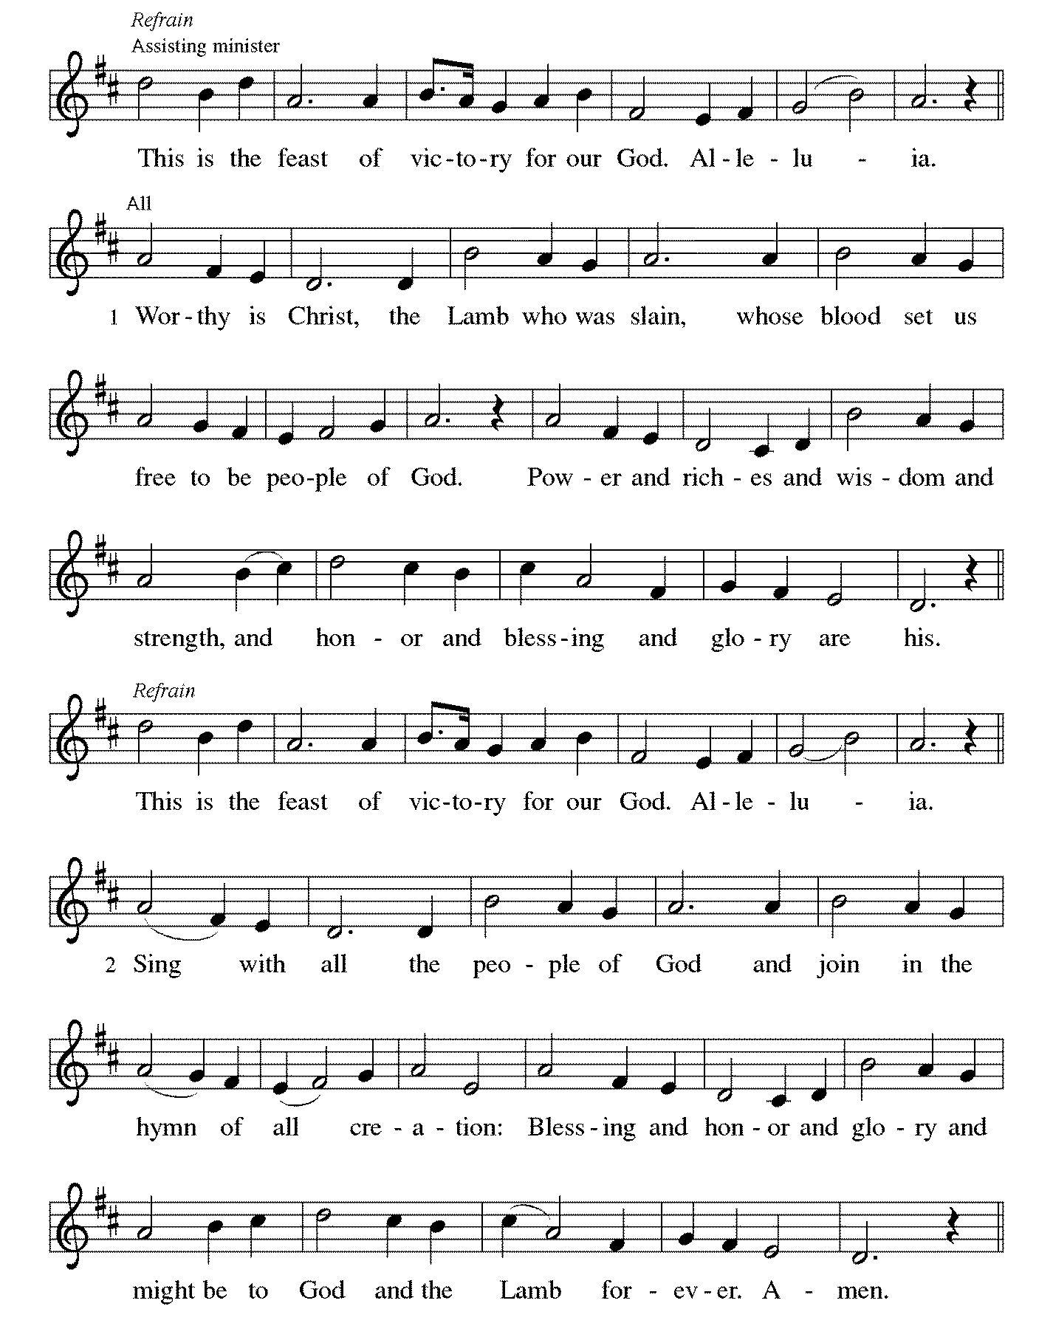

Continued on next page

*Prayer of the Day
Sovereign God, you turn your greatness into goodness for all the peoples on earth. Shape us into willing servants of your kingdom, and make us desire always and only your will, through Jesus Christ, our Savior and Lord. Amen. Be seated.

Word
God speaks to us in scripture reading, preaching, and song.
First Reading Isaiah 53:4-12
This reading is from the last of four passages in Isaiah that are often called “servant songs.” Christians are probably most familiar with this servant song. In light of Christian faith, the servant’s healing ministry and redemptive suffering are understood to be fulfilled in the life and death of Christ.

⁴Surely he has borne our infirmities and carried our diseases; yet we accounted him stricken, struck down by God, and afflicted. ⁵But he was wounded for our transgressions, crushed for our iniquities; upon him was the punishment that made us whole, and by his bruises we are healed. ⁶All we like sheep have gone astray; we have all turned to our own way, and the Lord has laid on him the iniquity of us all.
⁷He was oppressed, and he was afflicted, yet he did not open his mouth; like a lamb that is led to the slaughter, and like a sheep that before its shearers is silent, so he did not open his mouth. ⁸By a perversion of justice he was taken away. Who could have imagined his future? For he was cut off from the land of the living, stricken for the transgression of my people. ⁹They made his grave with the wicked and his tomb with the rich, although he had done no violence, and there was no deceit in his mouth.
¹⁰Yet it was the will of the Lord to crush him with pain. When you make his life an offering for sin, he shall see his offspring, and shall prolong his days; through him the will of the Lord shall prosper. ¹¹Out of his anguish he shall see light; he shall find satisfaction through his knowledge. The righteous one, my servant, shall make many righteous, and he shall bear their iniquities. ¹²Therefore I will allot him a portion with the great, and he shall divide the spoil with the strong; because he poured out himself to death, and was numbered with the transgressors; yet he bore the sin of many, and made intercession for the transgressors.

Word of God, Word of Life. Thanks be to God.

Psalm Psalm 91:9-16

⁹Because you have made the Lord your refuge, and the Most High your habitation,
¹⁰no evil will befall you, nor shall affliction come near your dwelling.
¹¹For God will give the angels charge over you, to guard you in all your ways.
¹²Upon their hands they will bear you up, lest you strike your foot against a stone.
¹³You will tread upon the lion cub and viper; you will trample down the lion and the serpent.
¹⁴I will deliver those who cling to me; I will uphold them, because they know my name.
¹⁵They will call me, and I will answer them; I will be with them in trouble; I will rescue and honor them.
¹⁶With long life will I satisfy them, and show them my salvation.

Second Reading Hebrews 5:1-10
Using imagery from scripture and from Jewish worship practices, Jesus is presented as the great high priest who was obedient to God’s saving plan. Through his suffering and death he has become the source of eternal salvation.

¹Every high priest chosen from among mortals is put in charge of things pertaining to God on their behalf, to offer gifts and sacrifices for sins. ²He is able to deal gently with the ignorant and wayward, since he himself is subject to weakness; ³and because of this he must offer sacrifice for his own sins as well as for those of the people. ⁴And one does not presume to take this honor, but takes it only when called by God, just as Aaron was.
⁵So also Christ did not glorify himself in becoming a high priest, but was You are my Son, today I have begotten you”; ⁶as he says also in another place, “You are a priest forever, according to the order of Melchizedek.”
⁷In the days of his flesh, Jesus offered up prayers and supplications, with loud cries and tears, to the one who was able to save him from death, and he was heard because of his reverent submission. ⁸Although he was a Son, he learned obedience through what he suffered; ⁹and having been made perfect, he became the source of eternal salvation for all who obey him, ¹⁰having been designated by God a high priest according to the order of Melchizedek.

Word of God, Word of Life. Thanks be to God.

*Please stand as you are able.
*Gospel Acclamation Alleluia

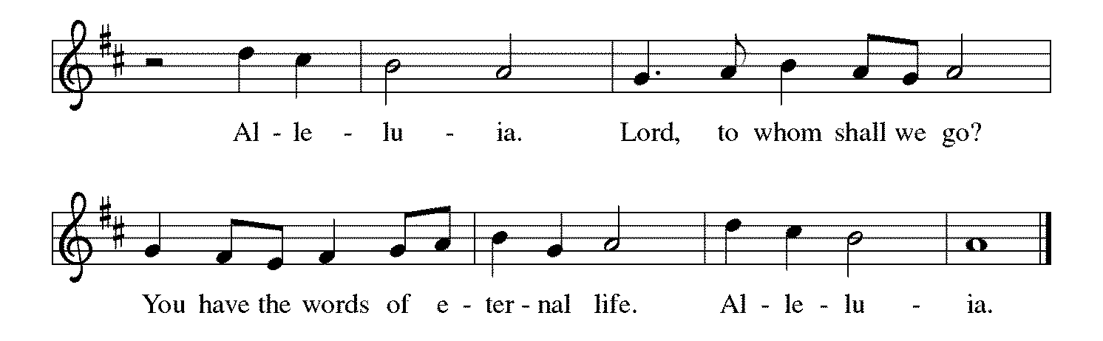

The holy Gospel according to Mark. Glory to you, O Lord.

*Gospel Mark 10:35-45
On the way to Jerusalem the disciples ask Jesus to grant them seats of honor. Jesus responds by announcing that he and his followers will “rule” through self-giving service.

³⁵James and John, the sons of Zebedee, came forward to [Jesus] and said to him, “Teacher, we want you to do for us whatever we ask of you.” ³⁶And he said to them, “What is it you want me to do for you?” ³⁷And they said to him, “Grant us to sit, one at your right hand and one at your left, in your glory.” ³⁸But Jesus said to them, “You do not know what you are asking. Are you able to drink the cup that I drink, or be baptized with the baptism that I am baptized with?” ³⁹They replied, “We are able.” Then Jesus said to them, “The cup that I drink you will drink; and with the baptism with which I am baptized, you will be baptized; ⁴⁰but to sit at my right hand or at my left is not mine to grant, but it is for those for whom it has been prepared.”
⁴¹When the ten heard this, they began to be angry with James and John. ⁴²So Jesus called them and said to them, “You know that among the Gentiles those whom they recognize as their rulers lord it over them, and their great ones are tyrants over them. ⁴³But it is not so among you; but whoever wishes to become great among you must be your servant, ⁴⁴and whoever wishes to be first among you must be slave of all. ⁴⁵For the Son of Man came not to be served but to serve, and to give his life a ransom for many.”

The Gospel of the Lord. Praise to you, O Christ. Be seated.

Sermon The Rev. Melody Eastman

*Please stand as you are able.

*Hymn of the Day ELW #712 Lord, Whose Love in Humble Service
sts. 1-3
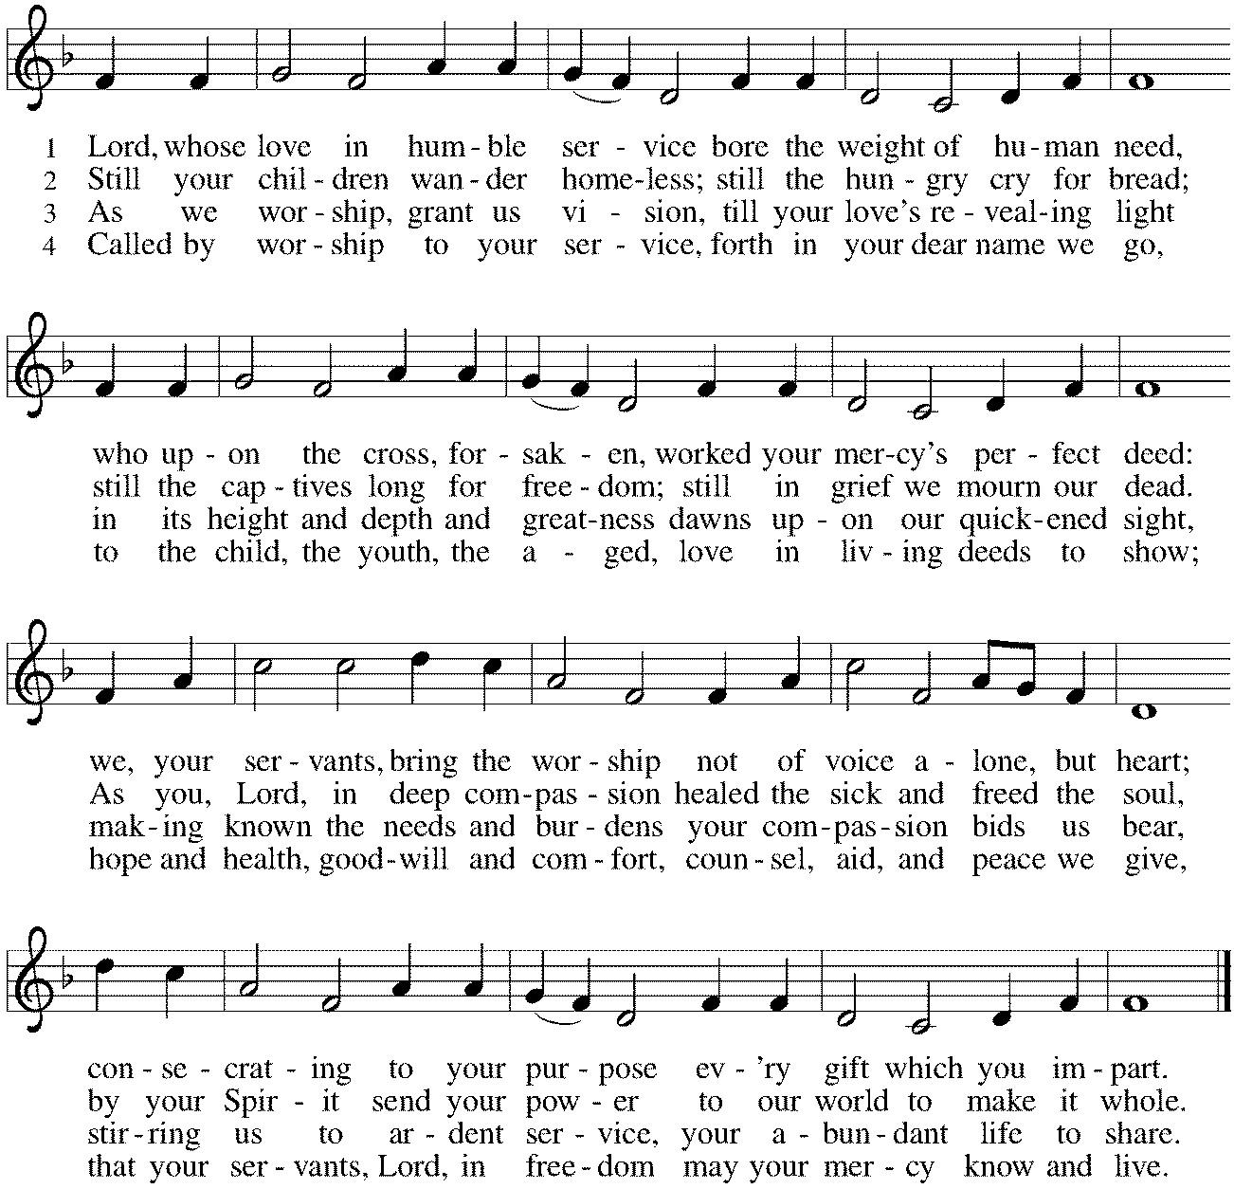

*Prayers of Intercession
Set free from sin and death and nourished by the word of truth, we join in prayer for all of God’s creation.
A brief silence.

Holy One, for the gift of the church handed down through the ages and for all who carry on the servant ministry of Jesus, we praise you. Send your Holy Spirit upon all who are discerning calls to ministry in its many forms and equip them with your gifts. Hear us, O God. Your mercy is great.

Creating One, for the lush and abundant habitat you provide for all your creatures, we praise you. Provide healing for the earth so that waterfowl, reptiles, wild horses, dolphins, and all living things flourish as you intend. Hear us, O God. Your mercy is great.

Suffering One, for all who work toward peace and who lead nations with a servant’s heart, we praise you. Bring justice for all who suffer violence, persecution, discrimination, hunger, poverty, and homelessness, and create places of refuge for all people. Hear us, O God. Your mercy is great.

Merciful One, for all who do the work of healing in mind, body, and spirit, we praise you. Surround and comfort all who struggle with depression, anxiety, cancer, diabetes, dementia, or any illness, especially Cathy, Rich, Dorothy, Sigrid, Dolores, Norma, Dorothy, and those we name before you now…that all may be healed. Hear us, O God. Your mercy is great.

Sustaining One, for all who volunteer for the vitality of this congregation, we praise you. Strengthen and encourage greeters, ushers, office volunteers, bakers, counters, committee and group leaders, teachers, students, evangelists, singers, builders, nurturers, and all who serve with generous hearts. Hear us, O God. Your mercy is great.
Here other intercessions may be offered.

Risen One, we thank you for those who have shaped your church and shared your gospel. Through the witness of your saints, continue to inspire us with hope until we all are gathered at your eternal feast. Hear us, O God. Your mercy is great.

Confident that you hear us, O God, we boldly place our prayers into your hands; through Jesus Christ, our truth and life. Amen.

*Peace
The peace of Christ be with you always. And also with you.
Please share the peace with others in your household, or by making a sign of peace to those on Zoom. Please remain standing.

Meal
God feeds us with the presence of Jesus Christ.
*Offering Prayer
God of abundance,
you cause streams to break forth in the desert
and manna to rain from the heavens.
Accept the gifts you have first given us.
Unite them with the offering of our lives
to nourish the world you love so dearly;
through Jesus Christ, our Savior and Lord. Amen

*Great Thanksgiving
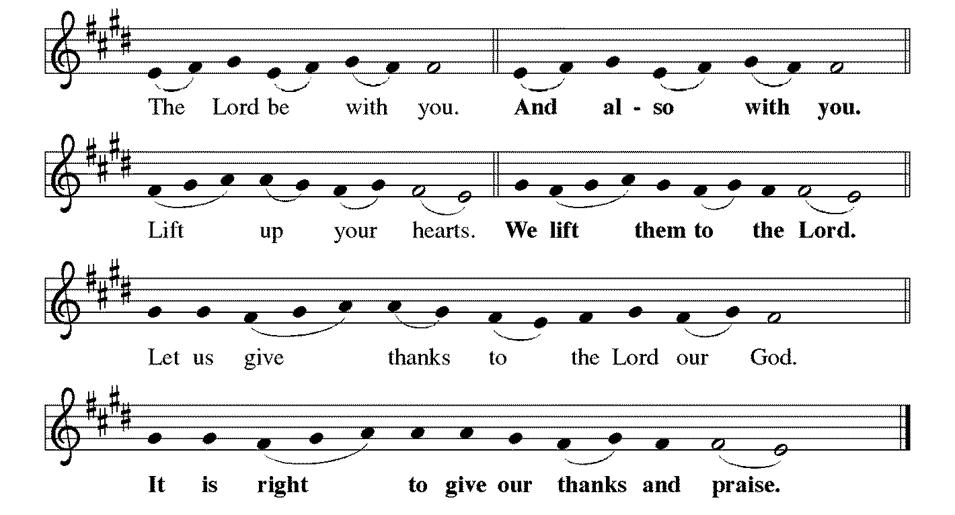

*Preface
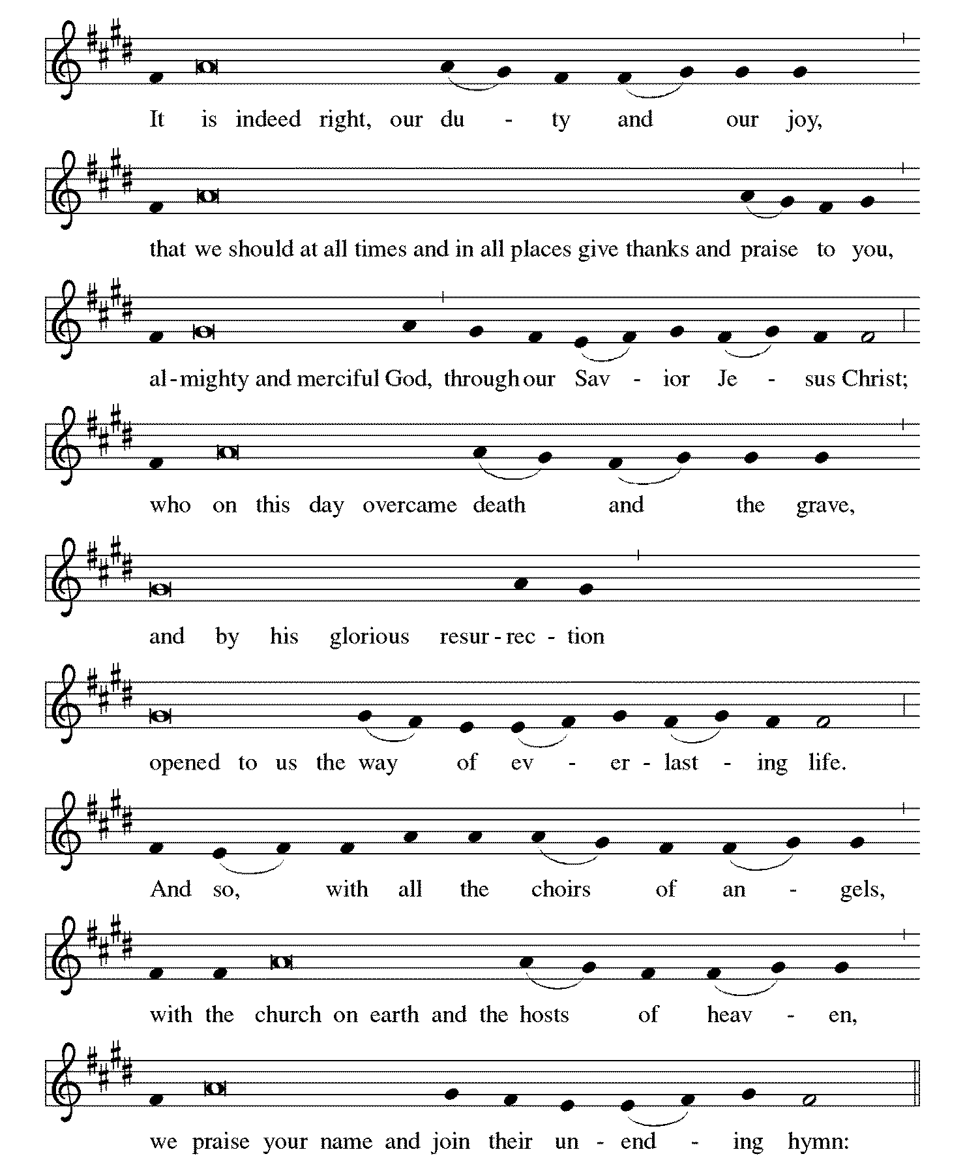

*Sanctus Holy, Holy, Holy
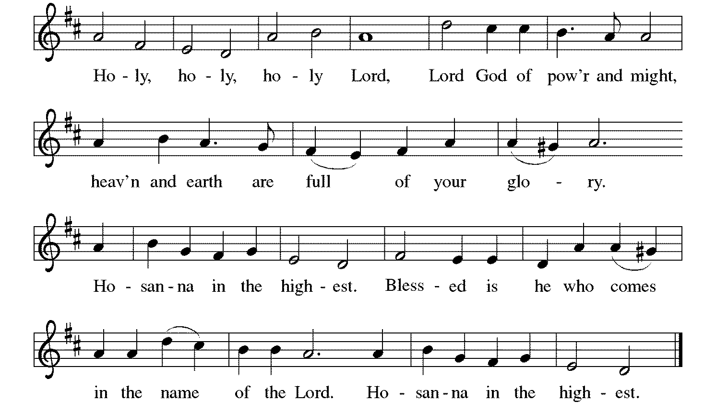

*Thanksgiving at the Table

O God most mighty, O God most merciful,
O God our rock and our salvation,
hear us as we praise, call us to your table, grant us your life.

When the earth was a formless void,
you formed order and beauty.
When Abraham and Sarah were barren,
you sent them a child.
When the Israelites were enslaved,
you led them to freedom.
Ruth faced starvation, David fought Goliath,
and the psalmists cried out for healing,
and full of compassion,
you granted the people your life.

You entered our sorrows in Jesus our brother.
He was born among the poor, he lived under oppression, he wept over the city.
With infinite love, he granted the people your life.

In the night in which he was betrayed,
our Lord Jesus took bread, and gave thanks;
broke it, and gave it to his disciples, saying:
Take and eat; this is my body, given for you.
Do this for the remembrance of me.

Again, after supper, he took the cup, gave thanks,
and gave it for all to drink, saying:
This cup is the new covenant in my blood,
shed for you and for all people for the forgiveness of sin.
Do this for the remembrance of me.

Remembering his death, we cry out Amen. [Amen.]
Celebrating his resurrection, we shout Amen. [Amen.]
Trusting his presence in every time and place, we plead Amen. [Amen.]

O God, you are Breath: send your Spirit on this meal.
O God, you are Bread: feed us with yourself.
O God, you are wine: warm our hearts and make us one.
O God, you are Fire: transform us with hope.
You may lower your communion kit.

O God most majestic,
O God most motherly,
O God our strength and our song,
you show us a vision of a tree of life
with fruits for all and leaves that heal the nations.
Grant us such life, the life of the Father to the Son,
the life of the Spirit of our risen Savior, life in you, now and forever.
Amen.

*The Lord’s Prayer Ecumenical Version
Gathered into one by the Holy Spirit, let us pray as Jesus taught us.
Our Father in heaven, hallowed be your name, your kingdom come, your will be done, on earth as in heaven. Give us today our daily bread. Forgive us our sins as we forgive those who sin against us. Save us from the time of trial and deliver us from evil. For the kingdom, the power, and the glory are yours, now and forever. Amen.

*Invitation to Communion
All who hunger and thirst, come. The table is ready. Be Seated.

If you have difficulty opening your communion, please signal an usher for assistance.
Peel up the clear top seal over the wafer, and hold the wafer up when you are ready.
This is the Body of Christ, given for you. (Eat the bread.) Amen.

Peel up the second foil seal over the juice, and hold your cup up when you are ready.
This is the blood of Christ, shed for you. (Drink the wine/juice.) Amen.
After communion you may place the packaging in the bowl in your pew. The ushers will dispose of these following the service.

Agnus Dei Lamb of God
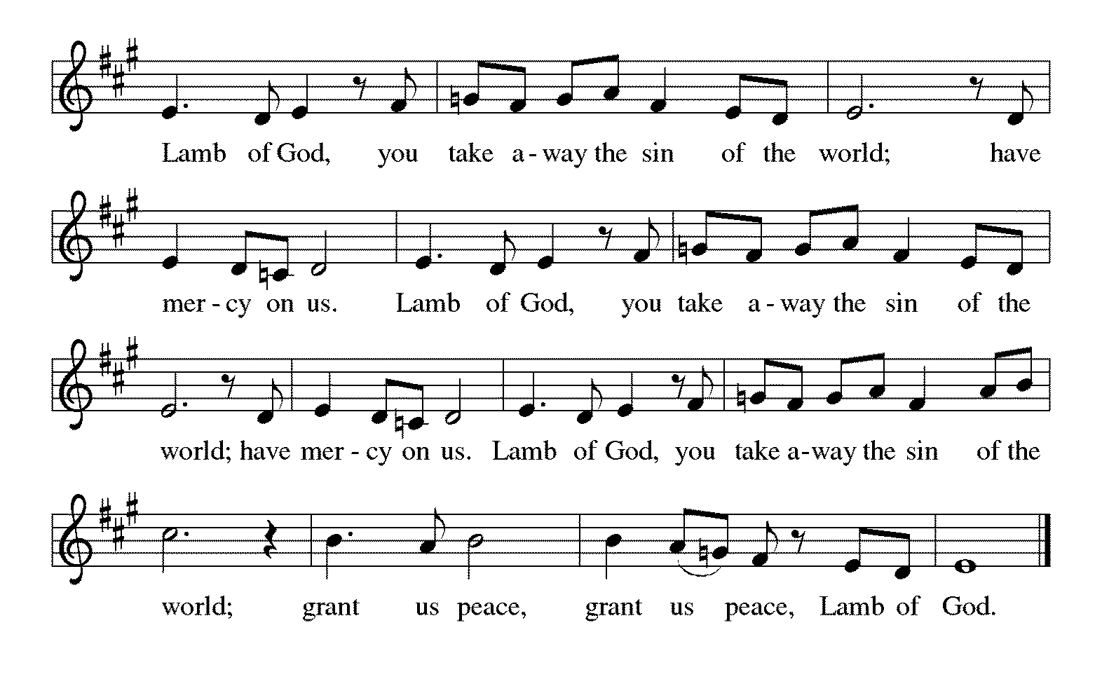

*Please stand as you are able.
*Post-Communion Blessing
The body and blood of our Lord Jesus Christ strengthen you and keep you in his grace. Amen.

*Prayer after Communion
Lord of life, in the gift of your body and blood
you turn the crumbs of our faith into a feast of salvation.
Send us forth into the world with shouts of joy,
bearing witness to the abundance of your love
in Jesus Christ, our Savior and Lord. Amen.
Sending
God blesses us and sends us in mission to the world.
*Blessing
People of God, you are Christ’s body,
bringing new life to a suffering world.
The holy Trinity, ☩ one God,
bless you now and forever. Amen.
*Sending Hymn ELW #551 The Spirit Sends Us Forth to Serve
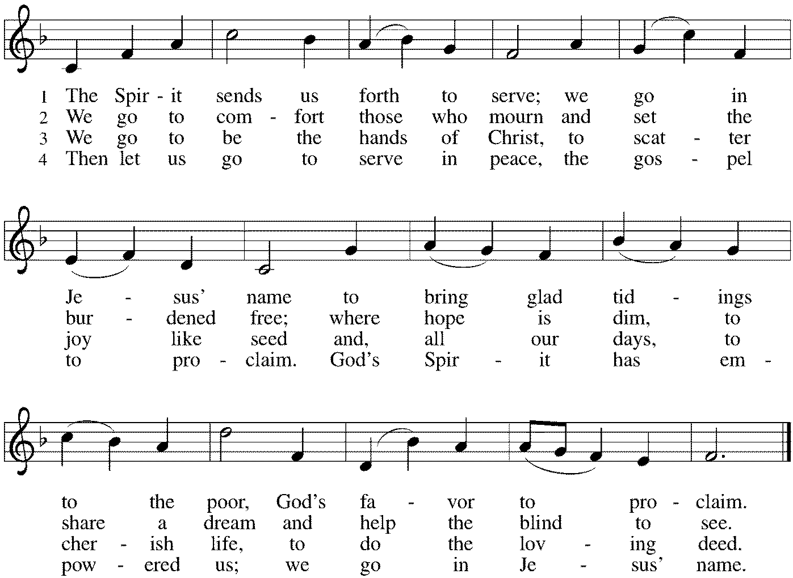

*Sent to the World
Go in peace. The living Word dwells in you. Thanks be to God.

Postlude

After the postlude, those who have joined via Zoom may unmute your mics
and share a greeting with your fellow worshippers.

From Sundays and Seasons
v.20190109.1233 Copyright © 2021 Augsburg Fortress. All rights reserved.
Reprinted by permission under Augsburg Fortress Liturgies Annual License #30867.
All rights reserved. Reprinted under OneLicense.net #A-718333.

Assisting in Worship Today
Ministry Associate Becky Ficarella
Minister of Music Bradford Thompson
Altar Guild Sue Davison
Lector Vince Hardt
Usher Jeff Nelson
Zoom Mark Hamilton, Jon & Cathy Milleville

Current Prayer Requests
Please keep these people in your prayers and reach out to our sisters and brothers in Christian love. Names will be left on the list for two weeks, unless you indicate that they should remain in our prayers for a longer period.
Name Relationship Prayer For
Family and Friends of Lucille Drager, Mother of Mark Drager Comfort in Grief
Family of Mark Jeschke Son of Former Member Arlene Jeschke Comfort in Grief
Rich Davison Member Healing & Strength
Cathy Milleville Member Healing & Strength
Sigrid Elliott Member Healing & Strength
Dorothy Tracy Member Healing & Strength
Mike, Dani DeVasto and family, friends of JoAnne Grewe Healing & Strength
Lori Garabrandt Relative of Chuck Miller and Lois Pertle Healing & Strength
Chris Danly Son of Mark & Pat Danly Healing & Strength
Prayers for our homebound Members
Dolores Nosal, Carol Petersen, Norma Petersen

Worship Volunteers: We have made it through the first few months of gathering in person with a core group of Lectors, so we are reaching out to see if there are any others who are willing to help with Lector duties in November and December this year. We are currently having all Lectors sit with their own family during the service and only coming forward to do the readings from the lectern. We are not using robes or assisting with communion. Please contact Susan Jacobson so she can add your name to the list moving forward. susan.lb.jacobson@gmail.com

Today, Holy Communion Instruction and Lunch 11:30-1:00pm: Open to all 1st-4th graders. The Holy Communion Service will take place on Sunday, October 24 during worship.

Monday Evening Bible Study: Mondays at 7:00pm, the group will begin review of a new, as yet unpublished, book from Dr. George Byron Koch. The topic is the Jewish roots of Christianity. Kindly contact Mark Hamilton or Vince Hardt if you have not participated before so that we may add you to our Email list.

Pill Bottle Project: Calling all volunteers! After being shut down for over a year, we will meet weekly on Tuesdays from 6-7:30pm in the upstairs kitchen next to the gym. If you would like to volunteer, just show up! Please note: at this time we are not accepting any pill bottles as it will take over a year to get through the current inventory we have. If you have any questions, please contact Mark Hamilton at (630) 841-2941 / mark.hamilton@ifs.com

Cancelled - Grace Worship and Fellowship Luncheon on October 20: Grace continues to abide by the state-recommended guideline of wearing masks indoors, so at this time we are generally not serving drinks or food since we don’t have the same ventilation system that restaurants do.

Bridge 36 Hand Chime Choir October 20: Open to 3rd-6th Grade Students the 1st and 3rd Wednesday of the month from 4:45-5:45pm. Bridge 36 is a new group for our older elementary students not quite in Confirmation yet! This is open for all 3rd-6th grade students, however we must have a group of at least five consistent students to make this offering work. We will open the day with a devotional and then rehearse hand chime songs for Advent. Our students will eventually present this music during a worship service in December. If this proves to be successful, we will offer this again in January to prepare for Holy Week and Easter services. Please RSVP with Becky Ficarella ASAP if you would like your student to participate.

Generations (Singing & Instrumental) Choir: Wednesday, October 20, 6-7:15pm. Come join Becky and Bradford for a new twist on praising with music! We will find new and creative ways to sing or play a song with instruments and movement in a socially distanced way. This is open to ANY member of Grace of ANY age (yep, your baby can shake a rattle too!) Please RSVP with Becky Ficarella so that I can communicate with you any updates for this event regarding dinner, etc.

Bell Choir rehearsal Wednesdays at 7pm! Come join us for an hour of fun, super low-pressure music-making! Not free on Wednesday evenings? You’re still welcome to join us on Sunday mornings at 8:40! Don’t know how to read music, we can work on that, too! No matter your skill level, there’s room for you! Get excited, my friends! The fun starts now :)

Grace’s Adult Vocal Choir: This is currently on hold due to the concern of our choir members gathering to sing together maskless at this time.

Men of Grace: Thursday, October 21 at 7pm. Contact Jeff Nelson for details.

Dorothy Stein Memorial Service: A memorial gathering will be held on Saturday, October 23, with visitation at the church beginning at 1:30pm and the funeral service following at 2pm. A reception will follow at the Village Links Reserve 22 beginning at 3:30pm.

Quilting Ministry October 26: This ministry will meet on the 2nd and 4th Tuesday of the month from 9:00-10:00am. Even if you can’t sew but are able to cut fabric into a 9” square we need you! We have 10⁺ bins of fabric waiting to be cut. After quilting you are invited to stay and attend the chair exercise class at 10:00am and if you like to knit hats, scarves, and gloves you can join the Wooly Knitters at 1pm! Everyone is welcome, bring a friend!

Versiti Blood Drive on November 4: We LOVE our donors! And we are hoping that due to our URGENT need – we can entice YOU to donate! Please sign up to give at our blood drive sponsored by: GRACE LUTHERAN CHURCH. Signup online or call the church office to schedule.
https://donate.illinois.versiti.org/donor/schedules/drive_schedule/5597316
Thursday, November 4 (2:30 pm - 7:00 pm)
Bring a friend! Appointments are preferred; walk-ins welcome! Photo ID and masks are required for ALL donors and VERSITI staff.

Got Capital Gains? Did you know that stock donations allow you to both claim a deduction at the appreciated value AND allow you to avoid capital gains taxes on these assets? Further, consolidating donations in a tax year could lead to increased ability to deduct charitable contributions in a given tax year. Consult your tax advisor for details, but if you’d like more information on how to go about donating stock, reach out to the church office.

Contributions to Grace: You may continue to mail your contributions for the General Fund and the Mortgage Reduction Fund to the church office; have your bank mail your contribution to the church office (this works great); or contribute on-line through Grace’s website (Grace/you pay fees). Please know, pandemic or no, our mission continues! Thank you for your continued support of our ministries at Grace Lutheran.

Sr. Center Chair Exercise: The exercise class meets Mondays at 10:00am, Tuesdays at 10:00am, and Thursdays at 11:00am. Registration is required as the number of attendees will be limited. Please contact Sue Davison at 630-858-6343 to register. (Monday’s class will not be held from October 18 - December 6 as Sue Davison will be working on Open Enrollment for Medicare Part D. Monday’s class will resume on December 13.)

Sr. Center Book Club: The Book Club meets on the third Tuesday of the month at 11:00am. The book for October is “My Left Foot.” Please contact Sue Davison at 630-858-6343 to register.

Every Member a Minister and Missionary!

Phone: 630-469-1555 Emergency Pastoral Contact: 630-674-2887
info@graceglenellyn.org www.graceglenellyn.org

Pastor
Rev. Melody Eastman office ext. 14
meastman@graceglenellyn.org

Minister of Music
Bradford Thompson 219-718-8879
bradfordmthompson@gmail.com

Ministry Associate
Becky Ficarella office ext. 17
bficarella@graceglenellyn.org

Office Manager
Barbara Sudds office ext. 10
bsudds@graceglenellyn.org

Parish Counselor
Carole LoGalbo M.S., LCPC 630-668-4594
carolelogalbo@yahoo.com

