Grace Lutheran Church
493 Forest Avenue, Glen Ellyn IL 630.469.1555
www.graceglenellyn.org

All Saints Day November 7, 2021

+ Proclaim Christ + Build Community +
+ Serve Our Neighbors +
Introduction
Of all three years of the lectionary cycle, this year’s All Saints readings have the most tears. Isaiah and Revelation look forward to the day when God will wipe away all tears; in John’s gospel, Jesus weeps along with Mary and all the gathered mourners before he demonstrates his power over death. On All Saints Day we celebrate the victory won for all the faithful dead, but we grieve for our beloved dead as well, knowing that God honors our tears. We bring our grief to the table and find there a foretaste of Isaiah’s feast to come.

Announcements

Prelude
Gathering
The Holy Spirit calls us together as the people of God.
*Please stand as you are able.
*Opening Hymn ELW#423 Shall We Gather at the River
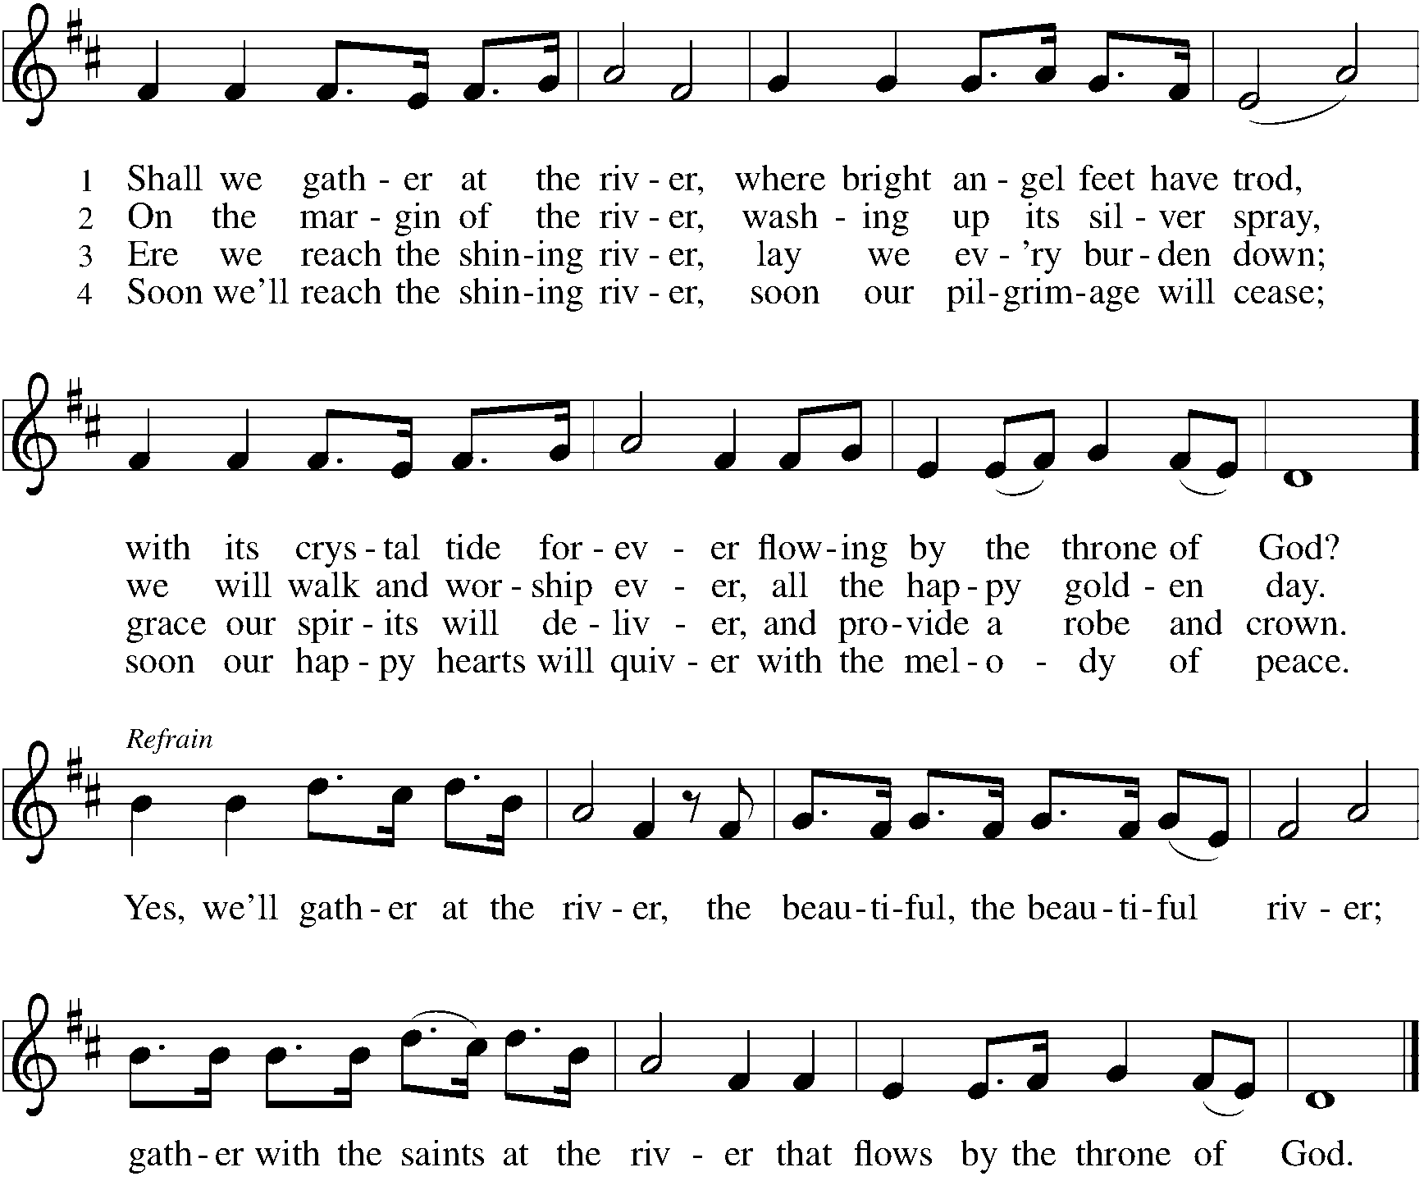
*Greeting
The grace of our Lord Jesus Christ, the love of God, and the communion of the Holy Spirit be with you all. And also with you.

*Hymn of Praise ELW #424 Ye Watchers and Ye Holy Ones
sts. 1,4
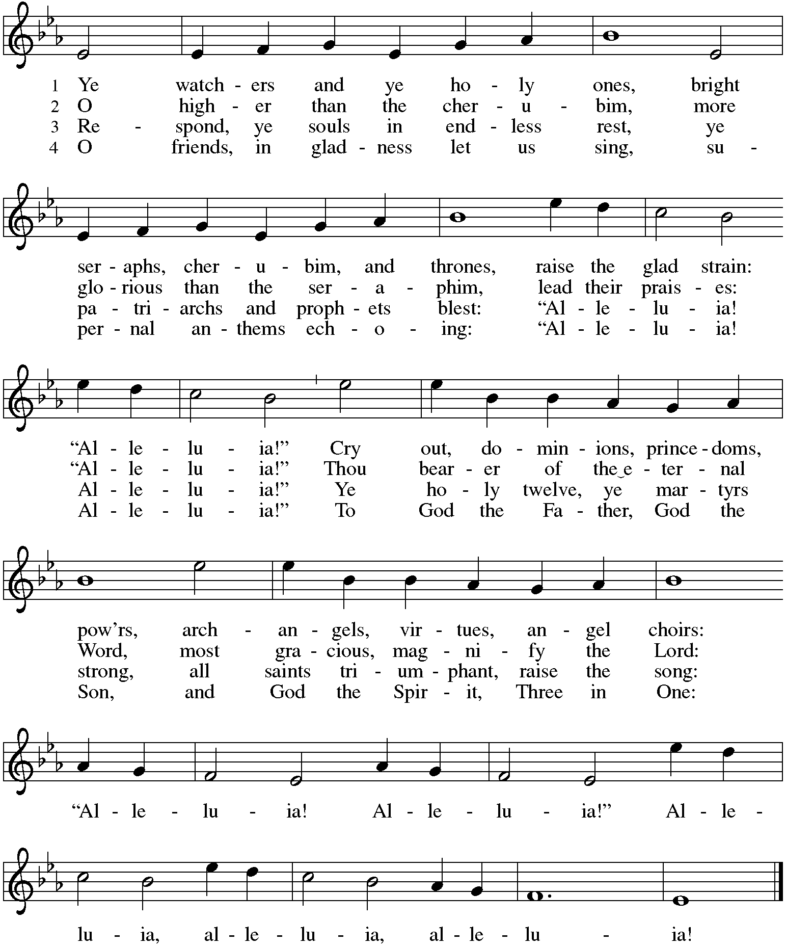
*Prayer of the Day
Almighty God, you have knit your people together in one communion in the mystical body of your Son, Jesus Christ our Lord. Grant us grace to follow your blessed saints in lives of faith and commitment, and to know the inexpressible joys you have prepared for those who love you, through Jesus Christ, our Savior and Lord, who lives and reigns with you and the Holy Spirit, one God, now and forever. Amen.

Rite of Remembrance
+ Joan Frank +
+ Evelyn Elson +
+ Anita Blakemore +
+ Jeremiah Jeske +
+ Robert Stein +
+ Robert LoGalbo +
+ Dorothy Stein +
+ James Sladek +

Blessed be the God and Father of our Lord Jesus Christ,
the source of all mercy and the God of all consolation,
who comforts us in all our sorrows
so that we can comfort others in their sorrows
with the consolation we ourselves have received from God.
When we were baptized in Christ Jesus, we were baptized into his death.
We were buried therefore with him by baptism into death,
so that as Christ was raised from the dead by the glory of the Father,
we too might live a new life.
For if we have been united with him in a death like his,
we shall certainly be united with him in a resurrection like his.

O God of the pilgrim’s way,
we give thanks for those in generations past
who have been examples for us of God’s love at work in the world.
As we pray, we know that we are surrounded
by this great, rejoicing cloud of witnesses.
Yet even as we name these holy ancestors, we thank you for others whose names we never knew or have forgotten, who showed us the meaning of life in Christ.

For our beloved Joan, we give you thanks.
For our beloved Evelyn, we give you thanks.
For our beloved Anita, we give you thanks.
For our beloved Jerry, we give you thanks.
For our beloved Bob, we give you thanks.
For our beloved Robert, we give you thanks.
For our beloved Dorothy, we give you thanks.
For our beloved Jim, we give you thanks.

Music during Candle lighting
During the music, those watching from home may light your candle and speak the name of a loved one, using the form “For our beloved ________, we give you thanks.”
You may name as many people as you like.

Worshippers in the sanctuary may call out the name of a loved one,
using the form “For our beloved ________.”
As you are able, speak so the congregation can hear the name;
after each name, the congregation says, “We give you thanks.”

Pastor Melody lights the other candles in the church.

Merciful God, you heal the broken in heart and bind up the wounds of the afflicted.
Strengthen us in our weakness, calm our troubled spirits, and dispel our doubts and fears.
In Christ's rising from the dead, you conquered death and opened the gates to everlasting life.
Renew our trust in you that by the power of your love we shall one day be brought together again with Joan, Evelyn, Anita, Jerry, Bob, Robert, Dorothy, Jim, and all our loved ones. Grant this, we pray, through Jesus Christ our Lord. Amen.

Word
God speaks to us in scripture reading, preaching, and song.
First Lesson Isaiah 25:6-9
Isaiah sees a vision of the end of days, when God will gather all people on God’s holy mountain and will prepare for them a rich feast. At this banquet God will wipe the tears from all eyes. And there will be no more sorrow, for God will destroy death itself.

⁶On this mountain the Lord of hosts will make for all peoples a feast of rich food, a feast of well-aged wines, of rich food filled with marrow, of well-aged wines strained clear. ⁷And he will destroy on this mountain the shroud that is cast over all peoples, the sheet that is spread over all nations; ⁸he will swallow up death forever. Then the Lord God will wipe away the tears from all faces, and the disgrace of his people he will take away from all the earth, for the Lord has spoken. ⁹It will be said on that day, Lo, this is our God; we have waited for him, so that he might save us. This is the Lord for whom we have waited; let us be glad and rejoice in his salvation.

Word of God, Word of Life. Thanks be to God.

Second Lesson Revelation 21:1-6a
Here is a vision of the new heaven and new earth in which God resides fully with God’s people so that mourning, despair, and pain have been eradicated. These renewing words from the God who spans all of time are trustworthy and true.

¹I saw a new heaven and a new earth; for the first heaven and the first earth had passed away, and the sea was no more. ²And I saw the holy city, the new Jerusalem, coming down out of heaven from God, prepared as a bride adorned for her husband. ³And I heard a loud voice from the throne saying, “See, the home of God is among mortals. He will dwell with them; they will be his peoples, and God himself will be with them; ⁴he will wipe every tear from their eyes. Death will be no more; mourning and crying and pain will be no more, for the first things have passed away.” ⁵And the one who was seated on the throne said, “See, I am making all things new.” Also he said, “Write this, for these words are trustworthy and true.” ^{6a}Then he said to me, “It is done! I am the Alpha and the Omega, the beginning and the end.”

Word of God, Word of Life. Thanks be to God.

*Please stand as you are able.
*Gospel Acclamation ELW #507 O God of Light
st. 1
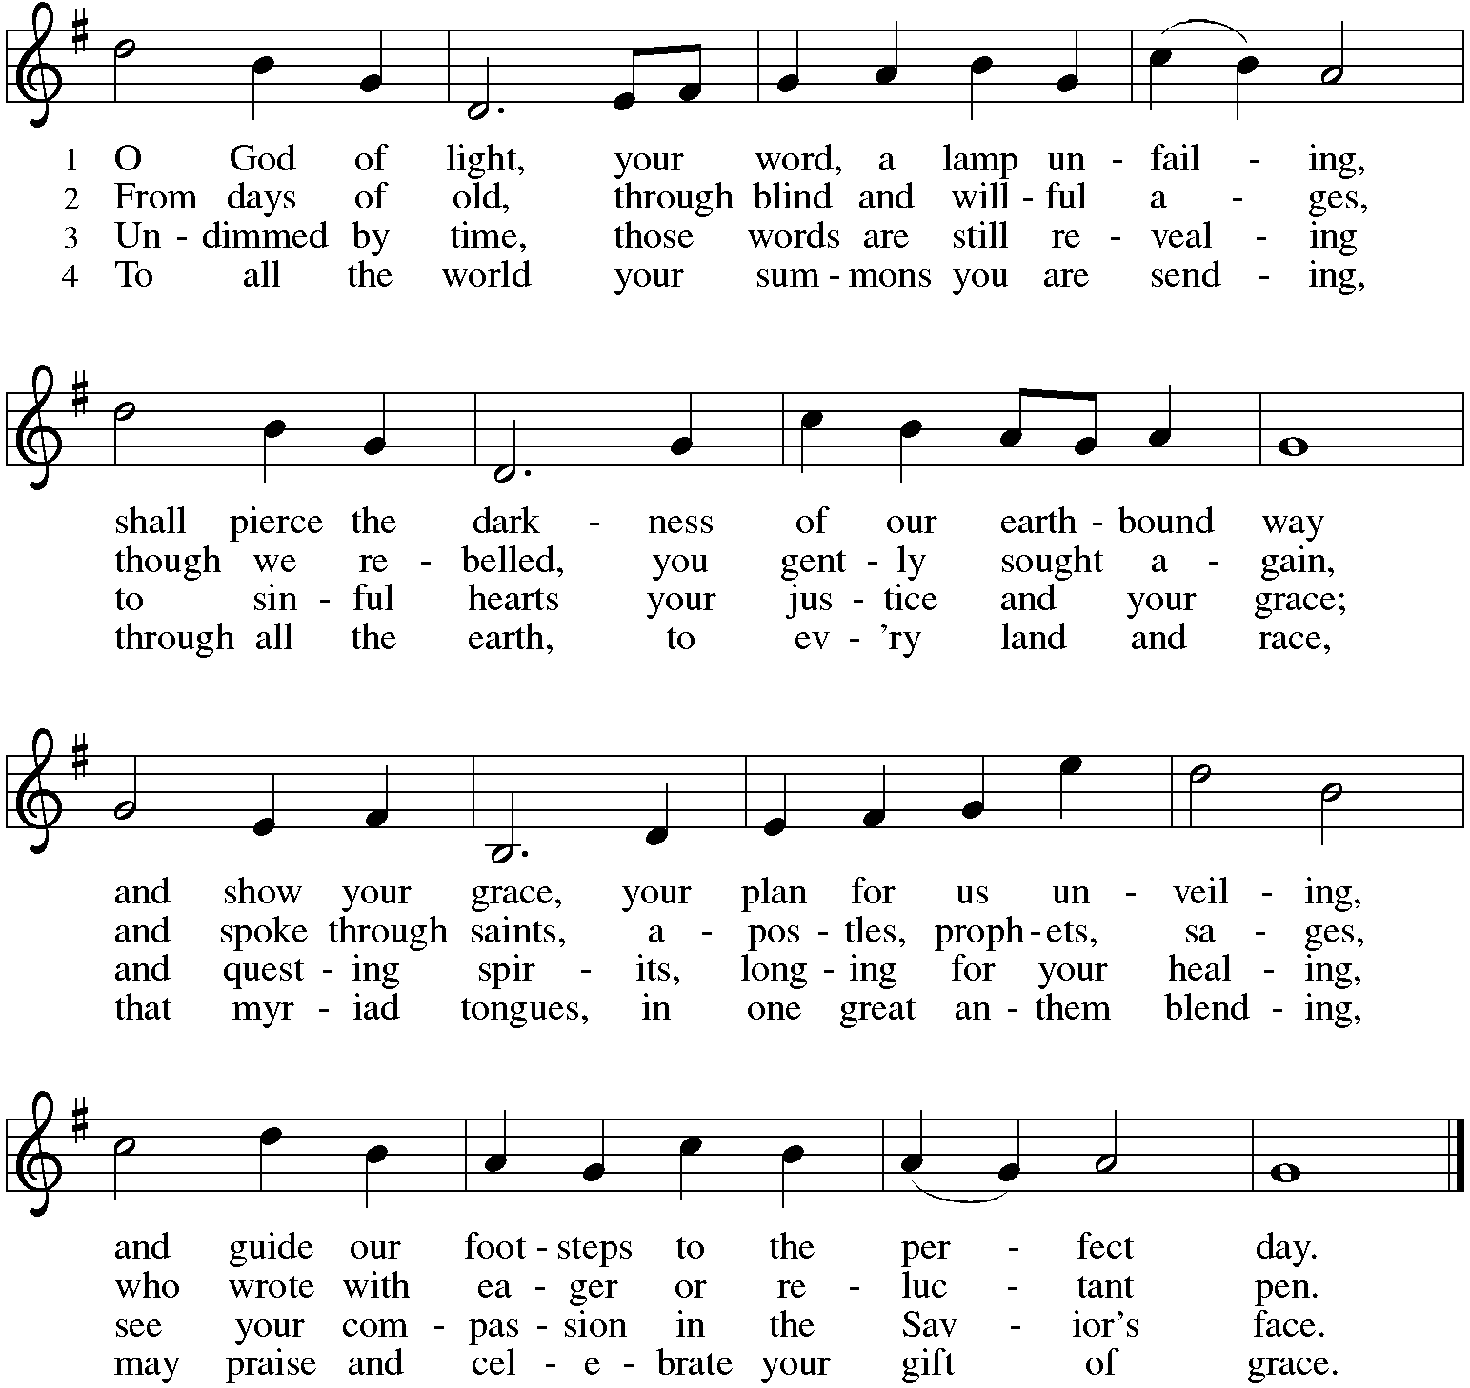

The holy Gospel according to John. Glory to you, O Lord.
Gospel John 11:32-44
Through the raising of Lazarus, Jesus offers the world a vision of the life to come, when death and weeping will be no more.

³²When Mary came where Jesus was and saw him, she knelt at his feet and said to him, “Lord, if you had been here, my brother would not have died.” ³³When Jesus saw her weeping, and the Jews who came with her also weeping, he was greatly disturbed in spirit and deeply moved. ³⁴He said, “Where have you laid him?” They said to him, “Lord, come and see.” ³⁵Jesus began to weep. ³⁶So the Jews said, “See how he loved him!” ³⁷But some of them said, “Could not he who opened the eyes of the blind man have kept this man from dying?”
³⁸Then Jesus, again greatly disturbed, came to the tomb. It was a cave, and a stone was lying against it. ³⁹Jesus said, “Take away the stone.” Martha, the sister of the dead man, said to him, “Lord, already there is a stench because he has been dead four days.” ⁴⁰Jesus said to her, “Did I not tell you that if you believed, you would see the glory of God?” ⁴¹So they took away the stone. And Jesus looked upward and said, “Father, I thank you for having heard me. ⁴²I knew that you always hear me, but I have said this for the sake of the crowd standing here, so that they may believe that you sent me.” ⁴³When he had said this, he cried with a loud voice, “Lazarus, come out!” ⁴⁴The dead man came out, his hands and feet bound with strips of cloth, and his face wrapped in a cloth. Jesus said to them, “Unbind him, and let him go.”

The Gospel of the Lord. Praise to you, O Christ. Be seated.

Sermon The Rev. Melody Eastman

*Please stand as you are able.
*Hymn of the Day ELW #422 For All the Saints
sts. 1,3,5
1 For all the saints who from their labors rest,
who thee by faith before the world confessed,
thy name, O Jesus, be forever blest.
Alleluia! Alleluia!

3 Oh, blest communion, fellowship divine,
we feebly struggle, they in glory shine;
yet all are one in thee, for all are thine.
Alleluia! Alleluia!

5 The golden evening brightens in the west;
soon, soon to faithful servants cometh rest;
sweet is the calm of paradise the blest.
Alleluia! Alleluia!
*Prayers of Intercession
Eternal God, you hold firm amid the changes of this world. Hear us now as we pray for the church, the world, and everyone in need.
A brief silence.

Merciful God, we give thanks for all missionaries who have brought your message of hope to new communities and wiped tears away. Continue to raise up courageous missionaries to share your gospel of hope. Hear us, O God. Your mercy is great.

Creating God, we praise you for abundant harvests and the goodness of creation. Create communities of care for your earth so that all land, water, and soil will be celebrated and cherished by future generations of saints. Hear us, O God.
Your mercy is great.

God of peace, we give you thanks for nations of peace that serve as a refuge for all whose homelands are afflicted with violence. Strengthen those who continue to work for peace and support all veterans who carry the scars of war. Hear us, O God. Your mercy is great.

God of healing, we give you thanks for health care workers who labor around the clock to answer cries for help. Bring wholeness to all who struggle with post-traumatic stress disorder, anxiety, depression, addiction, and all who long for healing in any way, especially Cathy, Rich, Dorothy, Dolores, Carol, Norma, and those we name before you now. . . Hear us, O God. Your mercy is great.

God of justice, we praise you for the feeding ministries and for all meals that bring people together for nourishment and fellowship. Bless chefs, bakers, servers, dishwashers, communion assistants, and meal ministry coordinators. Hear us, O God. Your mercy is great.

God of the ages, we give you thanks for the saints of this congregation who have inspired, challenged, loved, and taught us. Wipe away our tears and lead us by their example until we feast together on your holy mountain. Hear us, O God. Your mercy is great.

God our protection and strength, we entrust to you all for whom we pray. Remain with us always, through Jesus Christ, our Savior. Amen.

*Peace
The peace of Christ be with you always. And also with you.
Please share the peace with others in your household, or by making a sign of peace to those on Zoom. Please remain standing.

Meal
God feeds us with the presence of Jesus Christ.
*Great Thanksgiving
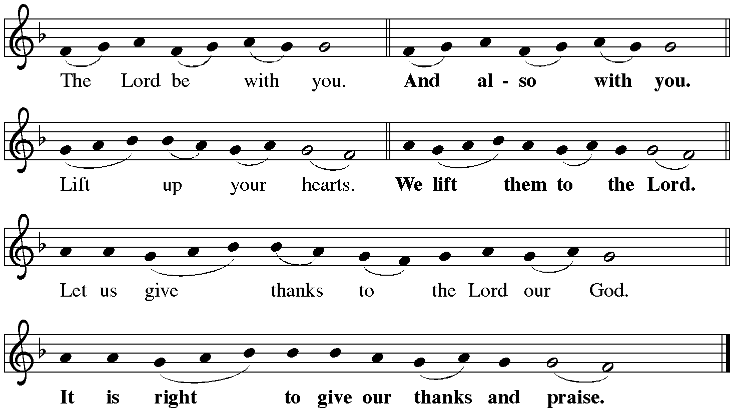

*Preface
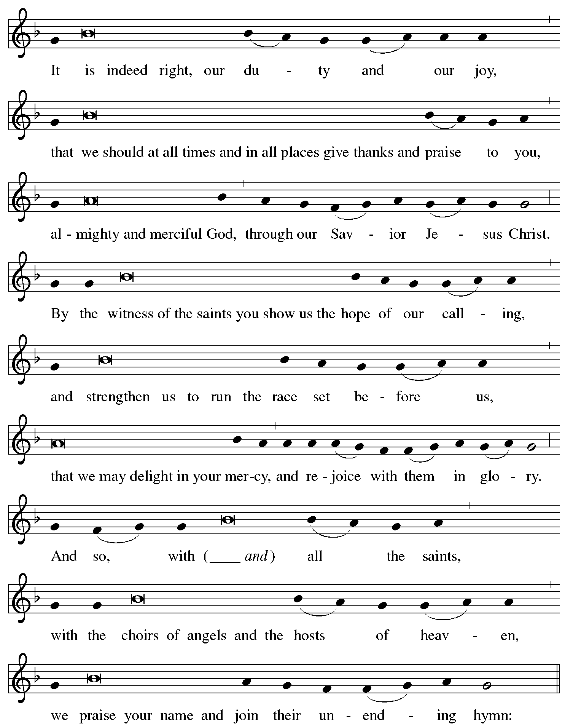
Joan, Evelyn, Anita, Jerry, Bob, Robert, Dorothy, Jim, and
*Sanctus ELW #422 For All the Saints
st. 6
6 But then there breaks a yet more glorious day:
the saints triumphant rise in bright array;
the King of glory passes on his way.
Alleluia! Alleluia!

*Thanksgiving at the Table
Blessed are you, O God of the universe.
Your mercy is everlasting and your faithfulness endures from age to age.

Praise to you for creating the heavens and the earth.
Praise to you for saving the earth from the waters of the flood.
Praise to you for bringing the Israelites safely through the sea.
Praise to you for leading your people through the wilderness
to the land of milk and honey.
Praise to you for the words and deeds of Jesus, your anointed one.
Praise to you for the death and resurrection of Christ.
Praise to you for your Spirit poured out on all nations.

In the night in which he was betrayed,
our Lord Jesus took bread, and gave thanks;
broke it, and gave it to his disciples, saying:
Take and eat; this is my body, given for you.
Do this for the remembrance of me.

Again, after supper, he took the cup, gave thanks,
and gave it for all to drink, saying:
This cup is the new covenant in my blood,
shed for you and for all people for the forgiveness of sin.
Do this for the remembrance of me.

With this bread and cup
we remember our Lord's passover from death to life
as we proclaim the mystery of faith:
Christ has died. Christ is risen. Christ will come again.

You may hold up your (unopened) communion kit as you are able.
O God of resurrection and new life:
Pour out your Holy Spirit on us and on these gifts of bread and wine.
Bless this feast. Grace our table with your presence.
Come, Holy Spirit.
You may lower your communion kit.

Reveal yourself to us in the breaking of the bread.
Raise us up as the body of Christ for the world.
Breathe new life into us.
Send us forth, burning with justice, peace, and love.
Come, Holy Spirit.

With Joan, Evelyn, Anita, Jerry, Bob, Robert, Dorothy,
Jim, and your holy ones of all times and places,
with the earth and all its creatures, with sun and moon and stars,
we praise you, O God, blessed and holy Trinity, now and forever.
Amen.

*The Lord’s Prayer
Gathered into one by the Holy Spirit, let us pray as Jesus taught us.
Our Father, who art in heaven, hallowed be thy name. Thy kingdom come, thy will be done on earth as it is in heaven. Give us this day our daily bread, and forgive us our trespasses, as we forgive those who trespass against us; and lead us not into temptation, but deliver us from evil. For thine is the kingdom, and the power, and the glory, forever and ever. Amen. Be seated.

Invitation to Communion
A feast of love is offered here for you and for all the saints.
If you have difficulty opening your communion, please signal an usher for assistance.

Peel up the clear top seal over the wafer, and hold the wafer up when you are ready.
This is the Body of Christ, given for you. (Eat the bread.) Amen.

Peel up the second foil seal over the juice, and hold your cup up when you are ready.
This is the blood of Christ, shed for you. (Drink the wine/juice.) Amen.

After communion you may place the packaging in the bowl in your pew. The ushers will dispose of these following the service.

*Please stand as you are able.
*Agnus Dei ELW #422 For All the Saints
st. 7
7 From earth's wide bounds, from ocean's farthest coast,
through gates of pearl streams in the countless host,
singing to Father, Son, and Holy Ghost:
Alleluia! Alleluia!

*Post-Communion Blessing
The body and blood of our Lord Jesus Christ strengthen you and keep you in his grace. Amen.

*Prayer after Communion
Blessed Jesus,
at this table, you have been for us both host and meal.
Now send us forth to extend our tables
and to share your gifts
until that day when all feast together
at your heavenly banquet.
Amen.

Sending
God blesses us and sends us in mission to the world.
*Blessing
God, the beginning and the end,
who has written your name in the book of life,
☩ bless and keep you in grace and peace
from this time forth and forevermore.
Amen.

*Sending Hymn ACS #950 Oh, When the Saints Go Marching In
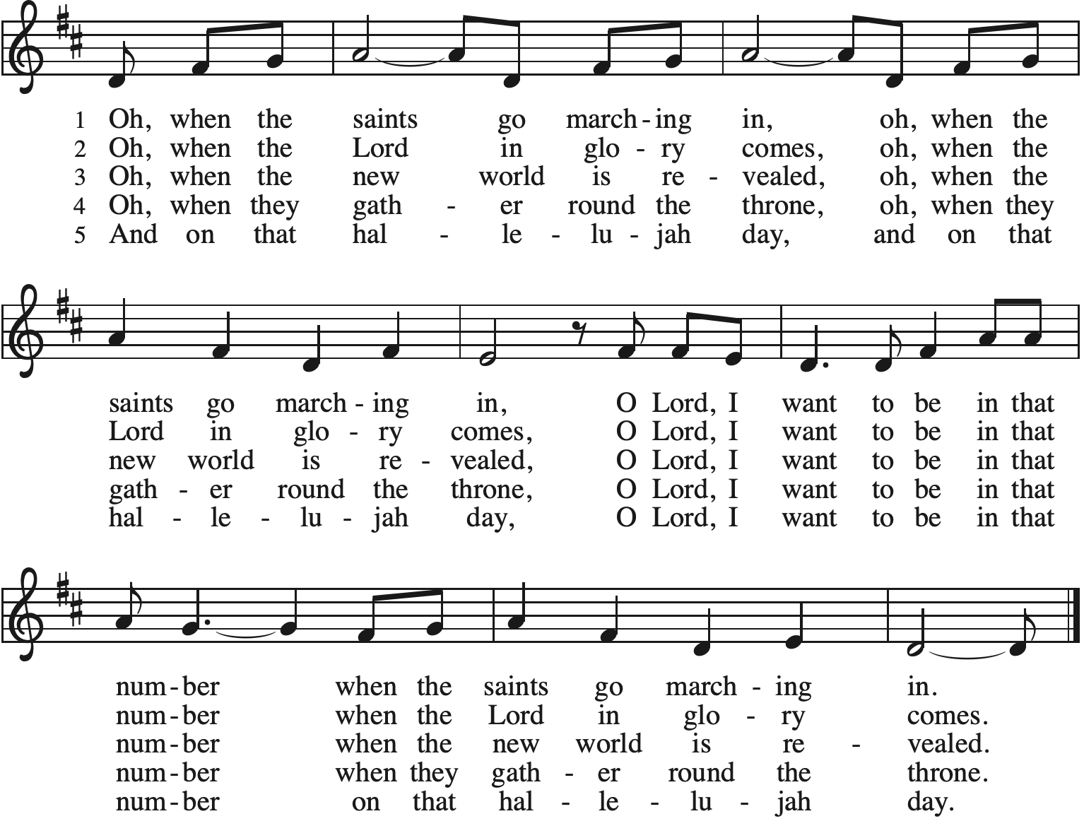

*Sent to the World
Led on by the saints before us, go in peace to serve the Lord. Thanks be to God.

Postlude

From Sundays and Seasons v.20190109.1233 Copyright © 2021 Augsburg Fortress. All rights reserved.
Reprinted by permission under Augsburg Fortress Liturgies Annual License #30867.
Reprinted under OneLicense.net #A-718333.

Current Prayer Requests
Name Relation to Grace Prayers For
Rich Davison Member Healing & Strength
Cathy Milleville Member Healing & Strength
Dorothy Tracy Member Healing & Strength
Prayers for our homebound Members
Dolores Nosal, Carol Petersen, Norma Petersen

Weekly Announcements

Quilting Ministry November 9: This ministry meets on the 2nd and 4th Tuesday of the month from 9:00-10:00am. Even if you can’t sew but are able to cut fabric into a 9” square we need you! We have 10⁺ bins of fabric waiting to be cut and cut squares ready to be assembled into beautiful quilts. After quilting you are invited to stay and attend the chair exercise class at 10:00am and if you like to knit hats, scarves, and gloves you can join the Wooly Knitters at 1pm! Everyone is welcome, bring a friend!

Commitment Cards for 2022: Pledge cards were mailed out earlier this week. We ask that everyone please sign and return a card even if you do not wish to commit to a pledge amount at this time. Commitment Sunday will be November 21. You may also submit your pledge through Grace’s website, www.GraceGlenEllyn.org

Transgender Day of Remembrance - Saturday, November 20: Grace Lutheran, Faith Lutheran, Congregation Etz Chaim and the First Congregational Church of Glen Ellyn are jointly offering a worship service marking the Transgender Day of Remembrance. The service will be held at First Congregational Church, 535 Forest Avenue at 7:00pm. The Transgender Day of Remembrance is an annual observance that has been held each November 20th since 1999. It honors the memory of transgender people whose lives were lost in acts of anti-transgender violence, and invites the community to join together in prayer for justice, safety, dignity and healing. If you have questions about the Transgender Day of Remembrance or about the service, please contact Pastor Melody.

Monday Evening Bible Study: Mondays at 7:00pm, the group will begin review of a new, as yet unpublished, book from Dr. George Byron Koch. The topic is the Jewish roots of Christianity. Kindly contact Mark Hamilton or Vince Hardt if you have not participated before so that we may add you to our Email list.

Pill Bottle Project: Calling all volunteers! After being shut down for over a year, we will meet weekly on Tuesdays from 6-7:30pm in the upstairs kitchen next to the gym. If you would like to volunteer, just show up! Please note: at this time we are not accepting any pill bottles as it will take over a year to get through the current inventory we have. If you have any questions, please contact Mark Hamilton at (630) 841-2941 / mark.hamilton@ifs.com

Bell Choir rehearsal Wednesdays at 7pm! Come join us for an hour of fun, super low-pressure music-making! Not free on Wednesday evenings? You’re still welcome to join us on Sunday mornings at 8:40! Don’t know how to read music, we can work on that, too! No matter your skill level, there’s room for you! Get excited, my friends! The fun starts now :)

Grace’s Adult Vocal Choir: This is currently on hold due to the concern of our choir members gathering to sing together maskless at this time.

Got Capital Gains? Did you know that stock donations allow you to both claim a deduction at the appreciated value AND allow you to avoid capital gains taxes on these assets? Further, consolidating donations in a tax year could lead to increased ability to deduct charitable contributions in a given tax year. Consult your tax advisor for details, but if you’d like more information on how to go about donating stock, reach out to the church office.

Contributions to Grace: You may continue to mail your contributions for the General Fund and the Mortgage Reduction Fund to the church office; have your bank mail your contribution to the church office (this works great); or contribute on-line through Grace’s website (Grace/you pay fees). Please know, pandemic or no, our mission continues! Thank you for your continued support of our ministries at Grace Lutheran.

Every Member a Minister and Missionary!

Phone: 630-469-1555 Emergency Pastoral Contact: 630-674-2887
info@graceglenellyn.org www.graceglenellyn.org

Pastor
Rev. Melody Eastman office ext. 14
meastman@graceglenellyn.org

Minister of Music
Bradford Thompson 219-718-8879
bradfordmthompson@gmail.com

Ministry Associate
Becky Ficarella office ext. 17
bficarella@graceglenellyn.org

Office Manager
Barbara Sudds office ext. 10
bsudds@graceglenellyn.org

Parish Counselor
Carole LoGalbo M.S., LCPC 630-668-4594
carolelogalbo@yahoo.com

