Grace Lutheran Church
493 Forest Avenue, Glen Ellyn IL 630.469.1555
www.graceglenellyn.org

23rd Sunday after Pentecost November 8, 2020

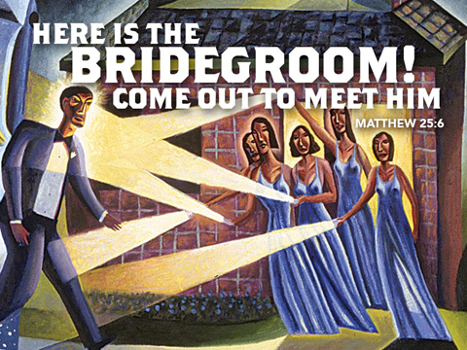

+ Proclaim Christ + Build Community +
+ Serve Our Neighbors +
Introduction
Today the prophet Amos calls for justice to roll down like waters. Paul urges us to encourage one another with the promised coming of the Lord. Jesus tells the parable of the wise and foolish bridesmaids. Surrounded by the faithful of every time and place, we celebrate Christ’s coming in our midst in the word of life and the feast of victory—the marriage feast of the lamb.

Gathering
The Holy Spirit calls us together as the people of God.

Prelude

Confession and Forgiveness
All may make the sign of the cross, the sign marked at baptism,
as the worship leader begins.
Blessed be the holy Trinity, ☩ one God,
in whose image we are made,
who claims us and calls us beloved.
Amen.
Silence is kept for reflection.

Holy One,
we confess that we are not awake for you.
We are not faithful in using your gifts.
We forget the least of our siblings.
We do not see your beautiful image in one another.
We are infected by sin
that divides your beloved community.
Open our hearts to your coming,
open our eyes to see you in our neighbor,
open our hands to serve your creation. Amen.

Beloved, we are God’s children,
and Jesus, our Beloved, opens the door to us.
Through ☩ Jesus we are forgiven,
by Jesus we are welcome,
in Jesus we are called to rejoice!
Let us live in the promises prepared for us
from the foundation of the world.
Amen.

Opening Hymn (Please mute your mic) ELW#841 Lift Every Voice and Sing; sts. 1, 3
(You may unmute your mic)
Greeting
The grace of our Lord Jesus Christ, the love of God, and the communion of the Holy Spirit be with you all. And also with you.

Prayer of the Day
O God of justice and love, you illumine our way through life with the words of your Son. Give us the light we need, and awaken us to the needs of others, through Jesus Christ, our Savior and Lord. Amen.

Word
God speaks to us in scripture reading, preaching, and song.

First Lesson Amos 5:18-24
In the days of Amos, people thought that the day of the LORD would be a time of great victory, but Amos announced that it would be a day of darkness, not light. He said liturgy is no substitute for obedience. The LORD demands justice and righteousness in the community.

¹⁸Alas for you who desire the day of the Lord! Why do you want the day of the Lord? It is darkness, not light; ¹⁹as if someone fled from a lion, and was met by a bear; or went into the house and rested a hand against the wall, and was bitten by a snake. ²⁰Is not the day of the Lord darkness, not light, and gloom with no brightness in it?
²¹I hate, I despise your festivals, and I take no delight in your solemn assemblies. ²²Even though you offer me your burnt offerings and grain offerings, I will not accept them; and the offerings of well-being of your fatted animals I will not look upon. ²³Take away from me the noise of your songs; I will not listen to the melody of your harps. ²⁴But let justice roll down like waters,
and righteousness like an ever-flowing stream.

Word of God, Word of Life. Thanks be to God.

The Psalm Read responsively by verse Psalm 70
¹Be pleased, O God, to deliver me;
O Lord, make haste to help me.
²Let those who seek my life be put to shame and confounded;
let those who take pleasure in my misfortune draw back and be disgraced.
³Let those who say to me “Aha!” and gloat over me
turn back because of their shame.
⁴Let all who seek you rejoice and be glad in you;
let those who love your salvation say forever, “Great is the Lord!”
⁵But as for me, I am poor and needy; come to me quickly, O God.
You are my helper and my deliverer; O Lord, do not tarry.

Second Lesson 1 Thessalonians 4:13-18
Some of the Thessalonians are worried that dead Christians will be excluded from the resurrection to eternal life when Christ comes again. Paul reassures them with the word of hope that all Christians, living or dead, will be raised into everlasting life with Christ.

¹³We do not want you to be uninformed, brothers and sisters, about those who have died, so that you may not grieve as others do who have no hope. ¹⁴For since we believe that Jesus died and rose again, even so, through Jesus, God will bring with him those who have died. ¹⁵For this we declare to you by the word of the Lord, that we who are alive, who are left until the coming of the Lord, will by no means precede those who have died. ¹⁶For the Lord himself, with a cry of command, with the archangel’s call and with the sound of God’s trumpet, will descend from heaven, and the dead in Christ will rise first. ¹⁷Then we who are alive, who are left, will be caught up in the clouds together with them to meet the Lord in the air; and so we will be with the Lord forever. ¹⁸Therefore encourage one another with these words.

Word of God, Word of Life. Thanks be to God.

Gospel Acclamation
Alleluia, Lord, to whom shall we go? You have the words of eternal life. Alleluia.

The holy Gospel according to Matthew. Glory to you, O Lord.

Gospel Matthew 25:1-13
Jesus tells a parable about his own second coming, emphasizing the need for readiness at all times.

[Jesus said to the disciples:] ¹“Then the kingdom of heaven will be like this. Ten bridesmaids took their lamps and went to meet the bridegroom. ²Five of them were foolish, and five were wise. ³When the foolish took their lamps, they took no oil with them; ⁴but the wise took flasks of oil with their lamps. ⁵As the bridegroom was delayed, all of them became drowsy and slept. ⁶But at midnight there was a shout, ‘Look! Here is the bridegroom! Come out to meet him.’ ⁷Then all those bridesmaids got up and trimmed their lamps. ⁸The foolish said to the wise, ‘Give us some of your oil, for our lamps are going out.’ ⁹But the wise replied, ‘No! there will not be enough for you and for us; you had better go to the dealers and buy some for yourselves.’ ¹⁰And while they went to buy it, the bridegroom came, and those who were ready went with him into the wedding banquet; and the door was shut. ¹¹Later the other bridesmaids came also, saying, ‘Lord, lord, open to us.’ ¹²But he replied, ‘Truly I tell you, I do not know you.’ ¹³Keep awake therefore, for you know neither the day nor the hour.”

The Gospel of the Lord. Praise to you, O Christ.

(Please mute your mic)
Sermon The Rev. Melody Eastman

(You may unmute your mic)

Apostles’ Creed

With the whole church, let us confess our faith.
I believe in God, the Father almighty, creator of heaven and earth. I believe in Jesus Christ, God's only Son, our Lord, who was conceived by the Holy Spirit, born of the virgin Mary, suffered under Pontius Pilate, was crucified, died, and was buried; he descended to the dead. On the third day he rose again; he ascended into heaven, he is seated at the right hand of the Father, and he will come to judge the living and the dead. I believe in the Holy Spirit, the holy catholic church, the communion of saints, the forgiveness of sins, the resurrection of the body, and the life everlasting. Amen.

Prayers of Intercession
Longing for Christ’s reign to come among us, we pray for the outpouring of God’s power on the church, the world, and all in need.

Holy God, rouse us to deep praise as we gather for worship. Infuse our community with sincere and heartfelt faith. Sustain the work of all church musicians and lay leaders who lead us in praise and prayer. Hear us, O God. Your mercy is great.

Holy Creator, surprise and delight us with the beauty of the world you have made. Bless the work of landscapers, architects, and artists whose work invites us into harmonious living with your creation. Hear us, O God. Your mercy is great.

Holy Sovereign, be with all those elected to positions of leadership. Uphold decision-makers in wisdom and righteousness. Guide us in establishing justice, restoration and wholeness as our nation moves into this next phase of our life together. Hear us, O God. Your mercy is great.

Holy Judge, let justice roll down like waters over this world. Reign over the courtrooms of every land, in the hearts of those who guard the law and those who stand accused of crimes. Be present in cases where we long for both justice and mercy to prevail. Hear us, O God. Your mercy is great.

Holy Companion, console those who feel lonely or abandoned. Share the hours of those who live and eat alone. Comfort those who have few friends or who struggle with their identity and place in this world. Be with all who need your healing strength, especially Marilyn, Sigrid, Dorothy, Anita, Evelyn, Carol and Norma. Hear us, O God. Your mercy is great.

Holy Protector, be with all observing Veterans Day. Guard the lives of active duty and retired military personnel. Comfort all who mourn those who have died in the line of duty. Heal the wounds, both physical and mental, experienced by service members. Hear us, O God. Your mercy is great.

Holy and Immortal One, we pray in thanksgiving for the lives of all who have died. Remind us of the frailty and shortness of our own lives and inspire us to use them for the building up of your kingdom. Hear us, O God. Your mercy is great.

Receive our prayers in the name of Jesus Christ our Savior, until that day when you gather all creation around your throne where you will reign forever and ever. Amen.

(If your House Church is celebrating Communion, refer to that liturgy here.)

The Lord’s Prayer Ecumenical Version
Gathered into one by the Holy Spirit, let us pray as Jesus taught us.
Our Father in heaven, hallowed be your name, your kingdom come, your will be done, on earth as in heaven. Give us today our daily bread. Forgive us our sins as we forgive those who sin against us. Save us from the time of trial and deliver us from evil. For the kingdom, the power and the glory are yours, now and forever. Amen.

Sending
God blesses us and sends us in mission to the world.
Blessing
May the God of all creation, in whose image we are made, who claims us and calls us beloved,
who strengthens us for service, give us reason to rejoice and be glad! The blessing of God,
Sovereign, ☩ Savior, and Spirit, be with us today and always. Amen.

Sending Hymn (Please mute your mic) ELW #638 Blessed Assurance; sts. 1, 3
(You may unmute your mic)
Sent to the World
Beloved of God, go in peace to love and serve the Lord. Thanks be to God.

From Sundays and Seasons v.20190109.1233 Copyright © 2020 Augsburg Fortress. All rights reserved.
Reprinted by permission under Augsburg Fortress Liturgies Annual License #30867.
Reprinted under OneLicense.net #A-718333.

Current Prayer Requests
Name Relation to Grace Prayers For
Marilyn Goodrich Member Healing & Strength
Chris Danly Son of Mark & Pat Danly Healing & Strength
Sigrid Elliott Friend of Grace Healing & Strength
Dorothy Tracy Member Healing & Strength
Prayers for our homebound Members
Anita Blakemore, Evelyn Elson, Carol Petersen, Norma Petersen, Dorothy Stein

Weekly Announcements
Commitment Cards for 2021 have been mailed. Please return yours to the office, or you can submit your commitment on Grace’s website. Your support remains critical; thank you for your prayerful response!

Sign up for AmazonSmile and pick Grace Lutheran Church as your charity of choice:
Remember to shop at AmazonSmile when making purchases online. In order to browse or shop at AmazonSmile, customers must first select a charitable organization. Here is the link for Grace Lutheran: http://smile.amazon.com/ch/36-2496438
When you sign on, you will see “Supporting Grace Lutheran Church” in the upper left hand corner. Then just shop as you normally do. There is no cost to Grace or to you, the customer. The shopping experience is identical to Amazon.com with the added benefit that the AmazonSmile Foundation will donate a percentage of your purchase amount to Grace.

House Church Worship via phone or internet every Sunday morning at 9:30am! We currently have five “House Churches” of worshipping members (each House Church consisting of 6-8 members/families meeting via Zoom or calling in by phone.) If you are unsure how to sign on, go ahead and register and let us know you need some help; we’ll walk you through it! We would be so blessed to have you join us. Register online for a House Church at graceglenellyn.org (on the main page Announcements) or contact Becky Ficarella directly at 847-347-0928 or bficarella@graceglenellyn.org.

Grace is the Sponsor for the Food Pantry Drive-Thru on Friday, November 6: Volunteers are needed to greet cars and load donations into carts. Two shifts: 9-10:30am and 10:30-noon. You can sign up on Grace’s website or call Carol Asselmeier to volunteer. (COVID-19 protocols are in place; please wear a mask. Thanks!)

Christmas in the Movies: Saturday, November 7 at 2:00pm, the Glen Ellyn Historical Society presents actress and historian Leslie Goddard in a ZOOM presentation titled, “Christmas in the Movies.” The program was taken from the book by Jeremy Arnold and looks back at some Hollywood classics. Included in the presentation are Holiday Inn, Miracle on 34th Street, A Christmas Story, Elf, White Christmas and others. Learn behind-the-scenes stories about each movie's production, reception and legacy. It is a glorious salute to Hollywood doing the holidays. This is a free event. It is shown on the Zoom platform. Registration is limited, so sign up today. To register go to EventBrite at https://www.eventbrite.com/e/christmas-in-the-movies-a-leslie-goddard-illustrated-lecture-tickets-122591266779. Call 630-469-1867 for information.

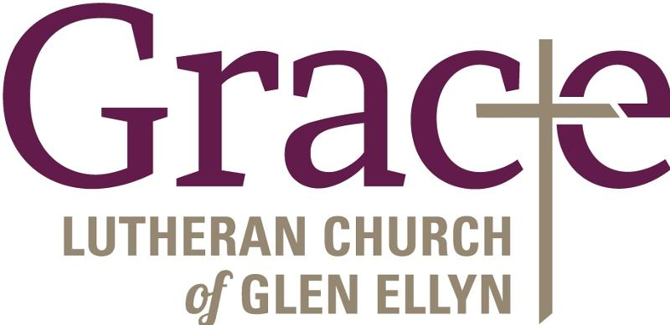
Every Member a Minister and Missionary!

Phone: 630-469-1555 Emergency Pastoral Contact: 630-674-2887
info@graceglenellyn.org www.graceglenellyn.org

Pastor
Rev. Melody Eastman office ext. 14
meastman@graceglenellyn.org

Minister of Music
Bradford Thompson 219-718-8879
bradfordmthompson@gmail.com

Ministry Associate
Becky Ficarella office ext. 17
bficarella@graceglenellyn.org

Office Manager
Barbara Sudds office ext. 10
bsudds@graceglenellyn.org

Parish Counselor
Carole LoGalbo M.S., LCPC 630-668-4594
carolelogalbo@yahoo.com

