Grace Lutheran Church

493 Forest Avenue, Glen Ellyn IL 630.469.1555
www.graceglenellyn.org

25th Sunday after Pentecost November 14, 2021

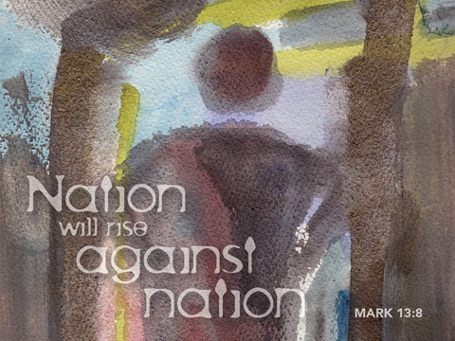

+ Proclaim Christ + Build Community +
+ Serve Our Neighbors +

Introduction
November begins with All Saints Day and ends in or near Advent, when we anticipate Christ’s coming again. It is fitting, then, that the readings today tell of the final resurrection and the end time. In the turmoil of hope, fear, and disbelief that these predictions provoke in us, Hebrews sounds a note of confident trust. Christ makes a way for us where there is no way, and we walk it confidently, our hearts and bodies washed in baptismal water, trusting the one who has promised forgiveness. The more we see the last day approaching, the more important it is to meet together to provoke one another to love.
Gathering
The Holy Spirit calls us together as the people of God.
Welcome/Announcements

Prelude

*Please stand as you are able and turn to face the font.
*Confession and Forgiveness
All may make the sign of the cross, the sign marked at baptism, as the presiding minister begins.
In the name of the Father, and of the ☩ Son, and of the Holy Spirit. Amen.

Let us confess our sin in the presence of God and of one another.
Silence is kept for reflection.
Have mercy on us, O God.

We confess that we have sinned against you
and against our neighbor.
We have built walls instead of tables
and have turned away the stranger.
We have sought glory for ourselves
and have treasured that which does not satisfy.
Help us to love as you love,
to welcome those you send,
and to treasure mercy and justice.
Turn us from our ways to your ways,
and free us to serve those in need. Amen.

God, who makes all things new,
forgives your sins for ☩ Jesus’ sake
and remembers them no more.
Lift up your heads and your hearts.
Yours is the kingdom of God.
Amen.

*Entrance Hymn ELW#837 Built on a Rock, sts. 1-3
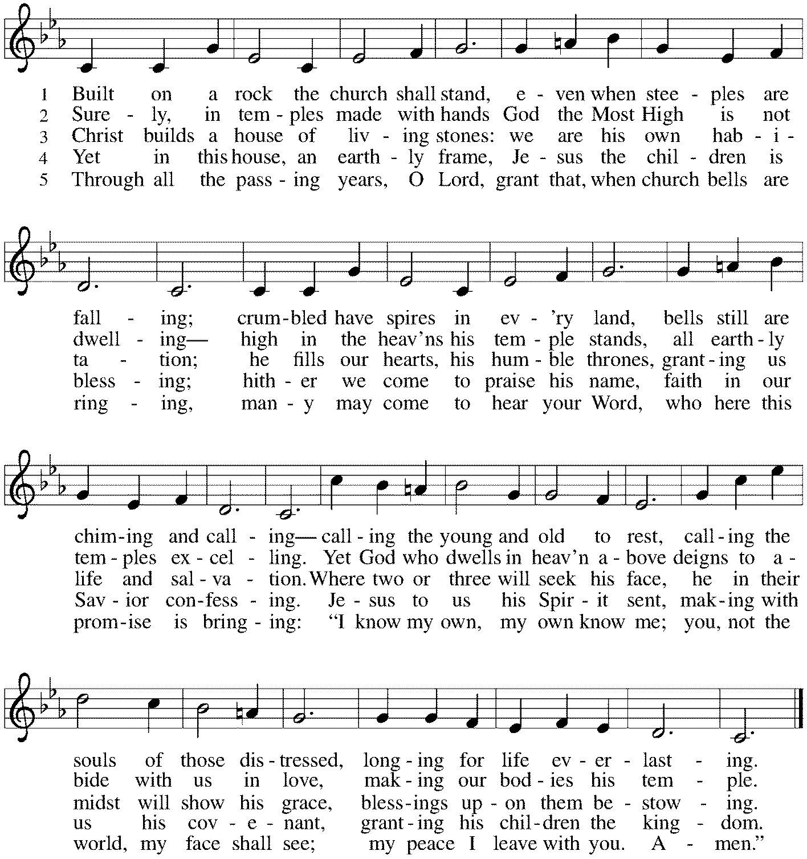

*Greeting
The grace of our Lord Jesus Christ, the love of God, and the communion of the Holy Spirit be with you all. And also with you.

*Kyrie

*Prayer of the Day
Almighty God, your sovereign purpose brings salvation to birth. Give us faith to be steadfast amid the tumults of this world, trusting that your kingdom comes and your will is done through your Son, Jesus Christ, our Savior and Lord.
Amen. Be seated.
Word
God speaks to us in scripture reading, preaching, and song.
First Reading Daniel 12:1-3
The book of Daniel is an example of apocalyptic literature, which is full of strange visions and symbolism. Arising during times of great persecution, apocalyptic literature is concerned with God’s revelation about the end time and the coming kingdom of God, when God will vindicate the righteous who have been persecuted.

¹“At that time Michael, the great prince, the protector of your people, shall arise. There shall be a time of anguish, such as has never occurred since nations first came into existence. But at that time your people shall be delivered, everyone who is found written in the book. ²Many of those who sleep in the dust of the earth shall awake, some to everlasting life, and some to shame and everlasting contempt. ³Those who are wise shall shine like the brightness of the sky, and those who lead many to righteousness, like the stars forever and ever.”

Word of God, Word of Life. Thanks be to God.

Psalm Psalm 16
¹Protect me, O God, for I take refuge in you; I have said to the Lord, “You are my Lord, my good above all other.”
²All my delight is in the godly that are in the land, upon those who are noble among the people.
³But those who run after other gods shall have their troubles multiplied.
⁴I will not pour out drink offerings to such gods, never take their names upon my lips.
⁵O Lord, you are my portion and my cup; it is you who uphold my lot.
⁶My boundaries enclose a pleasant land; indeed, I have a rich inheritance.
⁷I will bless the Lord who gives me counsel; my heart teaches me night after night.
⁸I have set the Lord always before me; because God is at my right hand, I shall not be shaken.
⁹My heart, therefore, is glad, and my spirit rejoices; my body also shall rest in hope.
¹⁰For you will not abandon me to the grave, nor let your holy one see the pit.
¹¹You will show me the path of life; in your presence there is fullness of joy, and in your right hand are pleasures forevermore.

Second Reading Hebrews 10:11-25
Images of worship and sacrifice are used throughout Hebrews to highlight what Christ has uniquely accomplished through his death. Because we have received forgiveness through Christ’s death, we live with sincere hearts by trusting in God’s promises and encouraging love and good works from each other.

¹¹Every priest stands day after day at his service, offering again and again the same sacrifices that can never take away sins. ¹²But when Christ had offered for all time a single sacrifice for sins, “he sat down at the right hand of God,” ¹³and since then has been waiting “until his enemies would be made a footstool for his feet.” ¹⁴For by a single offering he has perfected for all time those who are sanctified. ¹⁵And the Holy Spirit also testifies to us, for after saying, ¹⁶“This is: I will put my laws in their hearts, and I will write them on their minds,” ¹⁷he also adds, “I will remember their sins and their lawless deeds no more.” ¹⁸Where there is forgiveness of these, there is no longer any offering for sin.
¹⁹Therefore, my friends, since we have confidence to enter the sanctuary by the blood of Jesus, ²⁰by the new and living way that he opened for us through the curtain (that is, through his flesh), ²¹and since we have a great priest over the house of God, ²²let us approach with a true heart in full assurance of faith, with our hearts sprinkled clean from an evil conscience and our bodies washed with pure water. ²³Let us hold fast to the confession of our hope without wavering, for he who has promised is faithful. ²⁴And let us consider how to provoke one another to love and good deeds, ²⁵not neglecting to meet together, as is the habit of some, but encouraging one another, and all the more as you see the Day approaching.

Word of God, Word of Life. Thanks be to God.

*Please stand as you are able.
*Gospel Acclamation Alleluia

The holy Gospel according to Mark. Glory to you, O Lord.

*Gospel Mark 13:1-8
In the last week of his life, Jesus warned his disciples concerning trials that were to come upon them and upon the world. He exhorts the listener: Do not be alarmed.

¹As [Jesus] came out of the temple, one of his disciples said to him, “Look, Teacher, what large stones and what large buildings!” ²Then Jesus asked him, “Do you see these great buildings? Not one stone will be left here upon another; all will be thrown down.”
³When he was sitting on the Mount of Olives opposite the temple, Peter, James, John, and Andrew asked him privately, ⁴“Tell us, when will this be, and what will be the sign that all these things are about to be accomplished?” ⁵Then Jesus began to say to them, “Beware that no one leads you astray. ⁶Many will come in my name and say, ‘I am he!’ and they will lead many astray. ⁷When you hear of wars and rumors of wars, do not be alarmed; this must take place, but the end is still to come. ⁸For nation will rise against nation, and kingdom against kingdom; there will be earthquakes in various places; there will be famines. This is but the beginning of the birth pangs.”

The Gospel of the Lord. Praise to you, O Christ. Be seated.

Sermon The Rev. Melody Eastman

*Please stand as you are able.
*Hymn of the Day ELW #438 My Lord, What a Morning
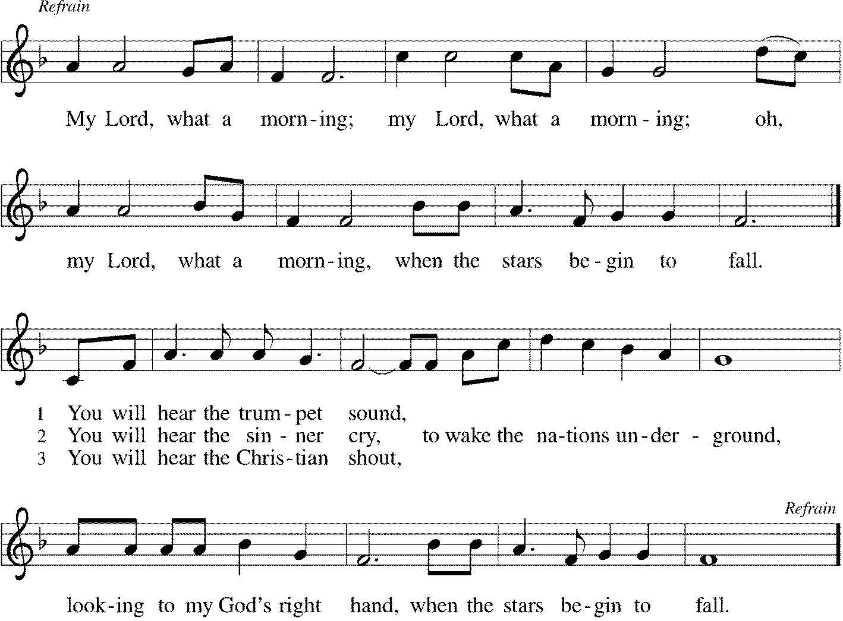
*Prayers of Intercession
Eternal God, you hold firm amid the changes of this world. Hear us now as we pray for the church, the world, and everyone in need.
A brief silence.

God our creator, you show us the path of life. Bless faithful people everywhere with humility as they extend compassion to those who have experienced harm in religious spaces. Cultivate healthy congregations that tell of and enact your reconciling love. God, in your mercy, hear our prayer.

God our constant, you love our universe from beginning to end. As the seasons change, protect animals that migrate and hibernate. Bring them safely to a sheltered place and a more abundant season. God, in your mercy, hear our prayer.

God our ruler, you write your law on human minds and hearts. Give wisdom to all elected leaders and officials to govern with insight and compassion. Make them mindful of the well-being of all people so that your world will flourish. God, in your mercy, hear our prayer.

God our stronghold, you are present amid disaster. We pray for those affected by natural disasters. Come to the aid of all survivors of earthquakes, famines, floods, hurricanes, and wildfires, and the first responders who support them. Calm their fear, supply their need, and be the solid ground beneath their feet. God, in your mercy, hear our prayer.

God our guide, you are greater than we can imagine. Surround congregations with your expansive inclusion. Be present in the midst of disagreements, differences, and questions. Unite people of diverse viewpoints in the love of Christ. God, in your mercy, hear our prayer.
Here other intercessions may be offered.

God our beginning and our end, your beloved people shine like the brightness of the sky. We thank you for the lives of all who rest in your eternal mercy, from famous saints to the people we have loved. Assure us of your resurrection promise. God, in your mercy, hear our prayer.

God our hope and strength, we entrust to you all for whom we pray. Remain with us always, through Jesus Christ, our Savior. Amen.

*Peace
The peace of Christ be with you always. And also with you.
Please share the peace with others in your household, or by making a sign of peace to those on Zoom. Please remain standing.

Meal
God feeds us with the presence of Jesus Christ.
*Offering Prayer
Holy God, the earth is yours and everything in it, yet you have chosen to dwell among your creatures. Come among us now in these gifts of bread and wine,
and strengthen us to be your body for the world through Jesus Christ our Lord.
Amen

*Great Thanksgiving
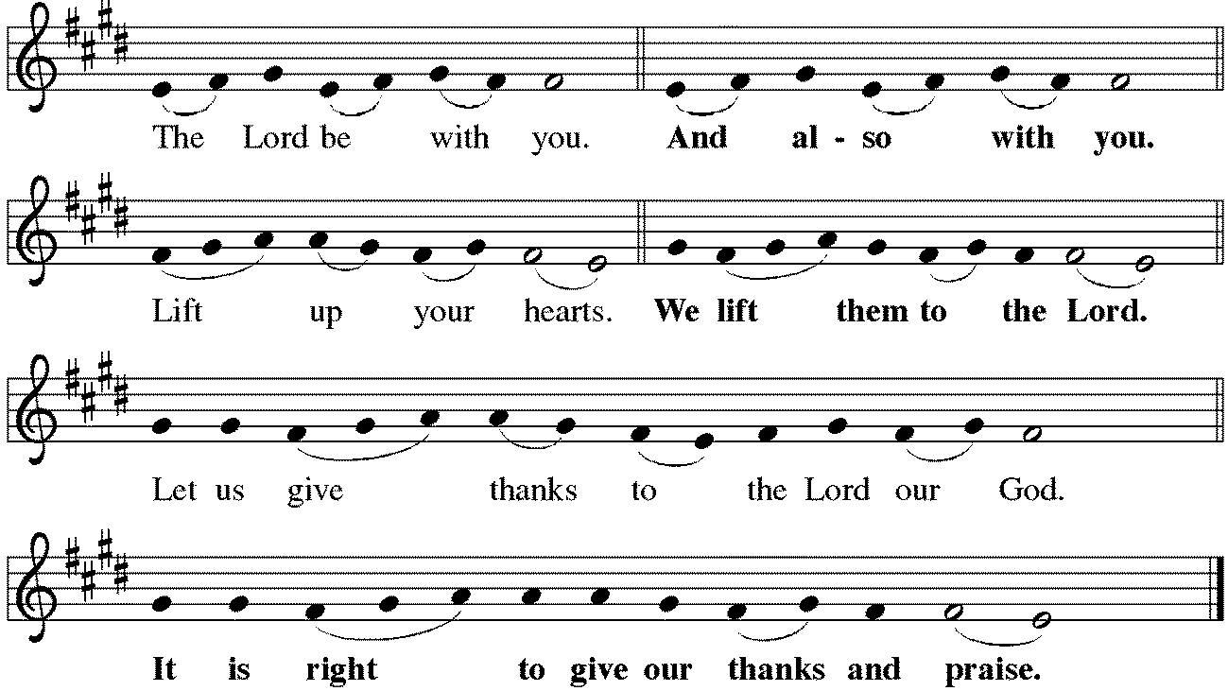

*Preface
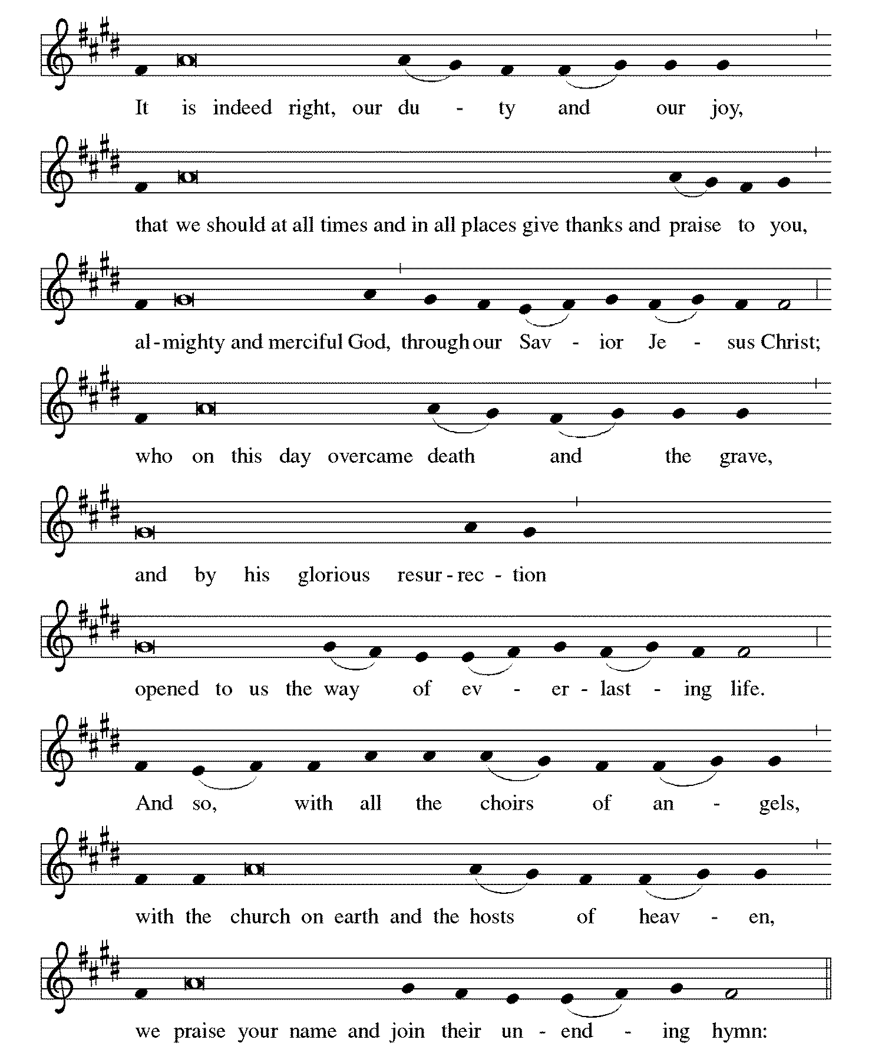

*Sanctus Holy, Holy, Holy
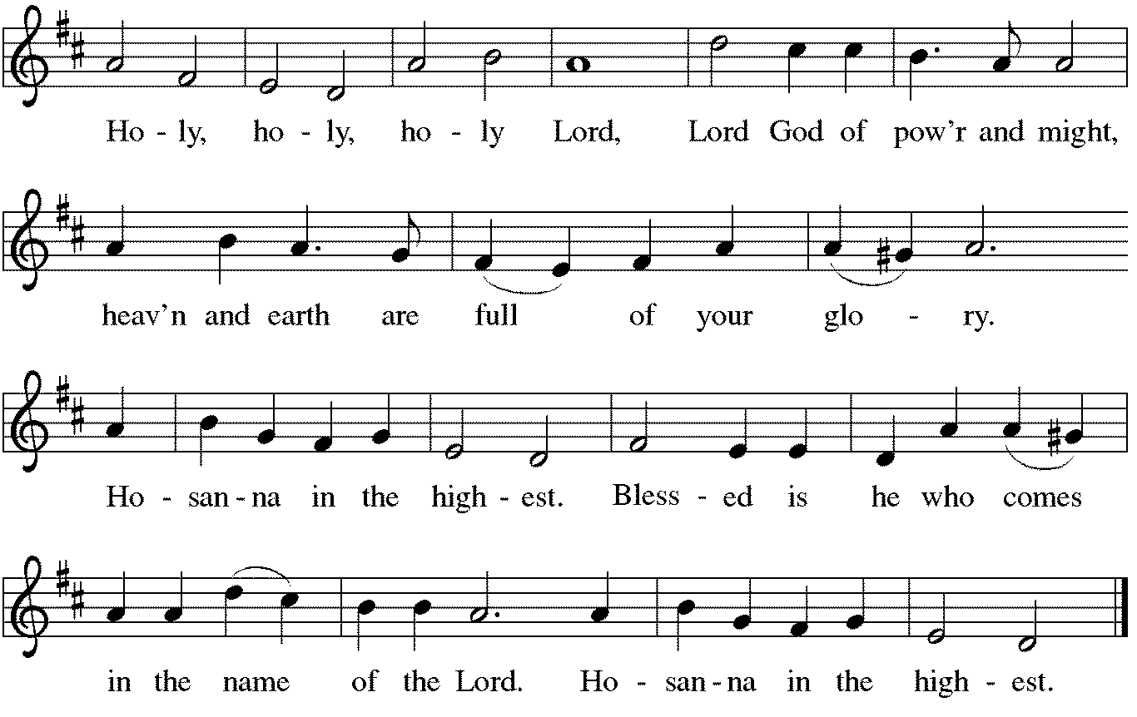

*Thanksgiving at the Table
O God most mighty, O God most merciful,
O God our rock and our salvation,
hear us as we praise, call us to your table, grant us your life.

When the earth was a formless void,
you formed order and beauty.
When Abraham and Sarah were barren,
you sent them a child.
When the Israelites were enslaved,
you led them to freedom.
Ruth faced starvation, David fought Goliath,
and the psalmists cried out for healing,
and full of compassion,
you granted the people your life.

You entered our sorrows in Jesus our brother.
He was born among the poor, he lived under oppression, he wept over the city.
With infinite love, he granted the people your life.

In the night in which he was betrayed,
our Lord Jesus took bread, and gave thanks;
broke it, and gave it to his disciples, saying:
Take and eat; this is my body, given for you.
Do this for the remembrance of me.

Again, after supper, he took the cup, gave thanks,
and gave it for all to drink, saying:
This cup is the new covenant in my blood,
shed for you and for all people for the forgiveness of sin.
Do this for the remembrance of me.

Remembering his death, we cry out Amen. [Amen.]
Celebrating his resurrection, we shout Amen. [Amen.]
Trusting his presence in every time and place, we plead Amen. [Amen.]

O God, you are Breath: send your Spirit on this meal.
O God, you are Bread: feed us with yourself.
O God, you are wine: warm our hearts and make us one.
O God, you are Fire: transform us with hope.
You may lower your communion kit.

O God most majestic,
O God most motherly,
O God our strength and our song,
you show us a vision of a tree of life
with fruits for all and leaves that heal the nations.
Grant us such life, the life of the Father to the Son,
the life of the Spirit of our risen Savior, life in you, now and forever.
Amen.

*The Lord’s Prayer Ecumenical Version
Gathered into one by the Holy Spirit, let us pray as Jesus taught us.
Our Father in heaven, hallowed be your name, your kingdom come, your will be done, on earth as in heaven. Give us today our daily bread. Forgive us our sins as we forgive those who sin against us. Save us from the time of trial and deliver us from evil. For the kingdom, the power, and the glory are yours, now and forever. Amen.

*Invitation to Communion
A feast of love is offered here for you and for all the saints. Be Seated.

If you have difficulty opening your communion, please signal an usher for assistance.
Peel up the clear top seal over the wafer, and hold the wafer up when you are ready.
This is the Body of Christ, given for you. (Eat the bread.) Amen.

Peel up the second foil seal over the juice, and hold your cup up when you are ready.
This is the blood of Christ, shed for you. (Drink the wine/juice.) Amen.
After communion you may place the packaging in the bowl in your pew. The ushers will dispose of these following the service.

Agnus Dei Lamb of God
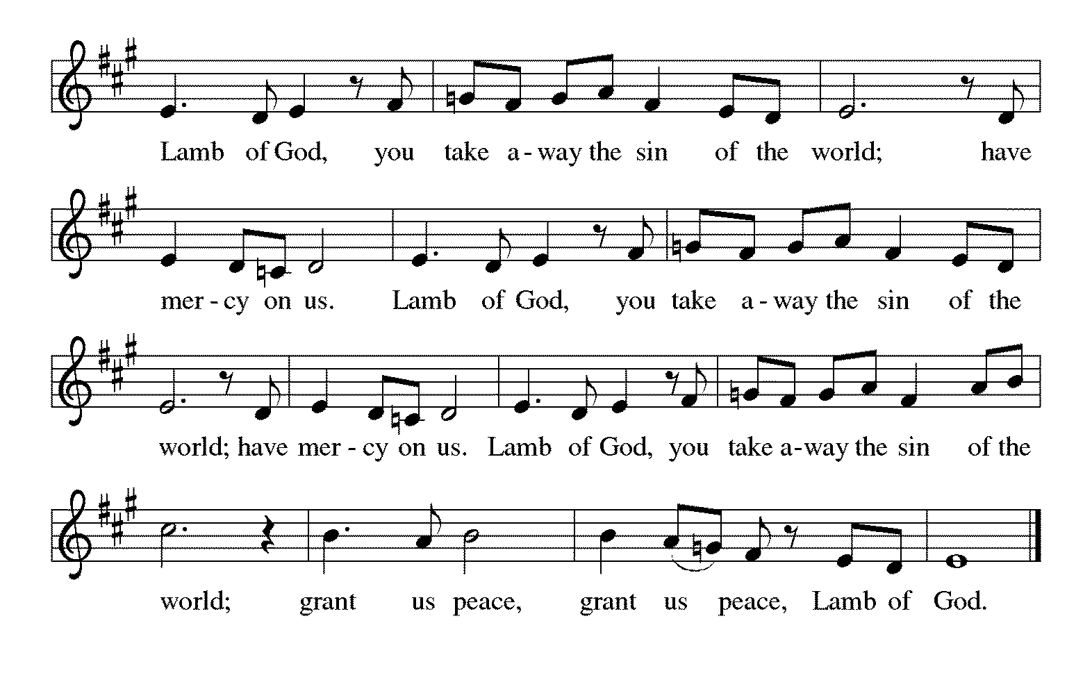

*Please stand as you are able.
*Post-Communion Blessing
The body and blood of our Lord Jesus Christ strengthen you and keep you in his grace. Amen.

*Prayer after Communion
Blessed Jesus, at this table, you have been for us both host and meal.
Now send us forth to extend our tables and to share your gifts
until that day when all feast together at your heavenly banquet.
Amen.
Sending
God blesses us and sends us in mission to the world.
*Blessing
God, the beginning and the end,
who has written your name in the book of life,
☩ bless and keep you in grace and peace
from this time forth and forevermore.
Amen.

*Sending Hymn ELW #880 O God beyond All Praising
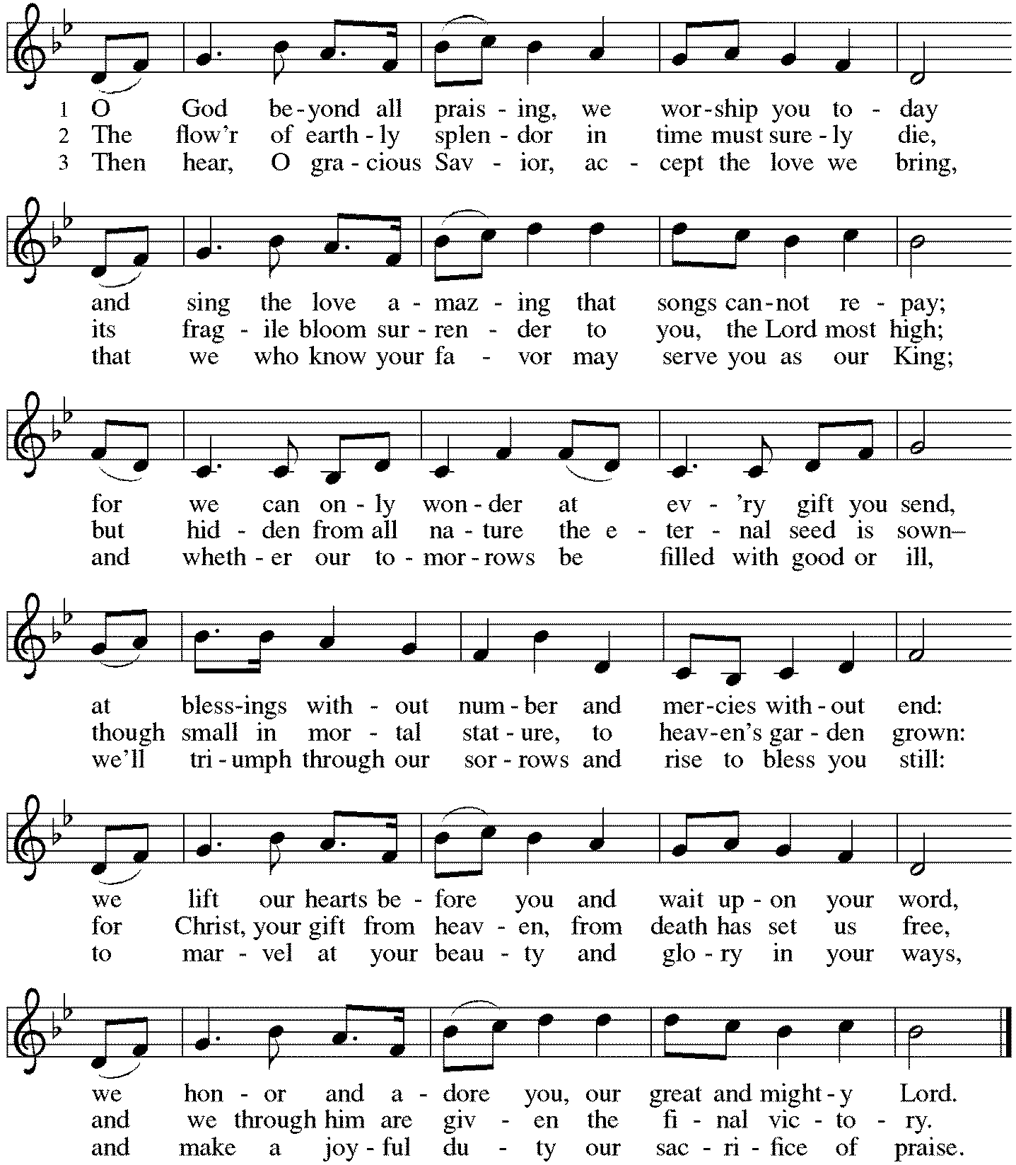

*Sent to the World
Led on by the saints before us,
go in peace to serve the Lord.
Thanks be to God.

Postlude

After the postlude, those who have joined via Zoom may unmute your mics
and share a greeting with your fellow worshippers.

From Sundays and Seasons
v.20190109.1233 Copyright © 2021 Augsburg Fortress. All rights reserved.
Reprinted by permission under Augsburg Fortress Liturgies Annual License #30867.
All rights reserved. Reprinted under OneLicense.net #A-718333.

Assisting in Worship Today
Ministry Associate Becky Ficarella
Minister of Music Bradford Thompson
Altar Guild Linda Kelly
Lector Jeff Nelson
Ushers Tim Kelly, Bruce Lantz, Open
Zoom Mark Hamilton, Jon & Cathy Milleville

Current Prayer Requests
Please keep these people in your prayers and reach out to our sisters and brothers in Christian love. Names will be left on the list for two weeks, unless you indicate that they should remain in our prayers for a longer period.
Name Relationship Prayer For
Rich Davison Member Healing & Strength
Cathy Milleville Member Healing & Strength
Dorothy Tracy Member Healing & Strength
Prayers for our homebound Members
Dolores Nosal, Carol Petersen, Norma Petersen

Council Members Needed: Jon Milleville, Susan Jacobson, and Sue Pagnoni, as nominating committee, will be contacting members about interest in council positions. The nominating committee is now accepting nominations for the following four council positions: three general council members plus one treasurer position. The term begins January 2022 after Grace’s annual meeting.
Terms are for two years and a member may serve two consecutive terms. Prior experience is not necessary. You may serve on council again if you have served in the past. You may nominate yourself or someone else. Please submit nominations to Jon Milleville, Susan Jacobson, Sue Pagnoni, or the church office by November 30.

Versiti Blood Drive: We had 16 registered donors; 3 were deferred and our team collected 16 units. Because of you and the generous donors, up to 48 lives were saved! Thank you! And the best news is that this was one of the best turnouts we have had there at Grace Lutheran Church! Thank you so much! Your partnership is very important to us and we appreciate all that you and your team are doing on a consistent basis to help us save lives. Also, if anyone asks, please tell donors that they will receive their e-gift card via email no later than 7 business days from your drive. Thank you again for ALL you do to help us maintain a healthy blood supply. It means a lot. Camille

Sunday Faith Formation: Worship at 9am, Fellowship (no coffee) at 10am; Faith Formation (children and youth) at 10:15am. Sunday school will meet in the Sanctuary with Becky; Confirmation will meet in the Youth Room with Marty Eastman. Adult Faith Formation is currently not meeting.

The Reverse Advent Food Drive for PADS and Glen Ellyn Food Pantry Returns! We will be collecting items for PADS and GEFP again this year. A list of items can be found online or in the Narthex. Countdown the December days, 1-24 and add an item to your bag each day! Bags can be dropped off to Grace the week leading up to Christmas Eve and also at our Christmas Eve Service at 4:00pm for a blessing. Thank you for your support!

Diaper Drive to Benefit Refugees: Grace will be assisting with a diaper drive in November and December to support Exodus Refugee Resettlement located in Wheaton. Bring your donations to the Narthex. Infant through adult diapers are needed. Thank you for your support!

Press Release from the Glen Ellyn Historical Society - 5th Annual Gingerbread House Contest - on Display Saturday December 4 from 4 to 7pm at Gingerbread and Candlelight: Join our gingerbread house contest with an entry made of Gingerbread, graham crackers or plastic bricks! Individuals, families, groups and businesses are all welcome to participate. No entry fee. Advance registration required. For more information, pick up a registration form in the lobby of the GE History Center at 800 N. Main Street. Or contact us at 630-469-1867 or director@gehs.org. Jean Jeske has registration forms as well and she will be sure you get one. Just call her at 630-469-6372 or jeanmjeske171@gmail.com.

Mondays at 7:00pm, the group is reviewing a new, as yet unpublished, book from Dr. George Byron Koch. The topic is the Jewish Roots of Christianity. Those who want to may meet with us live in the Great Room. We will also provide a Zoom option for those who prefer to participate that way. Kindly contact Mark Hamilton or Vince Hardt if you have not participated before so that we may add you to our Email list.

Pill Bottle Project: Calling all volunteers! After being shut down for over a year, we will meet weekly on Tuesdays from 6-7:30pm in the upstairs kitchen next to the gym. If you would like to volunteer, just show up! Please note: at this time we are not accepting any pill bottles as it will take over a year to get through the current inventory we have. If you have any questions, please contact Mark Hamilton at (630) 841-2941 / mark.hamilton@ifs.com

Bridge 36 Handchime Choir December 1: Open to 3rd-6th Grade Students the 1st and 3rd Wednesday of the month from 4:45-5:45pm. Bridge 36 is a new group for our older elementary students not quite in Confirmation yet! This is open for all 3rd-6th grade students; however we must have a group of at least five consistent students to make this offering work. We will open the day with a devotional and then rehearse hand chime songs for Advent. Our students will eventually present this music during a worship service in December. If this proves to be successful, we will offer this again in January to prepare for Holy Week and Easter services. Please RSVP with Becky Ficarella ASAP if you would like your student to participate.

Social Committee Special Event “Carols & Cookies” Wednesday, December 15th 7pm-8pm: Come join us for a cozy night of music for all! Wear pj’s or comfy clothing, bring along a blanket and find a comfortable place in the Sanctuary to sit and sing carols, listen to the Bridge 36 Handchime Choir, student instrumental solos and more. The Christmas tree and lights will be glowing as we enjoy celebration of the season together. Finish the night with a little goodie bag as you leave to enjoy at home.

Bell Choir rehearsal Wednesdays at 7pm! Come join us for an hour of fun, super low-pressure music-making! Not free on Wednesday evenings? You’re still welcome to join us on Sunday mornings at 8:40! Don’t know how to read music; we can work on that, too! No matter your skill level, there’s room for you! Get excited, my friends! The fun starts now :)

FaithTalk Thursday, December 2, 12:30pm: FaithTalk is a study and conversation group that meets to ask the deep and challenging questions of living our faith in today’s world. We gather the first Thursday of each month from 12:30-2:00 in the lower level of the church. (If you are attending Sue Davison’s exercise class that ends at noon, feel free to bring a sack lunch and meet before class. We’ll start our discussion at 12:30.) Please join us if you’re interested! If you have questions, feel free to reach out to Pastor Melody.

Quilting Ministry: This ministry meets on the 2nd and 4th Tuesday of the month from 9:00-10:00am. Even if you can’t sew but are able to cut fabric into a 9” square we need you! We have 10⁺ bins of fabric waiting to be cut. After quilting you are invited to stay and attend the chair exercise class at 10:00am and if you like to knit hats, scarves, and gloves you can join the Wooly Knitters at 1pm! Everyone is welcome, bring a friend!

Worship Volunteers: We have made it through the first few months of gathering in person with a core group of Lectors, so we are reaching out to see if there are any others who are willing to help with Lector duties in November and December this year. We are currently having all Lectors sit with their own family during the service and only coming forward to do the readings from the lectern. We are not using robes or assisting with communion. Please contact Susan
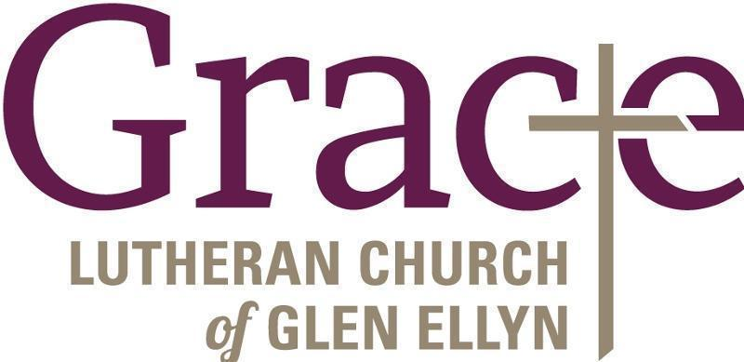

Every Member a Minister and Missionary!

Phone: 630-469-1555 Emergency Pastoral Contact: 630-674-2887
info@graceglenellyn.org www.graceglenellyn.org

Pastor
Rev. Melody Eastman office ext. 14
meastman@graceglenellyn.org

Minister of Music
Bradford Thompson 219-718-8879
bradfordmthompson@gmail.com

Ministry Associate
Becky Ficarella office ext. 17
bficarella@graceglenellyn.org

Office Manager
Barbara Sudds office ext. 10
bsudds@graceglenellyn.org

Parish Counselor
Carole LoGalbo M.S., LCPC 630-668-4594
carolelogalbo@yahoo.com

