Grace Lutheran Church

493 Forest Avenue, Glen Ellyn IL 630.469.1555
www.graceglenellyn.org

Christ the King November 21, 2021

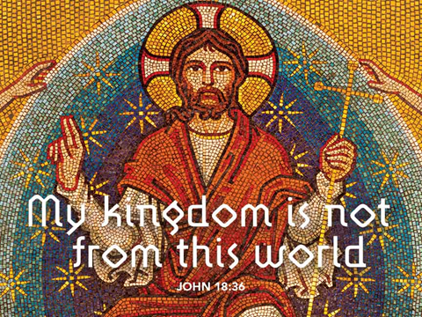

+ Proclaim Christ + Build Community +
+ Serve Our Neighbors +

Introduction
Even after Israel had experienced the vagaries of kings, the people still longed for a true king to set things right. He would have the king’s title of Anointed One (Messiah); he would be the “one like a human being” (Son of Man) given dominion in Daniel’s vision. Jesus is given these titles, even though he is nothing like an earthly king. His authority comes from the truth to which he bears witness, and those who recognize the truth voluntarily listen to him. We look forward to the day he is given dominion, knowing his victory will be the nonviolent victory of love.

Gathering
The Holy Spirit calls us together as the people of God.
Welcome/Announcements

Today is Commitment Sunday.
If you have brought your Commitment Card,
please leave it in the offering plate near the entrance of the sanctuary.
If you forgot to bring yours,
you may pick one up from the table in the narthex.
Thank you for your prayerful support of Christ’s work through Grace!
Prelude

*Please stand as you are able and turn to face the font.
*Confession and Forgiveness
All may make the sign of the cross, the sign marked at baptism, as the presiding minister begins.
In the name of the Father, and of the ☩ Son, and of the Holy Spirit. Amen.

Let us confess our sin in the presence of God and of one another.
Silence is kept for reflection.
Have mercy on us, O God.

We confess that we have sinned against you and against our neighbor. We have built walls instead of tables
and have turned away the stranger. We have sought glory for ourselves and have treasured that which does not satisfy. Help us to love as you love, to welcome those you send, and to treasure mercy and justice. Turn us from our ways to your ways, and free us to serve those in need. Amen.

God, who makes all things new, forgives your sins for ☩ Jesus’ sake and remembers them no more. Lift up your heads and your hearts. Yours is the kingdom of God. Amen.

*Entrance Hymn ELW#838 Beautiful Savior
sts. 1,3,4

*Greeting
The grace of our Lord Jesus Christ, the love of God, and the communion of the Holy Spirit be with you all. And also with you.

*Kyrie
*Prayer of the Day
Almighty and ever-living God, you anointed your beloved Son to be priest and sovereign forever. Grant that all the people of the earth, now divided by the power of sin, may be united by the glorious and gentle rule of Jesus Christ, our Savior and Lord, who lives and reigns with you and the Holy Spirit, one God, now and forever. Amen. Be seated.
Word
God speaks to us in scripture reading, preaching, and song.
First Reading Daniel 7:9-10, 13-14
To the community for whom this passage was written, it seemed as though the oppression they were experiencing would never end. Daniel’s message is: It shall end. The Ancient One, who is judge, will call all nations to account and will give dominion to “one like a human being,” the Messiah.

⁹As I watched, thrones were set in place, and an Ancient One took his throne, his clothing was white as snow, and the hair of his head like pure wool; his throne was fiery flames, and its wheels were burning fire. ¹⁰A stream of fire issued and flowed out from his presence. A thousand thousands served him, and ten thousand times ten thousand stood attending him. The court sat in judgment, and the books were opened. ¹³As I watched in the night visions, I saw one like a human being coming with the clouds of heaven. And he came to the Ancient One and was presented before him. ¹⁴To him was given dominion and glory and kingship, that all peoples, nations, and languages should serve him. His dominion is an everlasting dominion that shall not pass away, and his kingship is one that shall never be destroyed.

Word of God, Word of Life. Thanks be to God.

Psalm Psalm 93
¹The Lord is king, robed in majesty; the Lord is robed in majesty and armed with strength. The Lord has made the world so sure that it cannot be moved.
²Ever since the world began, your throne has been established; you are from everlasting.
³The waters have lifted up, O Lord, the waters have lifted up their voice; the waters have lifted up their pounding waves.
⁴Mightier than the sound of many waters, mightier than the breakers of the sea, mightier is the Lord who dwells on high.
⁵Your testimonies are very sure, and holiness befits your house, O Lord, forever and forevermore.

Second Reading Revelation 1:4b-8
The book of Revelation begins by celebrating the Almighty God, who spans all of time. Similarly, Jesus is celebrated as the firstborn from the dead who rules over the world’s rulers. He is the one whose return we eagerly await.

^{4b}Grace to you and peace from him who is and who was and who is to come, and from the seven spirits who are before his throne, ⁵and from Jesus Christ, the faithful witness, the firstborn of the dead, and the ruler of the kings of the earth.
To him who loves us and freed us from our sins by his blood, ⁶and made us to be a kingdom, priests serving his God and Father, to him be glory and dominion forever and ever. Amen.
⁷Look! He is coming with the clouds; every eye will see him, even those who pierced him; and on his account all the tribes of the earth will wail. So it is to be. Amen. ⁸“I am the Alpha and the Omega,” says the Lord God, who is and who was and who is to come, the Almighty.
Word of God, Word of Life. Thanks be to God.
*Please stand as you are able.
*Gospel Acclamation Alleluia

The holy Gospel according to John. Glory to you, O Lord.

*Gospel John 18:33-37
In John’s gospel, the story of Jesus and Pilate presents two different ways of exercising power: through force or with love.

³³Pilate entered the headquarters again, summoned Jesus, and asked him, “Are you the King of the Jews?” ³⁴Jesus answered, “Do you ask this on your own, or did others tell you about me?” ³⁵Pilate replied, “I am not a Jew, am I? Your own nation and the chief priests have handed you over to me. What have you done?” ³⁶Jesus answered, “My kingdom is not from this world. If my kingdom were from this world, my followers would be fighting to keep me from being handed over to the Jews. But as it is, my kingdom is not from here.” ³⁷Pilate asked him, “So you are a king?” Jesus answered, “You say that I am a king. For this I was born, and for this I came into the world, to testify to the truth. Everyone who belongs to the truth listens to my voice.”

The Gospel of the Lord. Praise to you, O Christ. Be seated.

Sermon The Rev. Melody Eastman

*Please stand as you are able.
*Hymn of the Day ELW #435 Lo! He Comes With Clouds Descending
*Please turn and face the baptismal font
*Holy Baptism of Fiona Skye Ficarella
Parents: Rebecca Ficarella
Mario Ficarella
Sponsors: Jessica Derrico
Colleen Derrico

God, who is rich in mercy and love, gives us a new birth into a living hope through the sacrament of baptism. By water and the Word God delivers us from sin and death and raises us to new life in Jesus Christ. We are united with all the baptized in the one body of Christ, anointed with the gift of the Holy Spirit, and joined in God’s mission for the life of the world.
Sponsors We present Fiona Skye Ficarella for baptism.

Called by the Holy Spirit, trusting in the grace and love of God, do you desire to have Fiona baptized into Christ?
Parents We do.

As you bring your child to receive the gift of baptism, you are entrusted with responsibilities: To live with her among God’s faithful people, to bring her to hear the word of God and to the holy supper, to teach her the Lord’s Prayer, the Creed and the Ten Commandments, to place in her hands the holy scriptures and nurture her in faith and prayer so that she may learn to trust God, proclaim Christ through word and deed, care for others and the world God made, and work for justice and peace.

Do you promise to help Fiona to grow in the Christian faith and life?
Parents We do.

Sponsors, do you promise to nurture Fiona in the Christian faith as you are empowered by God’s Spirit, and to help her live in the covenant of baptism and in communion with the church?
Sponsors We do.

People of God, do you promise to support Fiona and pray for her in her new life in Christ?
Congregation We do.

*Profession of Faith
I ask you to profess your faith in Christ Jesus, reject sin, and confess the faith of the church.

Do you renounce the devil and all the forces that defy God?
Parents/Sponsors I renounce them.

Do you renounce the powers of this world that rebel against God?
Parents/Sponsors I renounce them.

Do you renounce the ways of sin that draw you from God?
Parents/Sponsors I renounce them.

(The congregation joins in the profession of faith)
Do you believe in God the Father?
I believe in God, the Father almighty, creator of heaven and earth.

Do you believe in Jesus Christ, the Son of God?
I believe in Jesus Christ, God's only Son, our Lord, who was conceived by the Holy Spirit, born of the virgin Mary, suffered under Pontius Pilate, was crucified, died, and was buried; he descended to the dead. On the third day he rose again; he ascended into heaven, he is seated at the right hand of the Father, and he will come to judge the living and the dead.

Do you believe in God the Holy Spirit?
I believe in the Holy Spirit, the holy catholic church, the communion of saints, the forgiveness of sins, the resurrection of the body, and the life everlasting.

*Thanksgiving at the Font
The Lord be with you.
And also with you.

Let us give thanks to the Lord our God.
It is right to give our thanks and praise.

We give you thanks, O God, for in the beginning your Spirit moved over the waters and by your Word you created the world, calling forth life in which you took delight. Through the waters of the flood you delivered Noah and his family, and through the sea you led your people Israel from slavery into freedom. At the river your Son was baptized by John and anointed with the Holy Spirit. By the baptism of Jesus' death and resurrection you set us free from the power of sin and death and raise us up to live in you. Pour out your Holy Spirit, the power of your living Word, that those who are washed in the waters of baptism may be given new life. To you be given honor and praise through Jesus Christ our Lord, in the unity of the Holy Spirit, now and forever. Amen.

*Baptism
Fiona Skye, I baptize you in the name of the Father, and of the Son, and of the Holy Spirit.
Amen. You belong to Christ, in whom you have been baptized.

Let us pray. We give you thanks, O God, that through water and the Holy Spirit you give your beloved children new birth, cleanse them from sin, and raise them to eternal life. Sustain Fiona Skye with the gift of your Holy Spirit: the spirit of wisdom and understanding, the spirit of counsel and might, the spirit of knowledge and the fear of the Lord, the spirit of joy in your presence, both now and forever. Amen.

Fiona Skye, child of God, you have been sealed by the Holy Spirit and marked with the cross of Christ forever.
Amen.

*Welcome
Let your light so shine before others that they may see your good works and glorify your Father in heaven.

Let us welcome the newly baptized.
We welcome you into the body of Christ and into the mission we share: join us in giving thanks and praise to God and bearing God's creative and redeeming word to all the world.

*Prayers of Intercession
Eternal God, you hold firm amid the changes of this world. Hear us now as we pray for the church, the world, and everyone in need.
A brief silence.

God, you sent your Son Jesus to testify to the truth. We pray for preachers, missionaries, evangelists, and teachers who carry your forgiveness and love to the world. Fill their words and actions with compassion and kindness so that your truth will shine. God, in your mercy, hear our prayer.

God, you sent your Son Jesus to liberate all of creation. We pray for all living things longing for the freedom to flourish, from ancient trees and wild grasses to endangered animals and rare insects. Give human beings compassionate hearts to care for them. God, in your mercy, hear our prayer.

God, you sent your Son Jesus to lead us into the way of peace. Direct the members of international alliances in choosing a nonviolent path toward the future. Give them the humility and wisdom to make just decisions to benefit all. God, in your mercy, hear our prayer.

God, you sent your Son Jesus to make us into your own people, set free to serve you. We pray for people who serve the well-being of others, especially ministries in our community. Renew them in their work. God, in your mercy, hear our prayer.

God, you sent your Son Jesus to rule in all times and places. We pray for the friends of our congregation who are unable to join our worship in person and for all who are sick and suffering, especially Cathy, Rich, Dorothy, Dolores, Carol, Norma, and those we name before you now. . . Join their prayers with ours and unite them with us in the body of Christ. God, in your mercy, hear our prayer.

God, you sent your Son Jesus to be our beginning and our ending. We give thanks for those whose lives have given us a glimpse of Jesus’ reign of justice and peace. Empower us to join their witness. God, in your mercy, hear our prayer.

God our hope and strength, we entrust to you all for whom we pray. Remain with us always, through Jesus Christ, our Savior. Amen.

*Peace
The peace of Christ be with you always. And also with you.
Please share the peace with others in your household, or by making a sign of peace to those on Zoom. Please remain standing.

Meal
God feeds us with the presence of Jesus Christ.
The Commitment Cards are brought forward and placed on the altar.

* Blessing of Commitments and Offering Prayer
Holy God, the earth is yours and everything in it, yet you have chosen to dwell among your creatures. Receive our commitments to your work in our community through Grace, along with our deep thanks that you have provided for our every need. Bless us in generosity and faith, that we give freely and without anxiety for the sake of your gospel. Bless these commitments; we ask that they become blessing, through us, for all who need you. We ask also that you come among us now in these gifts of bread and wine, and that you strengthen us to be your body for the world through Jesus Christ our Lord. Amen

*Great Thanksgiving
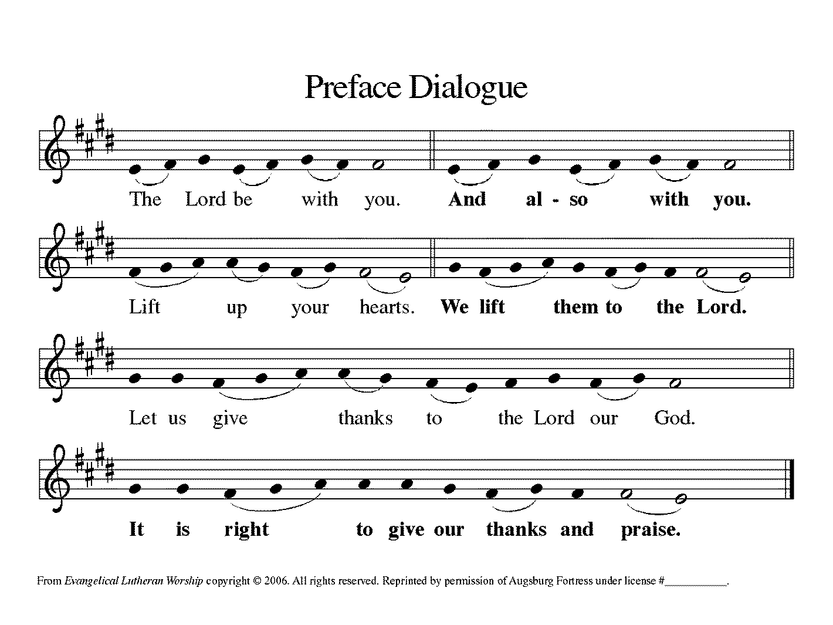

*Preface

*Sanctus Holy, Holy, Holy
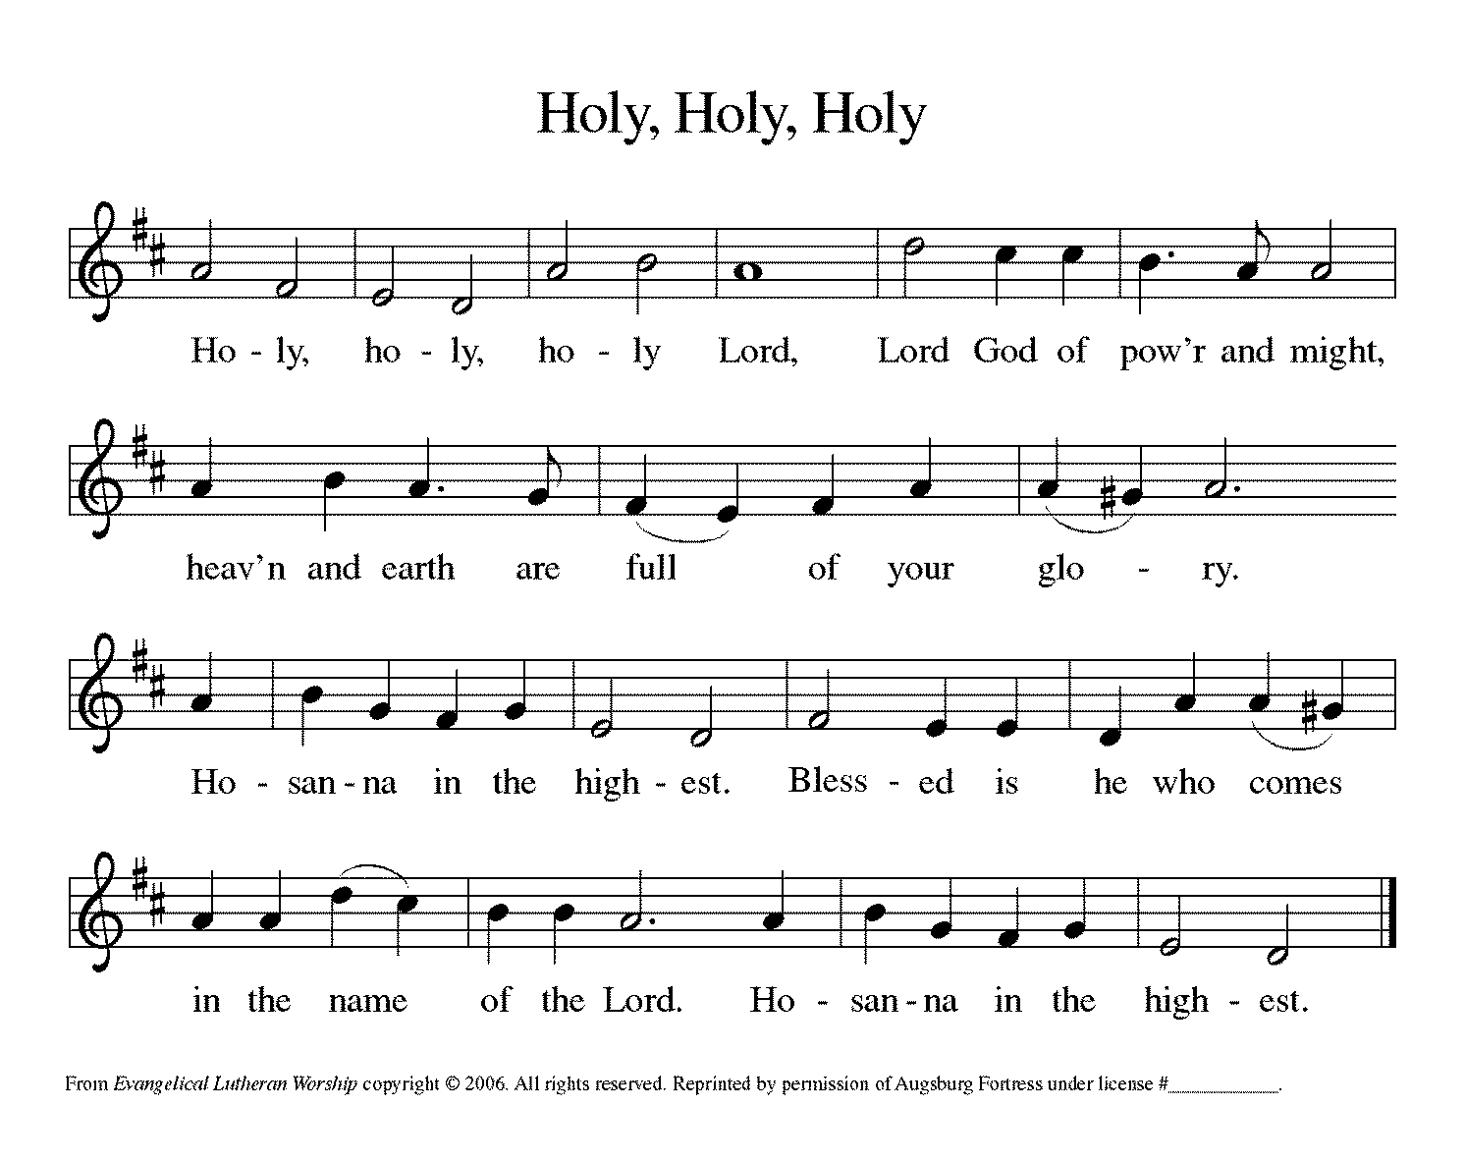

*Thanksgiving at the Table
O God most mighty, O God most merciful, O God our rock and our salvation, hear us as we praise, call us to your table, grant us your life.

When the earth was a formless void, you formed order and beauty. When Abraham and Sarah were barren,
you sent them a child. When the Israelites were enslaved, you led them to freedom. Ruth faced starvation, David fought Goliath, and the psalmists cried out for healing, and full of compassion, you granted the people your life.

You entered our sorrows in Jesus our brother. He was born among the poor, he lived under oppression, he wept over the city. With infinite love, he granted the people your life.

In the night in which he was betrayed, our Lord Jesus took bread, and gave thanks; broke it, and gave it to his disciples, saying: Take and eat; this is my body, given for you. Do this for the remembrance of me.

Again, after supper, he took the cup, gave thanks, and gave it for all to drink, saying: This cup is the new covenant in my blood, shed for you and for all people for the forgiveness of sin. Do this for the remembrance of me.

Remembering his death, we cry out Amen. [Amen.]
Celebrating his resurrection, we shout Amen. [Amen.]
Trusting his presence in every time and place, we plead Amen. [Amen.]

You may hold up your (unopened) communion kit as you are able.
O God, you are Breath: send your Spirit on this meal. O God, you are Bread: feed us with yourself. O God, you are wine: warm our hearts and make us one. O God, you are Fire: transform us with hope.
You may lower your communion kit.

O God most majestic, O God most motherly, O God our strength and our song, you show us a vision of a tree of life with fruits for all and leaves that heal the nations. Grant us such life, the life of the Father to the Son, the life of the Spirit of our risen Savior, life in you, now and forever. Amen.

*The Lord’s Prayer Ecumenical Version
Gathered into one by the Holy Spirit, let us pray as Jesus taught us.
Our Father in heaven, hallowed be your name, your kingdom come, your will be done, on earth as in heaven. Give us today our daily bread. Forgive us our sins as we forgive those who sin against us. Save us from the time of trial and deliver us from evil. For the kingdom, the power, and the glory are yours, now and forever. Amen.

*Invitation to Communion
A feast of love is offered here for you and for all the saints. Be Seated.

If you have difficulty opening your communion, please signal an usher for assistance.
Peel up the clear top seal over the wafer, and hold the wafer up when you are ready.
This is the Body of Christ, given for you. (Eat the bread.) Amen.
Peel up the second foil seal over the juice, and hold your cup up when you are ready.
This is the blood of Christ, shed for you. (Drink the wine/juice.) Amen.
After communion you may place the packaging in the bowl in your pew. The ushers will dispose of these following the service.
Agnus Dei Lamb of God
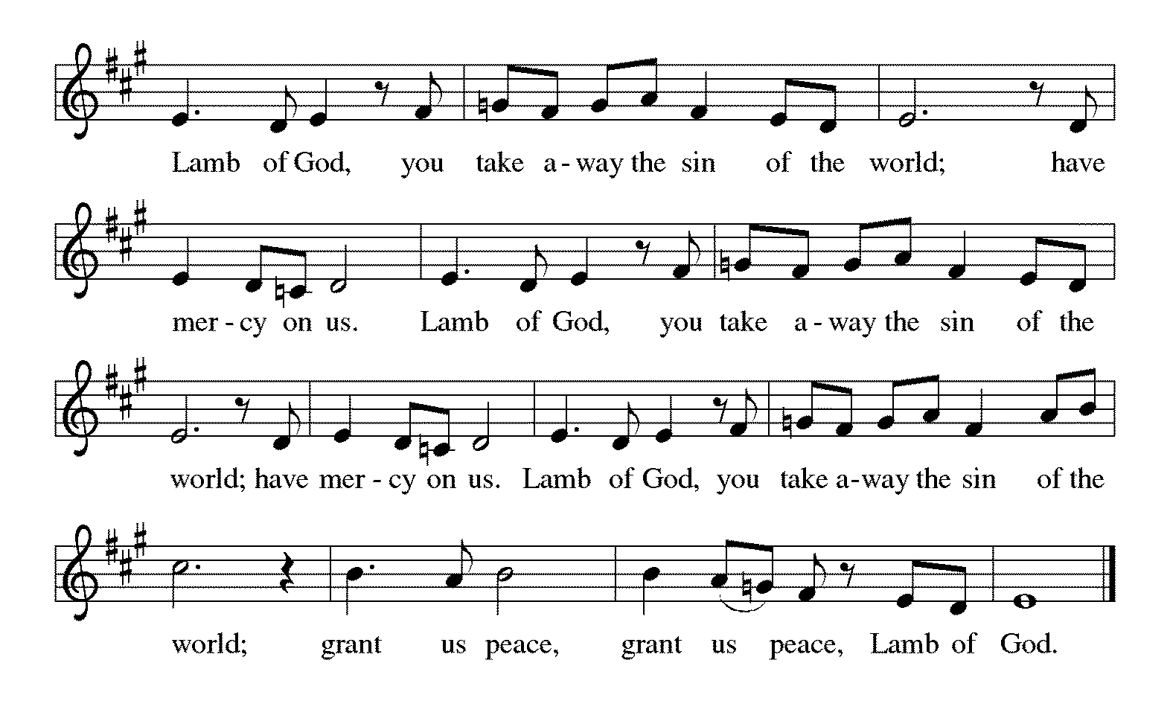

*Please stand as you are able.
*Post-Communion Blessing
The body and blood of our Lord Jesus Christ strengthen you and keep you in his grace. Amen.

*Prayer after Communion
Blessed Jesus, at this table, you have been for us both host and meal. Now send us forth to extend our tables and to share your gifts until that day when all feast together at your heavenly banquet. Amen.

Sending
God blesses us and sends us in mission to the world.
*Blessing
God, the beginning and the end, who has written your name in the book of life, ☩ bless and keep you in grace and peace from this time forth and forevermore. Amen.

*Sending Hymn ELW #439 Soon and Very Soon

*Sent to the World
Led on by the saints before us, go in peace to serve the Lord. Thanks be to God.

Postlude
After the postlude, those who have joined via Zoom may unmute your mics
and share a greeting with your fellow worshippers.
From Sundays and Seasons
v.20190109.1233 Copyright © 2021 Augsburg Fortress. All rights reserved.
Reprinted by permission under Augsburg Fortress Liturgies Annual License #30867.
All rights reserved. Reprinted under OneLicense.net #A-718333.

Flowers are given by The Berta Family in memory of loved ones.

Assisting in Worship Today
Ministry Associate Becky Ficarella
Minister of Music Bradford Thompson
Altar Guild Linda Kelly
Lector Heather Graf
Ushers Tim Kelly, Bruce Lantz, Open
Zoom Mark Hamilton, Jon & Cathy Milleville

Current Prayer Requests
Please keep these people in your prayers and reach out to our sisters and brothers in Christian love. Names will be left on the list for two weeks, unless you indicate that they should remain in our prayers for a longer period.
Name Relationship Prayer For
Rich Davison Member Healing & Strength
Cathy Milleville Member Healing & Strength
Dorothy Tracy Member Healing & Strength
Prayers for our homebound Members
Dolores Nosal, Carol Petersen, Norma Petersen

Council Members Needed: Jon Milleville, Susan Jacobson, and Sue Pagnoni, as nominating committee, will be contacting members about interest in council positions. The nominating committee is now accepting nominations for the following four council positions: three general council members plus one treasurer position. The term begins January 2022 after Grace’s annual meeting.

Terms are for two years and a member may serve two consecutive terms. Prior experience is not necessary. You may serve on council again if you have served in the past. You may nominate yourself or someone else. Please submit nominations to Jon Milleville, Susan Jacobson, Sue Pagnoni, or the church office by Tuesday, November 30.
Sunday Faith Formation: Worship at 9am, Fellowship (no coffee) at 10am. Faith Formation for Children and Youth 10:00-11am in the Sanctuary. Adult Faith Formation is not currently meeting.

The Reverse Advent Food Drive for PADS and Glen Ellyn Food Pantry: We will be collecting items for PADS and GEFP again this year. A list of items can be found online or in the Narthex. Countdown the December days, 1-24 and add an item to your bag each day! Bags can be dropped off to Grace the week leading up to Christmas Eve and also at our Christmas Eve Service at 4:00pm for a blessing. Thank you for your support!

Diaper Drive to Benefit Refugees: Grace will be assisting with a diaper drive in November and December to support Exodus Refugee Resettlement located in Wheaton. Bring your donations to the Narthex. Infant through adult diapers are needed. Thank you for your support!

Thanksgiving Eve Worship at Faith Lutheran Church, Glen Ellyn: November 24, 7:00pm -- Food donations (non-perishable) will be collected for People's Resource Center

Giving Tuesday November 30: Giving Tuesday refers to the Tuesday after U.S. Thanksgiving in the United States. It is a movement to create an international day of charitable giving at the beginning of the Christmas and holiday season.

Christmas Traditions at FaithTalk Thursday, December 2, 12:30pm: FaithTalk is a study and conversation group that meets to ask the deep and challenging questions of living our faith in today’s world. We gather the first Thursday of each month from 12:30-2:00 in the lower level of the church. (If you are attending Sue Davison’s exercise class that ends at noon, feel free to bring a sack lunch and meet before class. We’ll start our discussion at 12:30.) Please join us if you’re interested! If you have questions, feel free to reach out to Pastor Melody.

Social Committee Special Event “Carols & Cookies” Wednesday, December 15th 7pm-8pm: Come join us for a cozy night of music for all! Wear pj’s or comfy clothing, bring along a blanket and find a comfortable place in the Sanctuary to sit and sing carols, listen to the Bridge 36 Handchime Choir, student instrumental solos and more. The Christmas tree and lights will be glowing as we enjoy celebration of the season together. Finish the night with a little goodie bag as you leave to enjoy at home.

Worship Volunteers Wanted: We have made it through the first few months of gathering in person with a core group of Lectors, so we are reaching out to see if there are any others who are willing to help with Lector duties in November and December this year. We are currently having all Lectors sit with their own family during the service and only coming forward to do the readings from the lectern. We are not using robes or assisting with communion. Please contact Susan Jacobson if you are interested.

Press Release from the Glen Ellyn Historical Society - 5th Annual Gingerbread House Contest - on Display Saturday December 4 from 4 to 7pm at Gingerbread and Candlelight: Join our gingerbread house contest with an entry made of Gingerbread, graham crackers or plastic bricks! Individuals, families, groups and businesses are all welcome to participate. No entry fee. Advance registration required. For more information, pick up a registration form in the lobby of the GE History Center at 800 N. Main Street. Or contact us at 630-469-1867 or director@gehs.org. Jean Jeske has registration forms as well and she will be sure you get one. Just call her at 630-469-6372 or jeanmjeske171@gmail.com.

Mondays at 7:00pm, the group is reviewing a new, as yet unpublished, book from Dr. George Byron Koch. The topic is the Jewish Roots of Christianity. Those who want to may meet with us live in the Great Room. We will also provide a Zoom option for those who prefer to participate that way. Kindly contact Mark Hamilton or Vince Hardt if you have not participated before so that we may add you to our Email list.

Pill Bottle Project: Calling all volunteers! After being shut down for over a year, we will meet weekly on Tuesdays from 6-7:30pm in the upstairs kitchen next to the gym. If you would like to volunteer, just show up! Please note: at this time we are not accepting any pill bottles as it will take over a year to get through the current inventory we have. If you have any questions, please contact Mark Hamilton at (630) 841-2941 / mark.hamilton@ifs.com

Bell Choir rehearsal Wednesdays at 7pm! Come join us for an hour of fun, super low-pressure music-making! Not free on Wednesday evenings? You’re still welcome to join us on Sunday mornings at 8:40! Don’t know how to read music; we can work on that, too! No matter your skill level, there’s room for you! Get excited, my friends! The fun starts now :)

Quilting Ministry: This ministry meets on the 2nd and 4th Tuesday of the month from 9:00-10:00am. Even if you can’t sew but are able to cut fabric into a 9” square we need you! We have 10⁺ bins of fabric waiting to be cut. After quilting you are invited to stay and attend the chair exercise class at 10:00am and if you like to knit hats, scarves, and gloves you can join the Wooly Knitters at 1pm! Everyone is welcome, bring a friend!

Boy Scout Troop 45 Annual Pancake Breakfast (DRIVE THRU), Saturday December 4, 8am to Noon at First United Methodist Church, Glen Ellyn. $5

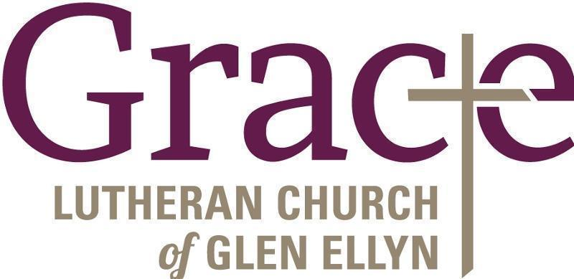

Every Member a Minister and Missionary!

Phone: 630-469-1555 Emergency Pastoral Contact: 630-674-2887
info@graceglenellyn.org www.graceglenellyn.org

Pastor
Rev. Melody Eastman office ext. 14
meastman@graceglenellyn.org

Minister of Music
Bradford Thompson 219-718-8879
bradfordmthompson@gmail.com

Ministry Associate
Becky Ficarella office ext. 17
bficarella@graceglenellyn.org

Office Manager
Barbara Sudds office ext. 10
bsudds@graceglenellyn.org

Parish Counselor
Carole LoGalbo M.S., LCPC 630-668-4594
carolelogalbo@yahoo.com

