Grace Lutheran Church
493 Forest Avenue, Glen Ellyn IL 630.469.1555
www.graceglenellyn.org

Christ the King November 22, 2020

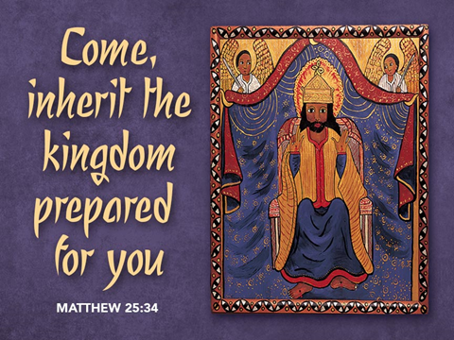

+ Proclaim Christ + Build Community +
+ Serve Our Neighbors +
Introduction
On this final Sunday of the church year our gospel is Jesus’ great story of judgment. In the end, the faithful are those who served Christ by ministering to those who are poor, hungry, naked, sick, or estranged. In the first reading God is the shepherd who seeks the lost, weak, and injured and feeds them with justice. We gather this day to celebrate the reign of Christ and his victory over death, yet we await the consummation of all things yet to come. Acknowledging Christ as our merciful ruler, we go forth that his reign may be known in our loving words and deeds.

Gathering
The Holy Spirit calls us together as the people of God.

Prelude

Confession and Forgiveness
All may make the sign of the cross, the sign marked at baptism,
as the worship leader begins.
Blessed be the holy Trinity, ☩ one God,
in whose image we are made,
who claims us and calls us beloved.
Amen.
Silence is kept for reflection.

Holy One,
we confess that we are not awake for you.
We are not faithful in using your gifts.
We forget the least of our siblings.
We do not see your beautiful image in one another.
We are infected by sin
that divides your beloved community.
Open our hearts to your coming,
open our eyes to see you in our neighbor,
open our hands to serve your creation. Amen.

Beloved, we are God’s children,
and Jesus, our Beloved, opens the door to us.
Through ☩ Jesus we are forgiven,
by Jesus we are welcome,
in Jesus we are called to rejoice!
Let us live in the promises prepared for us
from the foundation of the world.
Amen.
Opening Hymn (Please mute your mic) ELW#821 Shout to the Lord
(You may unmute your mic)
Greeting
The grace of our Lord Jesus Christ, the love of God, and the communion of the Holy Spirit be with you all. And also with you.

Prayer of the Day
O God of power and might, your Son shows us the way of service, and in him we inherit the riches of your grace. Give us the wisdom to know what is right and the strength to serve the world you have made, through Jesus Christ, our Savior and Lord, who lives and reigns with you and the Holy Spirit, one God, now and forever. Amen.

Word
God speaks to us in scripture reading, preaching, and song.

First Lesson Ezekiel 34:11-16, 20-24
Because Israel’s kings proved to be bad shepherds, Ezekiel declares that the Lord will assume the role of shepherd in Israel. The Lord will also set over them a shepherd-messiah, “my servant David,” who will feed and care for the people.

¹¹Thus says the Lord God: I myself will search for my sheep, and will seek them out. ¹²As shepherds seek out their flocks when they are among their scattered sheep, so I will seek out my sheep. I will rescue them from all the places to which they have been scattered on a day of clouds and thick darkness. ¹³I will bring them out from the peoples and gather them from the countries, and will bring them into their own land; and I will feed them on the mountains of Israel, by the watercourses, and in all the inhabited parts of the land. ¹⁴I will feed them with good pasture, and the mountain heights of Israel shall be their pasture; there they shall lie down in good grazing land, and they shall feed on rich pasture on the mountains of Israel. ¹⁵I myself will be the shepherd of my sheep, and I will make them lie down, says the Lord God. ¹⁶I will seek the lost, and I will bring back the strayed, and I will bind up the injured, and I will strengthen the weak, but the fat and the strong I will destroy. I will feed them with justice.
²⁰Therefore, thus says the Lord God to them: I myself will judge between the fat sheep and the lean sheep. ²¹Because you pushed with flank and shoulder, and butted at all the weak animals with your horns until you scattered them far and wide, ²²I will save my flock, and they shall no longer be ravaged; and I will judge between sheep and sheep.
²³I will set up over them one shepherd, my servant David, and he shall feed them: he shall feed them and be their shepherd. ²⁴And I, the Lord, will be their God, and my servant David shall be prince among them; I, the Lord, have spoken.

Word of God, Word of Life. Thanks be to God.

The Psalm Read responsively by verse Psalm 95:1-7a
¹Come, let us sing to the Lord; let us shout for joy to the rock of our salvation.
²Let us come before God’s presence with thanksgiving and raise a loud shout to the Lord with psalms.
³For you, Lord, are a great God, and a great ruler above all gods.
⁴In your hand are the caverns of the earth; the heights of the hills are also yours.
⁵The sea is yours, for you made it, and your hands have molded the dry land.
⁶Come, let us worship and bow down, let us kneel before the Lord our maker.
^{7a}For the Lord is our God, and we are the people of God’s pasture and the sheep of God’s hand.

Second Lesson Ephesians 1:15-23
In this passage, God is praised for revealing ultimate divine power in raising Jesus from the dead. The resurrected, exalted Christ is Lord of both the church and the entire universe, now and in the age to come.

¹⁵I have heard of your faith in the Lord Jesus and your love toward all the saints, and for this reason ¹⁶I do not cease to give thanks for you as I remember you in my prayers. ¹⁷I pray that the God of our Lord Jesus Christ, the Father of glory, may give you a spirit of wisdom and revelation as you come to know him, ¹⁸so that, with the eyes of your heart enlightened, you may know what is the hope to which he has called you, what are the riches of his glorious inheritance among the saints, ¹⁹and what is the immeasurable greatness of his power for us who believe, according to the working of his great power. ²⁰God put this power to work in Christ when he raised him from the dead and seated him at his right hand in the heavenly places, ²¹far above all rule and authority and power and dominion, and above every name that is named, not only in this age but also in the age to come. ²²And he has put all things under his feet and has made him the head over all things for the church, ²³which is his body, the fullness of him who fills all in all.

Word of God, Word of Life. Thanks be to God.

Gospel Acclamation
Alleluia, Lord, to whom shall we go? You have the words of eternal life. Alleluia.

The holy Gospel according to Matthew. Glory to you, O Lord.

Gospel Matthew 25:31-46
Jesus compares himself to a king who moves among his subjects to see how he is treated: what is done for the least of those who belong to his family is truly done for him.

[Jesus said to the disciples:] ³¹“When the Son of Man comes in his glory, and all the angels with him, then he will sit on the throne of his glory. ³²All the nations will be gathered before him, and he will separate people one from another as a shepherd separates the sheep from the goats, ³³and he will put the sheep at his right hand and the goats at the left. ³⁴Then the king will say to those at his right hand, ‘Come, you that are blessed by my Father, inherit the kingdom prepared for you from the foundation of the world; ³⁵for I was hungry and you gave me food, I was thirsty and you gave me something to drink, I was a stranger and you welcomed me, ³⁶I was naked and you gave me clothing, I was sick and you took care of me, I was in prison and you visited me.’ ³⁷Then the righteous will answer him, ‘Lord, when was it that we saw you hungry and gave you food, or thirsty and gave you something to drink? ³⁸And when was it that we saw you a stranger and welcomed you, or naked and gave you clothing? ³⁹And when was it that we saw you sick or in prison and visited you?’ ⁴⁰And the king will answer them, ‘Truly I tell you, just as you did it to one of the least of these who are members of my family you did it to me.’ ⁴¹Then he will say to those at his left hand, ‘You that are accursed, depart from me into the eternal fire prepared for the devil and his angels; ⁴²for I was hungry and you gave me no food, I was thirsty and you gave me nothing to drink, ⁴³I was a stranger and you did not welcome me, naked and you did not give me clothing, sick and in prison and you did not visit me.’ ⁴⁴Then they also will answer, ‘Lord, when was it that we saw you hungry or thirsty or a stranger or naked or sick or in prison, and did not take care of you?’ ⁴⁵Then he will answer them, ‘Truly I tell you, just as you did not do it to one of the least of these, you did not do it to me.’ ⁴⁶And these will go away into eternal punishment, but the righteous into eternal life.”

The Gospel of the Lord. Praise to you, O Christ.

(Please mute your mic)
Sermon The Rev. Melody Eastman

(You may unmute your mic)

Apostles’ Creed

With the whole church, let us confess our faith.
I believe in God, the Father almighty, creator of heaven and earth. I believe in Jesus Christ, God's only Son, our Lord, who was conceived by the Holy Spirit, born of the virgin Mary, suffered under Pontius Pilate, was crucified, died, and was buried; he descended to the dead. On the third day he rose again; he ascended into heaven, he is seated at the right hand of the Father, and he will come to judge the living and the dead. I believe in the Holy Spirit, the holy catholic church, the communion of saints, the forgiveness of sins, the resurrection of the body, and the life everlasting. Amen.

Prayers of Intercession
Longing for Christ’s reign to come among us, we pray for the outpouring of God’s power on the church, the world, and all in need.
A brief silence.

Sovereign of all, train our ears to hear your cry in the needs of those around us. Bless all social ministries of the church through which we seek to serve others as we ourselves have been served. Hear us, O God. Your mercy is great.

You cause rain to fall on the just and unjust alike. Direct our use of creation to provide for the needs of all people in ways that are sustainable for the earth. Hear us, O God. Your mercy is great.

Bring peace to every place where conflict rages. Grant opportunities for ending divisions among us and usher in your reign of unity and reconciliation. Hear us, O God. Your mercy is great.

Heal the sinful divisions we erect between us and release us from systems of oppression and prejudice. Restore our capacity to see your image in those whose dignity we have stripped away. Hear us, O God. Your mercy is great.

Pour out the gifts of your Spirit on children and youth throughout the church. Sustain those who work in children’s ministry, youth ministry, and campus ministry as they nurture the gifts of young people. Hear us, O God. Your mercy is great.
Here other intercessions may be offered.

Thank you for saints now departed who fed the hungry, clothed the naked, and tended to the sick. Inspire us by their example, that we may see your presence in those in need around us. Hear us, O God. Your mercy is great.

Receive our prayers in the name of Jesus Christ our Savior, until that day when you gather all creation around your throne where you will reign forever and ever. Amen.

(If your House Church is celebrating Communion, refer to that liturgy here.)

The Lord’s Prayer Ecumenical Version
Gathered into one by the Holy Spirit, let us pray as Jesus taught us.
Our Father in heaven, hallowed be your name, your kingdom come, your will be done, on earth as in heaven. Give us today our daily bread. Forgive us our sins as we forgive those who sin against us. Save us from the time of trial and deliver us from evil. For the kingdom, the power and the glory are yours, now and forever. Amen.

Sending
God blesses us and sends us in mission to the world.
Blessing
May the God of all creation, in whose image we are made, who claims us and calls us beloved,
who strengthens us for service, give us reason to rejoice and be glad! The blessing of God,
Sovereign, ☩ Savior, and Spirit, be with us today and always. Amen.

Sending Hymn (Please mute your mic) ELW #439 Soon and Very Soon
(You may unmute your mic)

Sent to the World
Beloved of God, go in peace to love and serve the Lord. Thanks be to God.

From Sundays and Seasons v.20190109.1233 Copyright © 2020 Augsburg Fortress. All rights reserved.
Reprinted by permission under Augsburg Fortress Liturgies Annual License #30867.
Reprinted under OneLicense.net #A-718333.

Current Prayer Requests
Name Relation to Grace Prayers For
Marilyn Goodrich Member Healing & Strength
Chris Danly Son of Mark & Pat Danly Healing & Strength
Sigrid Elliott Friend of Grace Healing & Strength
Dorothy Tracy Member Healing & Strength
Prayers for our homebound Members
Anita Blakemore, Evelyn Elson, Carol Petersen, Norma Petersen, Dorothy Stein

Weekly Announcements
All-Synod Worship Service with Metro Chicago Bishop Yehiel Curry Preaching next Sunday, November 29 at 10:30 a.m. Watch for the News From Grace e-blast to get the link for this service over Zoom, or call the office for the info. This is a great chance to hear our synod bishop and connect with congregations throughout the synod; it should be a wonderful service!

Contributions to Grace: You may continue to mail your contributions to the church office; have your bank mail your contribution to the church office; or contribute on-line through Grace’s website. Please know, pandemic or no, our mission continues! Thank you for your continued support of our ministries at Grace Lutheran.

Financial Commitment Cards: Please return your financial commitment/pledge to Grace for 2021 either by mail; through Grace’s website; or send an email to bsudds@graceglenellyn.org. Thank you. Only 25 cards have been returned to date.

House Church Worship via phone or internet every Sunday morning at 9:30am! We currently have five “House Churches” of worshipping members (each House Church consisting of 6-8 members/families meeting via Zoom or calling in by phone.) If you are unsure how to sign on, go ahead and register and let us know you need some help; we’ll walk you through it! We would be so blessed to have you join us. Register online for a House Church at graceglenellyn.org (on the main page Announcements) or contact Becky Ficarella directly at 847-347-0928 or bficarella@graceglenellyn.org.

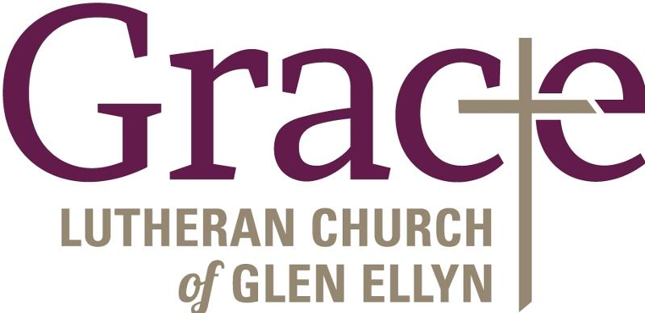
Every Member a Minister and Missionary!

Phone: 630-469-1555 Emergency Pastoral Contact: 630-674-2887
info@graceglenellyn.org www.graceglenellyn.org

Pastor
Rev. Melody Eastman office ext. 14
meastman@graceglenellyn.org

Minister of Music
Bradford Thompson 219-718-8879
bradfordmthompson@gmail.com

Ministry Associate
Becky Ficarella office ext. 17
bficarella@graceglenellyn.org

Office Manager
Barbara Sudds office ext. 10
bsudds@graceglenellyn.org

Parish Counselor
Carole LoGalbo M.S., LCPC 630-668-4594
carolelogalbo@yahoo.com

