Grace Bell Choir!!!

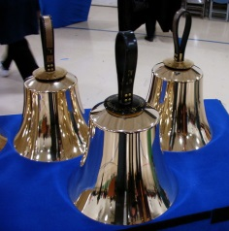
Bell Choir rehearsal, weekly at 7pm on Wednesdays! Come join us for an hour of fun, super low-pressure music-making! Not free on Wednesday evenings? You’re still welcome to join us on Sunday mornings at 8:40! Don’t know how to read music; we can work on that, too! No matter your skill level, there’s room for you! Get excited, my friends! The fun starts now :)

Grace Adult Vocal Choir

This is currently on hold due to the concern of our choir members gathering to sing together maskless at this time.

Generations (Singing & Instrumental) Choir
Wednesday, November 17, 6-7:15pm

All Ages Event: Come join Becky and Bradford for a new twist on praising with music! We will find new and creative ways to sing or play a song with instruments and movement in a socially distanced way. This is open to ANY member of Grace of ANY age (yep, your baby can shake a rattle too!) Please RSVP with Becky Ficarella so that I can communicate with you any updates for this event regarding dinner, etc.

Bridge 36 Hand Chime Choir
Wednesdays, October 6th & 20th 4:45-5:45pm

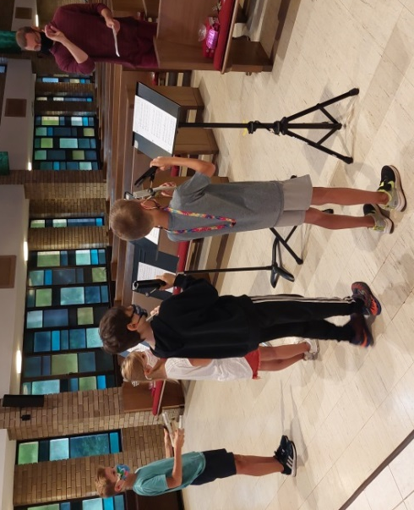
Bridge 36 is a new group for our older elementary students not quite in Confirmation yet! This is open for all 3rd-6th grade students; however we must have a group of at least five consistent students to make this offering work. We will open the day with a devotional and then rehearse hand chime songs for Advent. Our students will eventually present this music during a worship service in December. If this proves to be successful, we will offer this again in January to prepare for Holy Week and Easter services. Please RSVP with Becky Ficarella ASAP if you would like your student to participate.

