Grace Lutheran Church

493 Forest Avenue, Glen Ellyn IL 630.469.1555
www.graceglenellyn.org

Second Sunday of Advent December 5, 2021

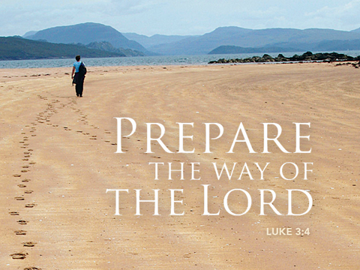

+ Proclaim Christ + Build Community +
+ Serve Our Neighbors +

Introduction
Forerunners and messengers advance the advent of our God. While John the baptizer’s voice in the wilderness may be the principal focus of the day, Malachi’s prophecy could as easily herald the coming Christ as forerunner of the Lord of hosts. Finally all the baptized are called to participate in the sharing of the gospel. In so doing we prepare the way for the coming of Jesus and assist all people in capturing a vision of the “salvation of God.”

Gathering
The Holy Spirit calls us together as the people of God.
Welcome/Announcements

Prelude

*Please stand as you are able and turn to face the font.
*Confession and Forgiveness
All may make the sign of the cross, the sign marked at baptism, as the presiding minister begins.
Blessed be the holy Trinity, ☩ one God, who alone does wonders, who lifts up the lowly, who fills the hungry with good things. Amen.

Let us confess our sin, trusting in the tender mercy of our God.
Silence is kept for reflection.
God for whom we wait, in the presence of one another, we confess our sin before you. We fail in believing that your good news is for us. We falter in our call to tend your creation. We find our sense of self in material wealth. We fear those different from ourselves. We forget that we are your children and turn away from your love. Forgive us, Blessed One, and assure us again of your saving grace. Amen.

God, in Christ Jesus, has looked with favor upon you! Through the power of the Holy Spirit, ☩ your sins are forgiven. You are children of the Most High, inheritors of the eternal promise, and recipients of divine mercy.
God strengthens you anew to follow the way of peace. Amen.

*Entrance Rite Hymn #254 Come Thou Long Expected Jesus, st. 1
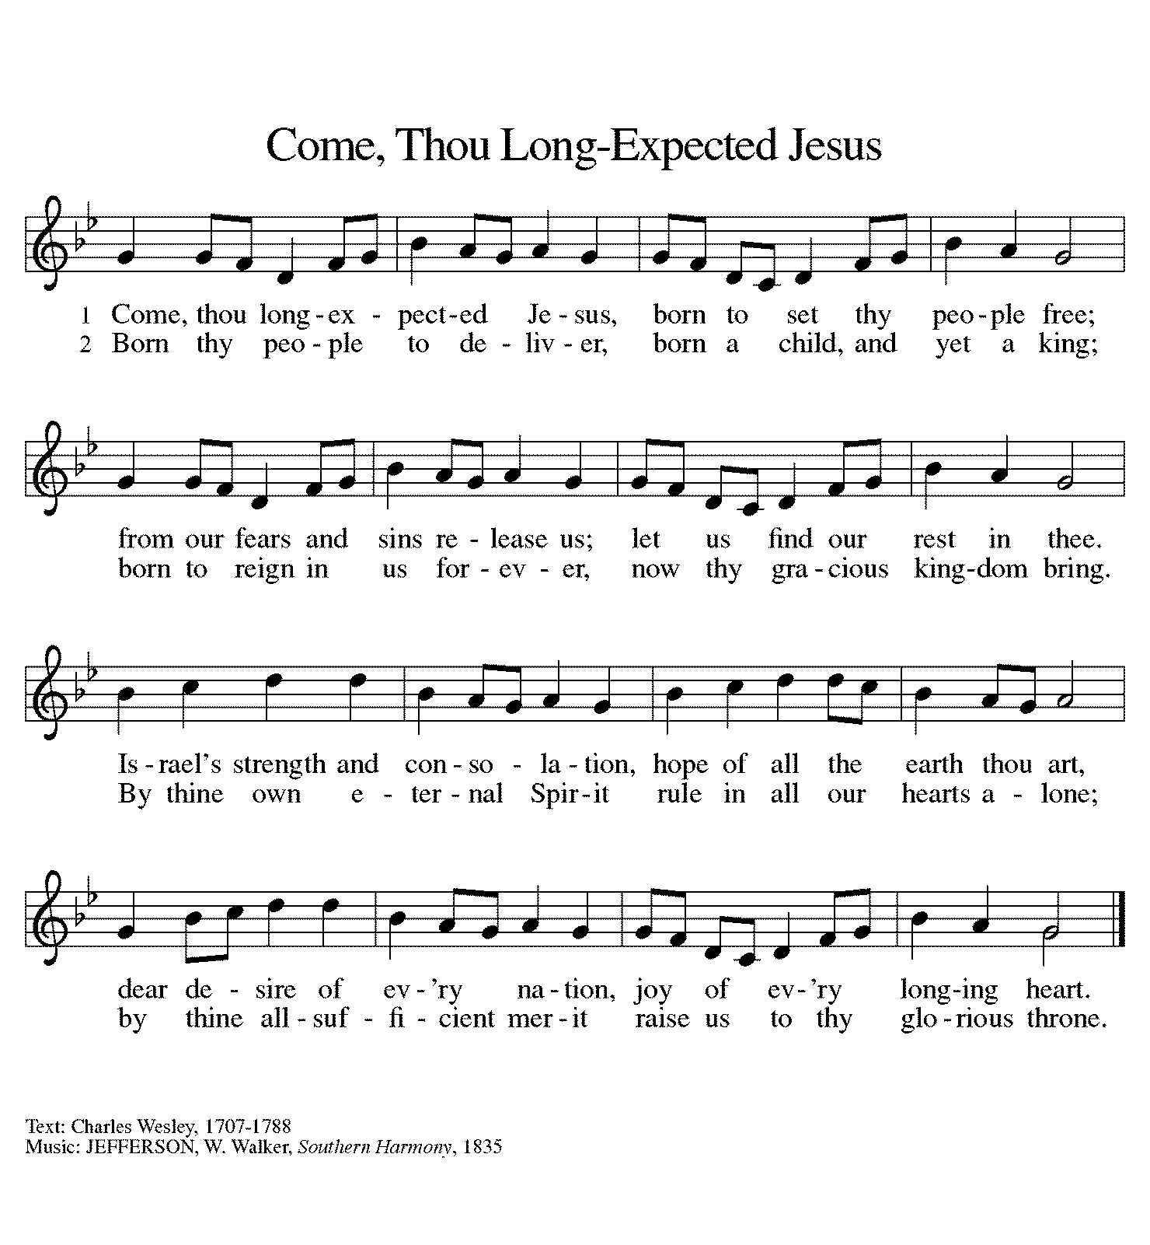
Prayer and Lighting of the Advent Wreath
We praise you, O God, for this circle of light that marks our days of preparation for Christ’s advent. As we light the candles on this wreath, kindle within us the fire of your Spirit. Remind us that the darkness of this season holds the rich and abundant blessing of your unseen presence. Fill us, so that we may guide and encourage those who do not know where to find you. Reform us with your grace, that we may welcome others as you have welcomed us. Grant this through Christ our Lord, whose coming is certain and whose day draws near. Amen.

Hymn #254 Come, Thou Long-Expected Jesus, st. 2
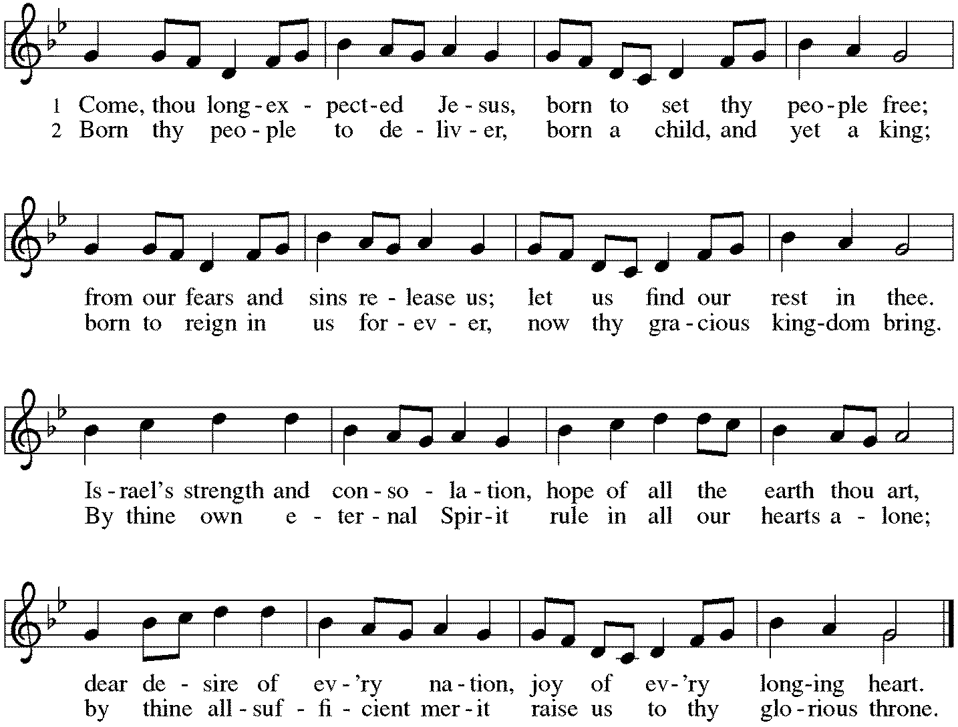

*Greeting
The grace of our Lord Jesus Christ, the love of God, and the communion of the Holy Spirit be with you all.
And also with you.

*Prayer of the Day
Stir up our hearts, Lord God, to prepare the way of your only Son. By his coming give to all the people of the world knowledge of your salvation; through Jesus Christ, our Savior and Lord, who lives and reigns with you and the Holy Spirit, one God, now and forever. Amen. Be seated.

Word
God speaks to us in scripture reading, preaching, and song.
First Reading Malachi 3:1-4
God announces a covenant with Israel. A messenger like Malachi (his name means “my messenger”) will prepare the way for the coming of the Lord by purifying and refining God’s people, as silver and gold are refined.
¹See, I am sending my messenger to prepare the way before me, and the Lord whom you seek will suddenly come to his temple. The messenger of the covenant in whom you delight—indeed, he is coming, says the Lord of hosts. ²But who can endure the day of his coming, and who can stand when he appears?
For he is like a refiner’s fire and like fullers’ soap; ³he will sit as a refiner and purifier of silver, and he will purify the descendants of Levi and refine them like gold and silver, until they present offerings to the Lord in righteousness. ⁴Then the offering of Judah and Jerusalem will be pleasing to the Lord as in the days of old and as in former years.

Word of God, Word of Life. Thanks be to God.

Psalm Luke 1:68-79
⁶⁸Blessed are you, Lord, the God of Israel, you have come to your people and set them free.
⁶⁹You have raised up for us a mighty Savior, born of the house of your servant David.
⁷⁰Through your holy prophets, you promised of old to save us from our enemies, ⁷¹from the hands of all who hate us,
⁷²to show mercy to our forebears, and to remember your holy covenant.
⁷³This was the oath you swore to our father Abraham: ⁷⁴to set us free from the hands of our enemies,
free to worship you without fear, ⁷⁵holy and righteous before you, all the days of our life.
⁷⁶And you, child, shall be called the prophet of the Most High, for you will go before the Lord to prepare the way,
⁷⁷to give God’s people knowledge of salvation by the forgiveness of their sins.
⁷⁸In the tender compassion of our God the dawn from on high shall break upon us,
⁷⁹to shine on those who dwell in darkness and in the shadow of death, and to guide our feet into the way of peace.

Second Reading Philippians 1:3-11
The apostle Paul was the pastor of many new churches. He writes in this letter about his joy to be in partnership with the Christians of Philippi. Listen to how tender-hearted Paul, sometimes a stern preacher, is with his friends as he encourages them to grow in love and knowledge.

³I thank my God every time I remember you, ⁴constantly praying with joy in every one of my prayers for all of you, ⁵because of your sharing in the gospel from the first day until now. ⁶I am confident of this, that the one who began a good work among you will bring it to completion by the day of Jesus Christ. ⁷It is right for me to think this way about all of you, because you hold me in your heart, for all of you share in God’s grace with me, both in my imprisonment and in the defense and confirmation of the gospel. ⁸For God is my witness, how I long for all of you with the compassion of Christ Jesus. ⁹And this is my prayer, that your love may overflow more and more with knowledge and full insight ¹⁰to help you to determine what is best, so that in the day of Christ you may be pure and blameless, ¹¹having produced the harvest of righteousness that comes through Jesus Christ for the glory and praise of God.

Word of God, Word of Life. Thanks be to God.

*Please stand as you are able.
*Gospel Acclamation Hymn #253 He Came Down, sts. 1, 2
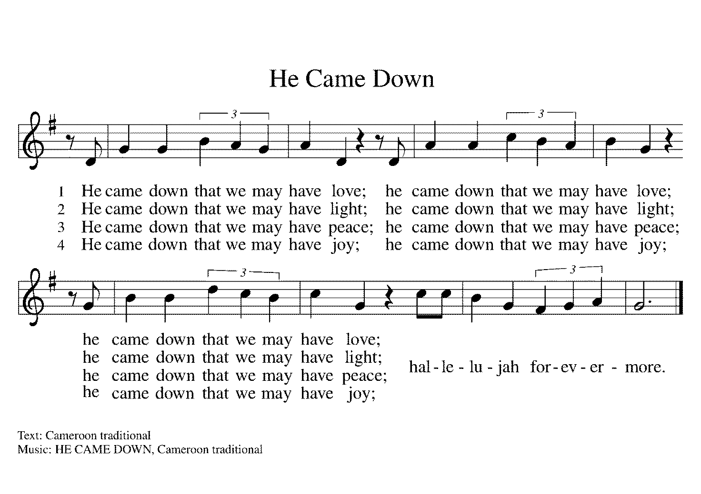

The holy Gospel according to Luke. Glory to you, O Lord.

*Gospel Luke 3:1-6
John the Baptist is a herald of Jesus, whose way is prepared by “repentance for the forgiveness of sins.” As we hear the careful record of human leaders, we sense the spectrum of political and religious authority that will be challenged by this coming Lord.

¹In the fifteenth year of the reign of Emperor Tiberius, when Pontius Pilate was governor of Judea, and Herod was ruler of Galilee, and his brother Philip ruler of the region of Ituraea and Trachonitis, and Lysanias ruler of Abilene, ²during the high priesthood of Annas and Caiaphas, the word of God came to John son of Zechariah in the wilderness. ³He went into all the region around the Jordan, proclaiming a baptism of repentance for the forgiveness of sins, ⁴as it is written in the book of the words of the prophet Isaiah, “The voice of one crying out in the wilderness: ‘Prepare the way of the Lord, make his paths straight. ⁵Every valley shall be filled, and every mountain and hill shall be made low, and the crooked shall be made straight, and the rough ways made smooth; ⁶and all flesh shall see the salvation of God.’ ”

The Gospel of the Lord. Praise to you, O Christ.

Hymn #253 He Came Down, sts. 3,4

Be seated.

Sermon The Rev. Melody Eastman

*Please stand as you are able.
*Hymn of the Day ELW #249 On Jordan’s Bank the Baptist’s Cry
sts. 1-3
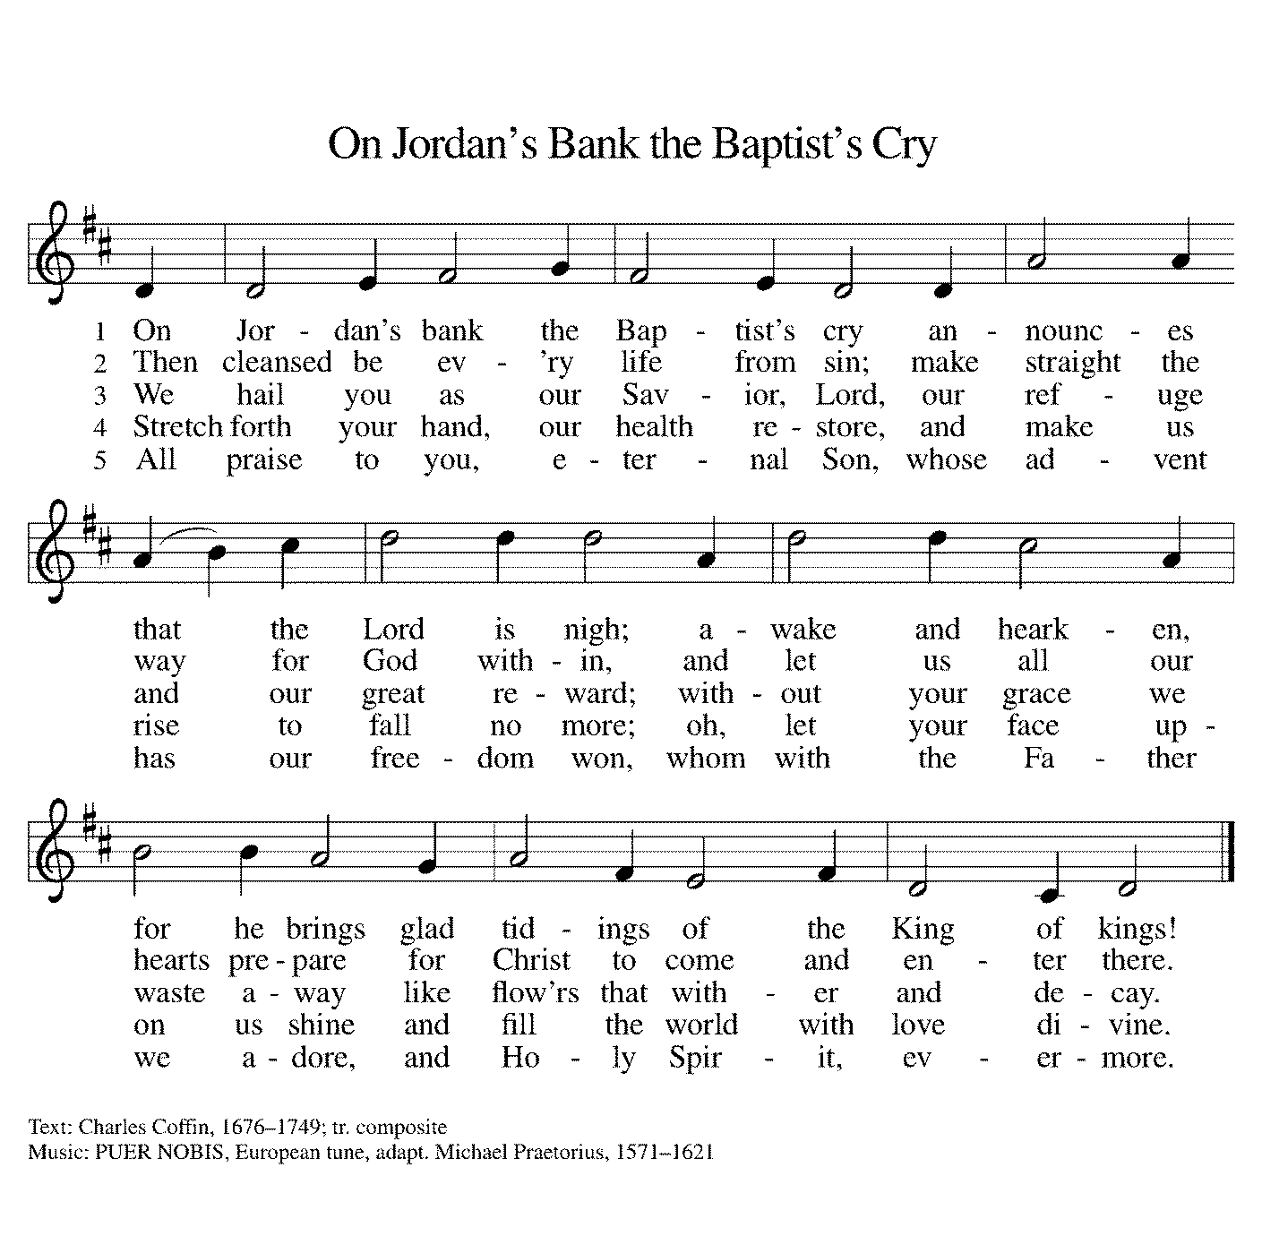

*Nicene Creed
With the whole church, let us confess our faith.
We believe in one God, the Father, the Almighty, maker of heaven and earth, of all that is, seen and unseen.

We believe in one Lord, Jesus Christ, the only Son of God, eternally begotten of the Father, God from God, Light from Light, true God from true God, begotten, not made, of one Being with the Father; through him all things were made. For us and for our salvation he came down from heaven, was incarnate of the Holy Spirit and the virgin Mary and became truly human. For our sake he was crucified under Pontius Pilate; he suffered death and was buried. On the third day he rose again in accordance with the scriptures; he ascended into heaven and is seated at the right hand of the Father. He will come again in glory to judge the living and the dead, and his kingdom will have no end.

We believe in the Holy Spirit, the Lord, the giver of life, who proceeds from the Father and the Son, who with the Father and the Son is worshiped and glorified, who has spoken through the prophets.
We believe in one holy catholic and apostolic church.
We acknowledge one baptism for the forgiveness of sins.
We look for the resurrection of the dead, and the life of the world to come. Amen.
*Prayers of Intercession
In this season of watching and waiting, let us pray for all people and places that yearn for God’s presence.
A brief silence.

You send messengers into the world to proclaim the day of your coming. Make our bishops, pastors, deacons, and lay preachers confident in their preaching, that their words and our lives witness to your grace. Hear us, O God. Your mercy is great.

Send your Spirit to all living creatures that are endangered. Provide them with shelter and care, and bring us into right relationship with the earth that you create and call good. Hear us, O God. Your mercy is great.

Send leaders to our nations, cities, schools, and businesses to work on behalf of those who have lost parents, spouses, and loved ones; immigrants; the imprisoned; those living in poverty; and all who are oppressed. Make them bold in their commitments to justice and reconciliation. Hear us, O God. Your mercy is great.

Send your servants to care for those who suffer. Use our ministries and our lives to reach out with compassion to those who are hungry, oppressed, lonely, or ill especially Paul, Dorothy, Cathy, Rich, Dolores, Carol, Norma, and those we name before you now. . . Grant them healing and wholeness. Hear us, O God. Your mercy is great.

Send prophets to speak difficult truths, even when they are poorly received. Embolden those who ask hard questions and challenge accepted ways. Instill in youth and elders alike a passion for pointing to Jesus in all things. Hear us, O God.
Your mercy is great.
Here other intercessions may be offered.

We remember your saints, both those publicly celebrated and those more humbly remembered. Confident that your work will be completed, we live in faith until the day of your coming. Hear us, O God. Your mercy is great.

God of new life, you come among us in the places we least expect. Receive these prayers and those of our hearts, in the name of Jesus. Amen.

*Peace
The peace of Christ be with you always. And also with you.
Please share the peace with others in your household, or by making a sign of peace to those on Zoom. Please remain standing as you are able.

Meal
God feeds us with the presence of Jesus Christ.
*Offering Prayer
God of our waiting and watching, we offer the gifts of our hearts and our lives to the service of all your people. Prepare the way before us as we meet you in this simple meal, through Christ Jesus, our pathway and our peace. Amen.

*Great Thanksgiving
The Lord be with you. And also with you.
Lift up your hearts. We lift them to the Lord.
Let us give thanks to the Lord our God. It is right to give our thanks and praise.
*Preface
It is indeed right, our duty and our joy, that we should at all times and in all places give thanks and praise to you, almighty and merciful God, through our Savior Jesus Christ. You comforted your people with the promise of the Redeemer, through whom you will also make all things new in the day when he comes to judge the world in righteousness. And so, with all the choirs of angels, with the church on earth and the hosts of heaven,
we praise your name and join their unending hymn:

*Sanctus Hymn #245 Creator of the Stars of Night
sts. 1,5
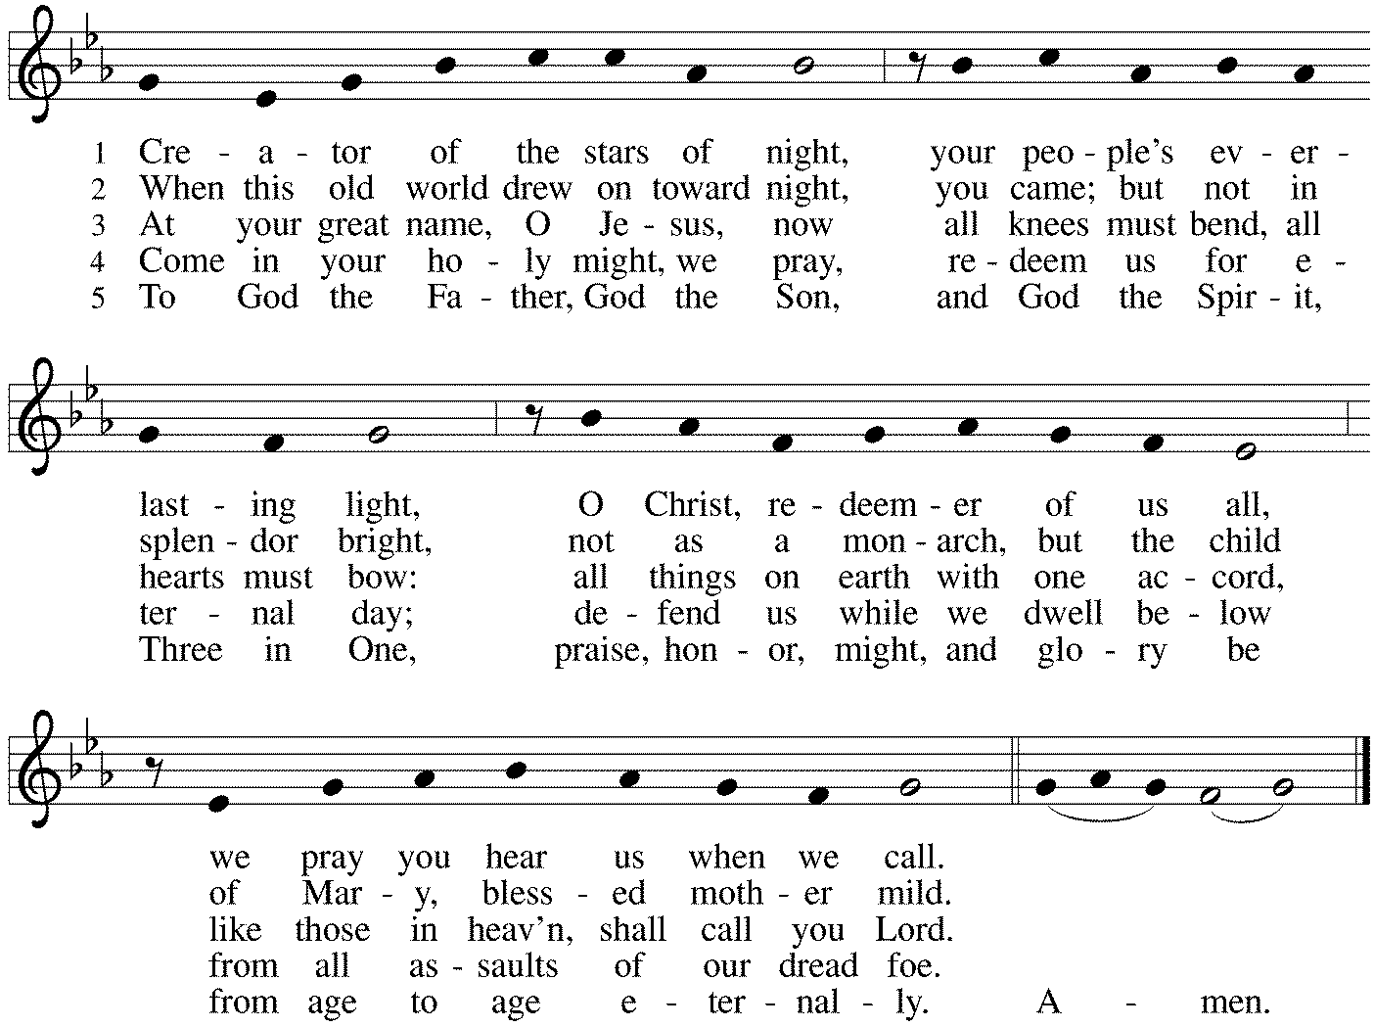

*Thanksgiving at the Table
Holy One, the beginning and the end, the giver of life: Blessed are you for the birth of creation. Blessed are you in the darkness and in the light. Blessed are you for your promise to your people. Blessed are you in the prophets' hopes and dreams. Blessed are you for Mary's openness to your will. Blessed are you for your Son Jesus, the Word made flesh.

In the night in which he was betrayed, our Lord Jesus took bread, and gave thanks; broke it, and gave it to his disciples, saying: Take and eat; this is my body, given for you. Do this for the remembrance of me.

Again, after supper, he took the cup, gave thanks, and gave it for all to drink, saying: This cup is the new covenant in my blood, shed for you and for all people for the forgiveness of sin. Do this for the remembrance of me.
Let us proclaim the mystery of faith: Christ has died. Christ is risen. Christ will come again.

With this bread and cup we remember your Word dwelling among us, full of grace and truth. We remember our new birth in his death and resurrection. We look with hope for his coming. Come, Lord Jesus.

You may hold up your (unopened) communion kit as you are able.
Holy God, we long for your Spirit. Come among us. Bless this meal. May your Word take flesh in us. Awaken your people. Fill us with your light. Bring the gift of peace on earth. Come, Holy Spirit.
You may lower your communion kit.

All praise and glory are yours, Holy One of Israel, Word of God incarnate, Power of the Most High, one God, now and forever. Amen.

*The Lord’s Prayer
Gathered into one by the Holy Spirit, let us pray as Jesus taught us. Our Father, who art in heaven, hallowed be thy name, thy kingdom come, thy will be done on earth as it is in heaven. Give us this day our daily bread; and forgive us our trespasses, as we forgive those who trespass against us; and lead us not into temptation, but deliver us from evil. For thine is the kingdom, and the power, and the glory, forever and ever. Amen.

*Invitation to Communion
Come to Christ’s banquet. Feast on God’s gift of grace. Be Seated.

If you have difficulty opening your communion, please signal an usher for assistance.
Peel up the clear top seal over the wafer, and hold the wafer up when you are ready.
This is the Body of Christ, given for you. (Eat the bread.) Amen.

Peel up the second foil seal over the juice, and hold your cup up when you are ready.
This is the blood of Christ, shed for you. (Drink the wine/juice.) Amen.
After communion you may place the packaging in the bowl in your pew. The ushers will dispose of these following the service.

Agnus Dei Hymn #263 Savior of the Nations, Come
sts. 1,2
*Please stand as you are able.
*Post-Communion Blessing
The body and blood of our Lord Jesus Christ strengthen you and keep you in his grace. Amen.

*Prayer after Communion
Most High God, you have come among us at this table. By the Spirit’s power, form us to be bearers of your word, sharing gifts of mercy and grace with all, through Christ Jesus, our host and our guest. Amen.
Sending
God blesses us and sends us in mission to the world.
*Blessing
The God of hope fill us with all joy and peace in believing, so that we may abound in hope by the power of the Holy Spirit,
through Christ Jesus for whom we wait. Amen.

*Sending Hymn ELW #256 Comfort, Comfort Now My People
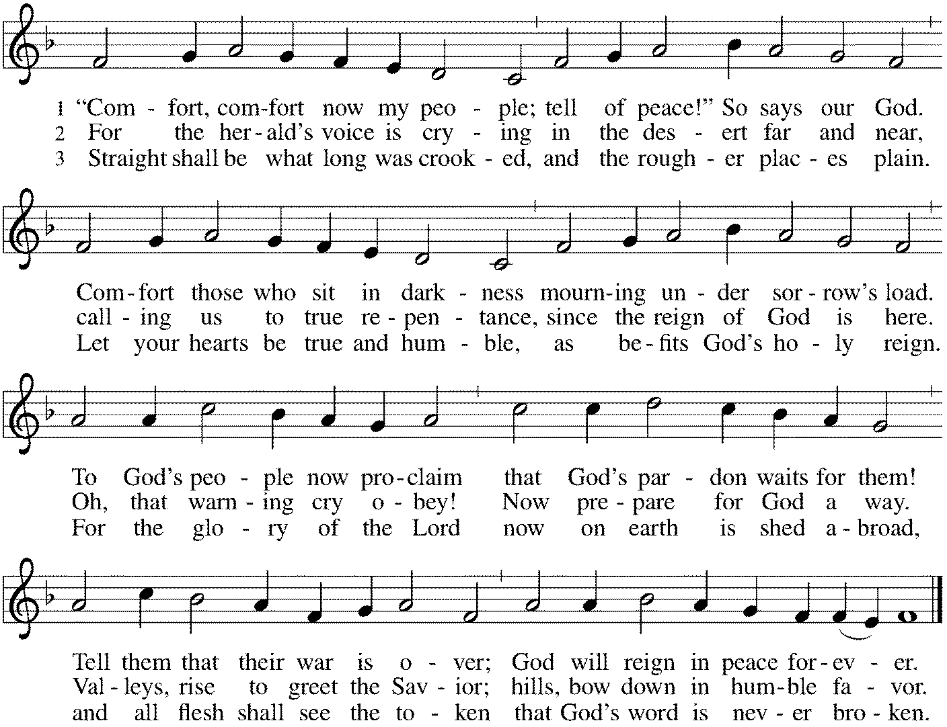

*Sent to the World
Go in peace. Christ is near.
Thanks be to God.

Postlude
After the postlude, those who have joined via Zoom may unmute your mics
and share a greeting with your fellow worshippers.
From Sundays and Seasons
v.20190109.1233 Copyright © 2021 Augsburg Fortress. All rights reserved.
Reprinted by permission under Augsburg Fortress Liturgies Annual License #30867.
All rights reserved. Reprinted under OneLicense.net #A-718333.

Assisting in Worship Today
Ministry Associate Becky Ficarella
Minister of Music Bradford Thompson
Altar Guild Cheryl Huizenga
Lector Susan Jacobson
Ushers Mario Ficarella, Brad Goertzen, Chuck Miller, Open
Zoom Mark Hamilton, Jon & Cathy Milleville

Current Prayer Requests
Paul Griffin Member Healing & Strength
Rich Davison Member Healing & Strength
Cathy Milleville Member Healing & Strength
Dorothy Tracy Member Healing & Strength
Family of Cirina Jacobo Joe Jacobo’s Mother Comfort in Grief
Derrico/Ficarella Families Members Comfort in Grief
Mourning the death of Meta Marek, sister of Dorothy Derrico
Kris Diesness Friend of Eastmans Healing & Strength
Prayers for our homebound Members
Dolores Nosal, Carol Petersen, Norma Petersen

Weekly Announcements
Social Committee Special Event “Carols & Cookies” Wednesday, December 15th 7pm-8pm: Come join us for a cozy night of music for all! Wear PJ’s or comfy clothing, bring along a blanket and find a comfortable place in the Sanctuary to sit and sing carols, listen to the Bridge 36 Handchime Choir, student instrumental solos and more. The Christmas tree and lights will be glowing as we enjoy celebration of the season together. Finish the night with a little goodie bag of cookies as you leave to enjoy at home.

Pill Bottle Project: Until COVID gets under control, we are suspending this project. Processed inventory will be delivered. We are NOT accepting bottles at this time or at any time in the near future as we still have about a year’s worth of bottles to process once we start up again. If you have any questions, please contact Mark Hamilton at (630) 841-2941 / mark.hamilton@ifs.com

The Reverse Advent Food Drive for PADS and Glen Ellyn Food Pantry: We will be collecting items for PADS and GEFP again this year. A list of items can be found online or in the Narthex. Countdown the December days, 1-24 and add an item to your bag each day! Bags can be dropped off to Grace the week leading up to Christmas Eve and also at our Christmas Eve Service at 4:00pm for a blessing. Thank you for your support!

Diaper Drive to Benefit Refugees: Grace will be assisting with a diaper drive in November and December to support Exodus Refugee Resettlement located in Wheaton. Bring your donations to the Narthex. Infant through adult diapers are needed. Thank you for your support!

Pledge Cards: If you haven’t yet, please return your pledge card to the church office asap.
Radiators in Sanctuary: During the week the blowers are to be kept on “low.” They can be turned to “high” on Saturday or Sunday morning. The one radiator with the loud blower on the east side can be turned to “off” during the service but then all radiators should be turned to “low” following the service. Toggle switch is on north side of radiators. The radiator on the west wall does not work.

Ushers Still Needed: If you are able, please help us meet the need for at least two ushers during the worship service each Sunday—one to monitor needs in the sanctuary and one to stand at the entrance to the sanctuary and monitor the narthex and entrances to the bathrooms. We have occasionally had people we don’t know enter the building and remain for some time, and while we welcome everyone, we also want to be able to make sure everyone in the building is secure. Two ushers help us appropriately monitor both needs in the sanctuary and in the narthex and bathrooms. Please contact Mark Drager or the church office and Barbara can add you to the schedule. Thank you.

Got Capital Gains? Did you know that stock donations allow you to both claim a deduction at the appreciated value AND allow you to avoid capital gains taxes on these assets? Further, consolidating donations in a tax year could lead to increased ability to deduct charitable contributions in a given tax year. Consult your tax advisor for details, but if you’d like more information on how to go about donating stock, reach out to the church office.

Council Members Needed: Jon Milleville, Susan Jacobson, and Sue Pagnoni, as nominating committee, will be contacting members about interest in council positions. The nominating committee is now accepting nominations for the following four council positions: three general council members plus one treasurer position. The term begins January 2022 after Grace’s annual meeting.

Terms are for two years and a member may serve two consecutive terms. Prior experience is not necessary. You may serve on council again if you have served in the past. You may nominate yourself or someone else. Please submit nominations to Jon Milleville, Susan Jacobson, Sue Pagnoni, or the church office by Tuesday, November 30.

Bell Choir rehearsal Wednesdays at 7pm! Come join us for an hour of fun, super low-pressure music-making! Not free on Wednesday evenings? You’re still welcome to join us on Sunday mornings at 8:40! Don’t know how to read music; we can work on that, too! No matter your skill level, there’s room for you! Get excited, my friends! The fun starts now :)

Mondays at 7:00pm, the group is reviewing a new, as yet unpublished, book from Dr. George Byron Koch. The topic is the Jewish Roots of Christianity. Those who want to may meet with us live in the Great Room. We will also provide a Zoom option for those who prefer to participate that way. Kindly contact Mark Hamilton or Vince Hardt if you have not participated before so that we may add you to our Email list.

Quilting Ministry: This ministry meets on the 2nd and 4th Tuesday of the month from 9:00-10:00am. Even if you can’t sew but are able to cut fabric into a 9” square we need you! We have 10⁺ bins of fabric waiting to be cut. After quilting you are invited to stay and attend the chair exercise class at 10:00am and if you like to knit hats, scarves, and gloves you can join the Wooly Knitters at 1pm! Everyone is welcome, bring a friend!

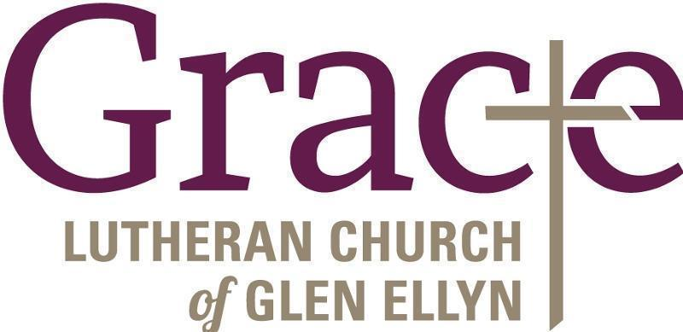

Every Member a Minister and Missionary!

Phone: 630-469-1555 Emergency Pastoral Contact: 630-674-2887
info@graceglenellyn.org www.graceglenellyn.org

Pastor
Rev. Melody Eastman office ext. 14
meastman@graceglenellyn.org

Minister of Music
Bradford Thompson 219-718-8879
bradfordmthompson@gmail.com

Ministry Associate
Becky Ficarella office ext. 17
bficarella@graceglenellyn.org

Office Manager
Barbara Sudds office ext. 10
bsudds@graceglenellyn.org

Parish Counselor
Carole LoGalbo M.S., LCPC 630-668-4594
carolelogalbo@yahoo.com

