Grace Lutheran Church

493 Forest Avenue, Glen Ellyn IL 630.469.1555
www.graceglenellyn.org

Nativity of Our Lord: Christmas eve
December 24, 2022

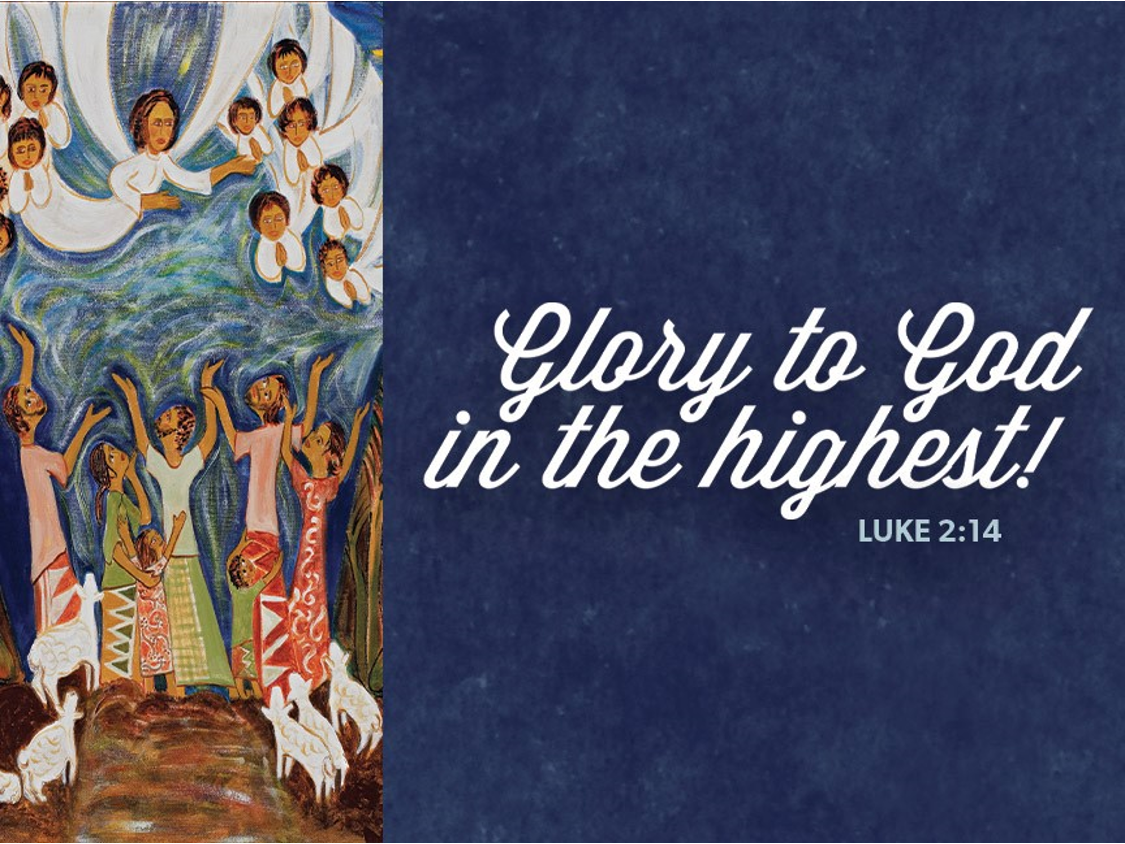

+ Proclaim Christ + Build Community +
+ Serve Our Neighbors +

*Please stand as you are able at the portions marked with an asterisk,
but feel free to be seated as you need. Congregation responses are in bold print.

Gathering
The Holy Spirit calls us together as the people of God.
Welcome/Announcements

Prelude: Instrumental

Christmas Proclamation
On this night, the twenty-fourth of December,
Unknown ages from the time when God created the heavens and the earth
And then formed all human beings in God’s own image,

Several thousand years after the flood,
When God made the rainbow shine forth as a sign of the covenant,
Twenty-one centuries from the time of Abraham and Sarah;
Thirteen centuries after Moses led the people of Israel out of Egypt;

Eleven hundred years from the time of Ruth and the Judges;
One thousand years from the anointing of David as king;
In the sixty-fifth week according to the prophecy of Daniel,
In the one hundred and ninety-fourth Olympiad;

The seven hundred and fifty-second year from the foundation of the city of Rome;
The forty-second year of the reign of Octavian Augustus;
The whole world being at peace,

Jesus Christ, eternal God and Son of the eternal Father,
Desiring to sanctify the world by his most merciful coming,
Being conceived by the Holy Spirit,

And nine months having passed since his conception,
Was born in Bethlehem of Judea of the Virgin Mary.
This is the nativity of our Lord Jesus Christ according to the flesh.

*Please stand as you are able.
*Entrance Hymn ELW #283 O, Come, All Ye Faithful
st. 1, 2, 3
1 O come, all ye faithful, 2 The highest, most holy,
joyful and triumphant! light of light eternal,
O come ye, O come ye to Bethlehem; born of a virgin, a mortal he comes;
come and behold him, Son of the Father
born the king of angels: now in flesh appearing! Refrain

Refrain 3 Sing, choirs of angels,
O come, let us adore him, sing in exultation,
O come, let us adore him, sing, all ye citizens of heaven above!
O come, let us adore him, Glory to God
Christ the Lord! In the highest: Refrain

*Greeting
The grace of our Lord Jesus Christ, the love of God, and the communion of the Holy Spirit be with you all. And also with you.

*Hymn of Praise ELW #289 Angels We Have Heard on High
sts. 1, 3
1 Angels we have heard on high, 3 Come to Bethlehem and see
sweetly singing o'er the plains, him whose birth the angels sing;
and the mountains in reply, come, adore on bended knee
echoing their joyous strains. Christ the Lord, the newborn king. Refrain

Refrain
Gloria in excelsis Deo;
gloria in excelsis Deo.

*Prayer of the Day
Almighty God, you made this holy night shine with the brightness of the true Light. Grant that here on earth we may walk in the light of Jesus’ presence and in the last day wake to the brightness of his glory; through your Son, Jesus Christ our Lord, who lives and reigns with you and the Holy Spirit, one God, now and forever. Amen. You may be seated.
Word
God speaks to us in scripture reading, preaching, and song.
First Lesson Isaiah 9:2-7
This poem promises deliverance from Assyrian oppression, a hope based on the birth of a royal child with a name full of promise. While Judah’s king will practice justice and righteousness, the real basis for faith lies in God’s passion for the people: The zeal of the Lord of hosts will do this!

²The people who walked in darkness have seen a great light; those who lived in a land of deep darkness— on them light has shined. ³You have multiplied the nation, you have increased its joy; they rejoice before you as with joy at the harvest, as people exult when dividing plunder. ⁴For the yoke of their burden, and the bar across their shoulders, the rod of their oppressor, you have broken as on the day of Midian. ⁵For all the boots of the tramping warriors and all the garments rolled in blood shall be burned as fuel for the fire. ⁶For a child has been born for us, a son given to us; authority rests upon his shoulders; and he is named Wonderful Counselor, Mighty God, Everlasting Father, Prince of Peace. ⁷His authority shall grow continually, and there shall be endless peace for the throne of David and his kingdom. He will establish and uphold it with justice and with righteousness from this time onward and forevermore. The zeal of the Lord of hosts will do this.

Word of God, Word of Life. Thanks be to God.

Advent Bell Carol

Second Lesson Titus 2:11-14
The appearance of God’s grace in Jesus Christ brings salvation for all humanity. Consequently, in the present we live wisely and justly while also anticipating the hope of our Savior’s final appearance.

¹¹The grace of God has appeared, bringing salvation to all, ¹²training us to renounce impiety and worldly passions, and in the present age to live lives that are self-controlled, upright, and godly, ¹³while we wait for the blessed hope and the manifestation of the glory of our great God and Savior, Jesus Christ. ¹⁴He it is who gave himself for us that he might redeem us from all iniquity and purify for himself a people of his own who are zealous for good deeds.

Word of God, Word of Life. Thanks be to God.
*Please stand as you are able.
*Gospel Acclamation ELW #270 Hark, the Herald Angels Sing
st. 1
Hark! The herald angels sing, Refrain
"Glory to the newborn king; Hark! The herald angels sing,
peace on earth, and mercy mild, "Glory to the newborn king!"
God and sinners reconciled."
Joyful, all you nations, rise;
join the triumph of the skies;
with angelic hosts proclaim,
"Christ is born in Bethlehem!"

The holy Gospel according to Luke. Glory to you, O Lord.

*Gospel Luke 2:1-20
God’s greatest gift comes as a baby in a manger. Angels announce the “good news of great joy” and proclaim God’s blessing of peace.

¹In those days a decree went out from Emperor Augustus that all the world should be registered. ²This was the first registration and was taken while Quirinius was governor of Syria. ³All went to their own towns to be registered. ⁴Joseph also went from the town of Nazareth in Galilee to Judea, to the city of David called Bethlehem, because he was descended from the house and family of David. ⁵He went to be registered with Mary, to whom he was engaged and who was expecting a child. ⁶While they were there, the time came for her to deliver her child. ⁷And she gave birth to her firstborn son and wrapped him in bands of cloth, and laid him in a manger, because there was no place for them in the inn.
⁸In that region there were shepherds living in the fields, keeping watch over their flock by night. ⁹Then an angel of the Lord stood before them, and the glory of the Lord shone around them, and they were terrified. ¹⁰But the angel said to them, “Do not be afraid; for see—I am bringing you good news of great joy for all the people: ¹¹to you is born this day in the city of David a Savior, who is the Messiah, the Lord. ¹²This will be a sign for you: you will find a child wrapped in bands of cloth and lying in a manger.” ¹³And suddenly there was with the angel a multitude of the heavenly host, praising God and saying,
¹⁴“Glory to God in the highest heaven,
and on earth peace among those whom he favors!”

¹⁵When the angels had left them and gone into heaven, the shepherds said to one another, “Let us go now to Bethlehem and see this thing that has taken place, which the Lord has made known to us.” ¹⁶So they went with haste and found Mary and Joseph, and the child lying in the manger. ¹⁷When they saw this, they made known what had been told them about this child; ¹⁸and all who heard it were amazed at what the shepherds told them. ¹⁹But Mary treasured all these words and pondered them in her heart. ²⁰The shepherds returned, glorifying and praising God for all they had heard and seen, as it had been told them.

The Gospel of the Lord. Praise to you, O Christ.

*Gospel Acclamation ELW #270 Hark, the Herald Angels Sing
st. 3
Hail the heav'n-born Prince of peace! Refrain
Hail the Sun of righteousness! Hark! The herald angels sing,
Light and life to all he brings, "Glory to the newborn king!"
ris'n with healing in his wings.
Mild he lays his glory by,
born that we no more may die,
born to raise each child of earth,
born to give us second birth.
You may be seated.

Sermon The Rev. Melody Eastman

*Please stand as you are able.
*Hymn of the Day ELW #279 O Little Town of Bethlehem
sts. 1, 3, 4
1 O little town of Bethlehem, 4 O holy child of Bethlehem,
how still we see thee lie! descend to us, we pray;
Above thy deep and dreamless sleep cast out our sin, and enter in,
the silent stars go by; be born in us today.
yet in thy dark streets shineth We hear the Christmas angels
the everlasting light. The great glad tidings tell;
The hopes and fears of all the years oh, come to us, abide with us,
are met in thee tonight. Our Lord Immanuel!

3 How silently, how silently
the wondrous gift is giv'n!
So God imparts to human hearts
the blessings of his heav'n.
No ear may hear his coming;
but, in this world of sin,
where meek souls will receive him, still
the dear Christ enters in.

*Prayers of Intercession
With wonder and thanksgiving for Christ’s coming into the world, we pray for the church, the life of the earth, and the whole human family. A brief silence.

Your infinite love is born to us this night. With choirs of angels the church proclaims the good news. Send us out as messengers of the hope that has come to all people. God of grace, hear our prayer.

You are pleased to dwell with your creatures and the whole earth sings for joy. Renew the splendor of creation from the smallest cell to the widest galaxies. Guide us to be wise stewards of your gifts for the sake of generations to come. God of grace, hear our prayer.

Your authority is over the nations. Break the rod of oppression in every land and free all people from fear. Bring peace where there is war, compassion where there is suffering, and healing where there is disease. God of grace, hear our prayer.

You cherish those who are most vulnerable. Protect infants and children, and bless those who care for them. Watch over women giving birth, attend the dying, and relieve any who are in pain especially Dorothy, Norma, Carol, Brittany, Donald, Leo, and those we name before you now. . . Shelter refugee families and those who have no home. God of grace, hear our prayer.

Your lovingkindness embraces everyone in need. Help any for whom this season is lonely or joyless. Comfort those among us, or known to us, who are experiencing distress of body or mind, missing loved ones, or grieving. God of grace, hear our prayer.
Here other intercessions may be offered.

You welcome those who have died into the joyous light of glory. We give thanks for the saints of every time and place who have praised you with lives of faith and humility. Inspire us by their example to love you by serving others. God of grace, hear our prayer.

Pondering the mystery of eternal love made flesh in Christ Jesus, we commend all for whom we pray to the mercy of God. Amen.
*Dedication of the Advent Offerings
Dearest Lord Jesus, you know what it is to be cold, to be hungry. Your parents knew what it feels to fear for the well-being of their beloved child. They knew what it feels like to be unsure how they would provide for you. They knew what it was like to be homeless, and to have to flee to a foreign land with no family to help them.

We have gathered these gifts for you tonight, because your love for us calls us to care. We pray that all the people who receive them find comfort in their time of struggle. We pray that you use these gifts to restore hope and security and health to your beloved children who are in need. We pray for the time when no one has to fear for the safety of their children, or to wonder where they will sleep or eat. We pray for security and dignity to be restored to everyone. We pray that you work in us to make this happen, in your holy name. Amen.

*Peace
The peace of Christ be with you always. And also with you.
Please share the peace with others in your household, or by making a sign of peace to those on Zoom. You may then be seated as the table is prepared.

Meal
God feeds us with the presence of Jesus Christ.
Gathering of Gifts
We gather gifts for those in need and for the church’s mission.

Music During Offering

*Please stand as you are able. The gifts are brought forward while the congregation sings:
*Offertory Response ELW #245 Creator of the Stars of Night

sts. 1, 2
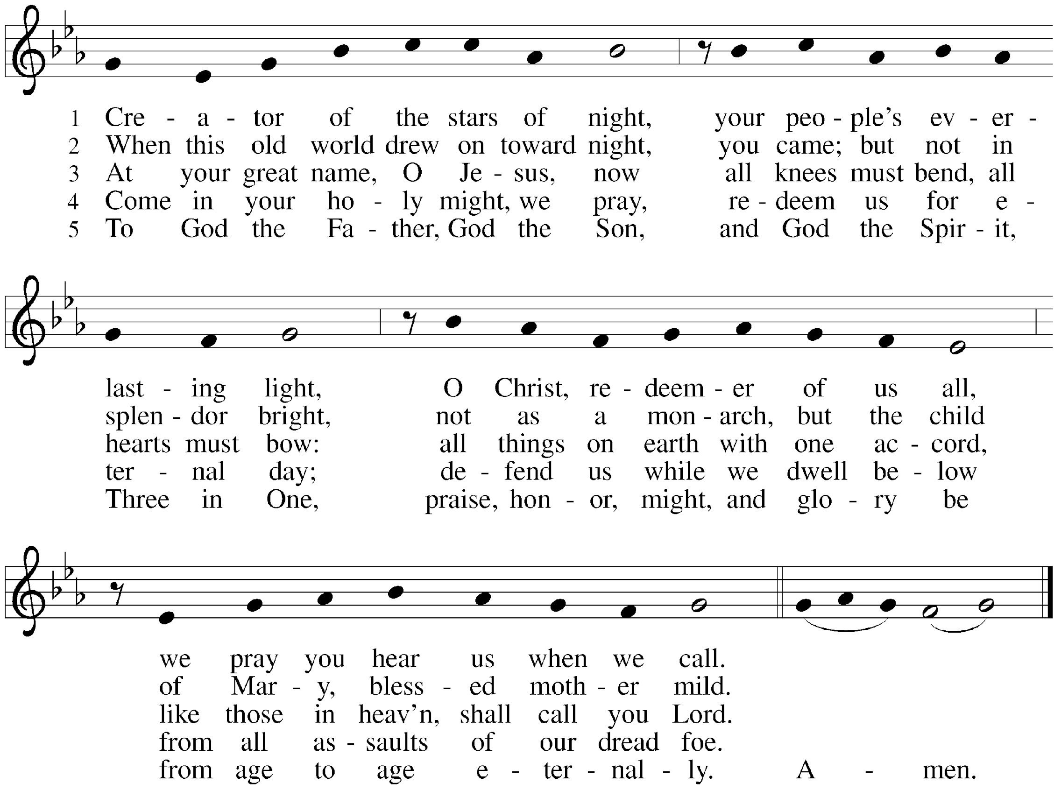

*Offering Prayer
God of abundance,
receive and bless these gifts we have offered.
Join our hearts with the song of the angels,
and gather us at your table of celebration.
Strengthen us to share with all the world
the abundance of your grace upon grace,
poured out in Jesus Christ, the Word made flesh.
Amen.

*Great Thanksgiving
The Lord be with you. And also with you.
Lift up your hearts. We lift them to the Lord.
Let us give thanks to the Lord our God. It is right to give our thanks and praise.

*Preface
It is indeed right, our duty and our joy,
that we should at all times and in all places give thanks and praise to you,
almighty and merciful God, through our Savior Jesus Christ.
In the wonder and mystery of the Word made flesh
you have opened the eyes of faith to a new and radiant vision of your glory,
that, beholding the God made visible,
we may be drawn to love the God whom we cannot see.
And so, with all the choirs of angels,
with the church on earth and the hosts of heaven,
we praise your name and join their unending hymn:

*Sanctus ELW #295 Of the Father’s Love Begotten
st. 1, 4
1 Of the Father's love begotten 4 Let the heights of heav’n adore him;
ere the worlds began to be, angel hosts, his praises sing;
he is Alpha and Omega, pow’rs, dominions, bow before him
he the source, the ending he, and extol our God and King;
of the things that are, that have been, let no tongue on earth be silent,
and that future years shall see, ev’ry voice in concert ring
evermore and evermore. evermore and evermore.

*Thanksgiving at the Table
Holy One, the beginning and the end, the giver of life:
Blessed are you for the birth of creation.
Blessed are you in the darkness and in the light.
Blessed are you for your promise to your people.
Blessed are you in the prophets' hopes and dreams.
Blessed are you for Mary's openness to your will.
Blessed are you for your Son Jesus, the Word made flesh.

In the night in which he was betrayed,
our Lord Jesus took bread, and gave thanks;
broke it, and gave it to his disciples, saying:
Take and eat; this is my body, given for you.
Do this for the remembrance of me.

Again, after supper, he took the cup, gave thanks,
and gave it for all to drink, saying:
This cup is the new covenant in my blood,
shed for you and for all people for the forgiveness of sin.
Do this for the remembrance of me.

Let us proclaim the mystery of faith:
Christ has died. Christ is risen. Christ will come again.
With this bread and cup
we remember your Word dwelling among us,
full of grace and truth.
We remember our new birth in his death and resurrection.
We look with hope for his coming.
Come, Lord Jesus.

Holy God, we long for your Spirit.
Come among us. Bless this meal.
May your Word take flesh in us.
Awaken your people. Fill us with your light.
Bring the gift of peace on earth.
Come, Holy Spirit.

All praise and glory are yours,
Holy One of Israel,
Word of God incarnate,
Power of the Most High,
one God, now and forever. Amen.

*Lord’s Prayer
Gathered into one by the Holy Spirit, let us pray as Jesus taught us.
Our Father in heaven, hallowed be your name, your kingdom come, your will be done, on earth as in heaven. Give us today our daily bread. Forgive us our sins as we forgive those who sin against us. Save us from the time of trial and deliver us from evil. For the kingdom, the power and the glory are yours, now and forever. Amen.

*Invitation to Communion
Glory to God in the highest! Come to the table of peace. You may be seated.

Agnus Dei ELW #295 Of the Father’s Love Begotten
st. 5
Christ, to thee, with God the Father,
and, O Holy Ghost, to thee,
hymn and chant and high thanksgiving
and unwearied praises be:
honor, glory, and dominion,
and eternal victory
evermore and evermore! Amen.

Communion
For those receiving communion from home:
This is the body of Christ, given for you. Amen (Eat the bread.)
This is the blood of Christ, shed for you. Amen (Drink the juice.)
Those who wish to come forward for communion or a blessing may do so at the ushers’ direction. You may return to your seat after you have received the bread and wine.

Duet O Holy Night Rob Granner & Tom Roete

*Please stand as you are able.
*Post Communion Blessing
The body and blood of our Lord Jesus Christ strengthen you and keep you in his grace. Amen

*Post Communion Prayer
God our redeemer,
you have fed us at this table
with gifts of grace, truth, and life.
As you have gathered us in joy,
send us forth as messengers of your peace.
Make us shine with the good news of your glory,
born to us in Jesus Christ, our Savior and Lord. Amen.

*Service of Candlelight
Please turn your candle on.
Those worshipping via Zoom may light a candle at home.
Hold your candle aloft while you sing.

*Hymn ELW #281 Silent Night, Holy Night
1 Silent night, holy night! 3 Silent night, holy night!
All is calm, all is bright Son of God, love’s pure light
Round yon virgin mother and child. Radiant beams from your holy face
Holy infant so tender and mild, With the dawn of redeeming grace,
Sleep in heavenly peace, Jesus, Lord, at your birth,
Sleep in heavenly peace. Jesus, Lord, at your birth.
2 Silent night, holy night!
Shepherds quake at the sight;
Glories stream from heaven afar
Heavenly hosts sing, alleluia!
Christ, the Savior, is born!
Christ, the Savior, is born!

Sending
God blesses us and sends us in mission to the world.
*Blessing
God bless you and keep you,
☩ Jesus grant you grace and truth,
and the Spirit send peace upon your hearts,
now and forever. Amen.
You may extinguish your candle.

*Sending Hymn ELW #267 Joy to the World
1 Joy to the world, the Lord is come! 3 No more let sin and sorrow grow
Let earth receive her king; nor thorns infest the ground;
let ev'ry heart prepare him room he comes to make his blessings flow
and heav'n and nature sing, far as the curse is found,
and heav'n and nature sing, far as the curse is found,
and heav'n, and heav'n and nature sing. far as, far as the curse is found.

2 Joy to the earth, the Savior reigns! 4 He rules the world with truth and grace
Let all their songs employ, and makes the nations prove
while fields and floods, rocks, hills, and plains the glories of his righteousness
repeat the sounding joy, and wonders of his love,
repeat the sounding joy, and wonders of his love,
repeat, repeat the sounding joy. and wonders, wonders of his love.

*Sent to the World
Christ the Savior is born! Go in peace. Proclaim this good news.
Thanks be to God.

Postlude

From Sundays and Seasons v.20190109.1233 Copyright © 2020 Augsburg Fortress. All rights reserved.
Reprinted by permission under Augsburg Fortress Liturgies Annual License #30867.
All rights reserved. Reprinted under OneLicense.net #A-718333.

Grace’s Church Office and the Glen Ellyn Food Pantry
will be closed December 26 through January 2.

Assisting in Worship Today
Pastor Rev. Melody Eastman
Minister of Music Bradford Thompson
Ministry Associate Becky Ficarella
Altar Care Cheryl Huizenga
Lector Vince Hardt
Ushers Mario Ficarella, Chuck Miller
Zoom Mark Hamilton, Jon & Cathy Milleville

Remember in Prayer
Brittany Huizenga, Cousin of Cheryl Huizenga, Healing & Strength
Dorothy Tracy, Member, Healing & Strength
Norma Petersen, Member, Healing & Strength
Rodger Plant and his wife, Victoria, welcomed identical twin boys November 27. Donald Allen Oak Plant – 4.3 pounds and Leo David Spruce Plant – 4.7 pounds. They are premature at 33 weeks and currently in Neonatal ICU.

Announcements
There will not be an in-person worship service on Sunday, December 25 or on New Year’s Day, January 1. Watch for additional details on a video worship service for January 1, when we will celebrate the Epiphany of Our Lord with St. Paul Lutheran and Holy Cross Lutheran.

Congregational Meeting: Mark your calendars for Sunday, January 29th at 11:15am. Grace will have its annual congregational meeting following our Sunday worship service. Your attendance is needed to reach our 50-member quorum requirement. The meeting will be conducted in the Sanctuary and on Zoom. We will be voting to approve the 2023 budget and electing new Church Council members. We will also share with the congregation our vision and plans for a new and exciting ministry partnership that will carry Grace into the future. Come and be a part of this exciting time at Grace.

PADS: Tuesday, January 3, 5:15pm at the Interim Housing Center. As part of our community outreach along with the amazing support of our volunteers, Grace continues to support PADS. In the last couple of years PADS has continued to evolve to serve the needs of their guests. PADS guests are now housed in a 130-unit Interim Housing Center (IHC) using a repurposed hotel in Downers Grove.

So here is the latest approach to PADS:
The guests now have access to snacks and desserts at the PADS site. We at Grace would like to concentrate more on shelf stable or homemade meals, fruits, vegetables and healthy snacks if possible. Of course, all donations are appreciated. If anyone has contacts with restaurants or stores who would like to help, please let us know.
Please leave donated food for PADS (1st Tuesday of the month) upstairs in the Church Kitchen via the gym or you can drop-off at our home. The food at the Church is picked up around 1:30pm in the afternoon. At home we will accept food until 3pm.
Thanks to all for your generosity and volunteering!! Joe and Donna Jacobo

HELP US SAVE LIVES THIS JANUARY DURING NATIONAL BLOOD DONOR MONTH!
Grace Lutheran’s next blood drive will be Thursday, January 5 from 2:30-7pm. Donors will be entered into the Drive to Save Lives Sweepstakes to win an SUV. Appointments are encouraged, walk-ins welcome!
Our goal is 15 units but this drive is able to process 25⁺ donors!

https://donate.illinois.versiti.org/donor/schedules/drive_schedule/5602181

FaithTalk: January’s FaithTalk will take us through the journey of the liturgical year. (What does that mean anyway?, for example!) What are the seasons of the Church Year, what do they mean, where did they come from, and what’s the point? There’s more to it than you might think, and getting the whole picture can truly enrich your worship experience. Join us in the downstairs Kitchen Meeting Room on Thursday, January 5 from 12:30-2:00pm. Everyone is welcome!

Poinsettias
Tim & Linda Kelly to the “Glory of God”
Carole LoGalbo in memory of Robert LoGalbo
Joe & Donna Jacobo in memory of Ramon & Cirina Jacobo
Ginny Stein in memory of Bob & Dorothy Stein
Sue & Rich Davison
Shirley Sauerman in memory of Jack Sauerman
Jake & Susan Jacobson in honor of our mothers; Alice Bartells and
Beverly ‘Sue’ Jacobson
The family of Joan Ulhorn in memory of Joan Uhlhorn and
Ernst & Wilma Thielbert
Venus Petcoff Davis in loving memory of my parents; Martin & Ruth Petcoff
and my brother Martin Petcoff, Jr.
Jean Jeske in memory of Jerry Jeske
Mark & Cyndy Drager
Helen Sladek in memory of James Sladek
Jerry & Brigitte Miller-Happy Birthday Baby Jesus!

Every Member a Minister and Missionary!

Phone: 630-469-1555 Emergency Pastoral Contact: 630-674-2887
info@graceglenellyn.org www.graceglenellyn.org

Pastor
Rev. Melody Eastman office ext. 14
meastman@graceglenellyn.org

Minister of Music
Bradford Thompson 219-718-8879
bradfordmthompson@gmail.com

Ministry Associate
Becky Ficarella office ext. 17
bficarella@graceglenellyn.org

Office Manager
Barbara Sudds office ext. 10
bsudds@graceglenellyn.org

Parish Counselor
Carole LoGalbo M.S., LCPC 630-668-4594
carolelogalbo@yahoo.com

