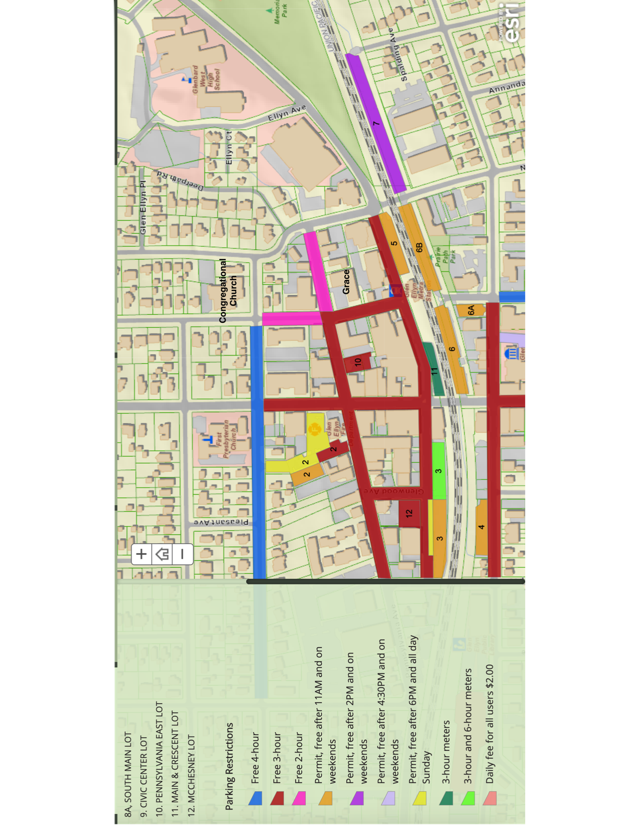

Park

**Main**

**Crescent**

**Forest**

**Pennsylvania**

**The 19 spaces in Grace’s parking lot are reserved for those with limited mobility. If you are able to walk, please park in the lot at the Congregational Church (2 blocks north of Grace on Forest Ave.) or in another parking area. (Grace is labeled on the map, near the intersection of the pink and red lines.)**

Note that there is free parking just south of the train tracks (4, 6, 6A, 6B, as well as on the street). You will need to walk to Main or Park to cross the tracks, so be sure you allow enough time.

Check the legend for other available parking. Most parking is free at the time of the concert.

You may access a full, interactive map at <https://www.glenellyn.org/198/Parking>. Click on the second option, “Customer Parking” to look for parking beyond the boundaries of this map.